## Image 01 (kitchen)

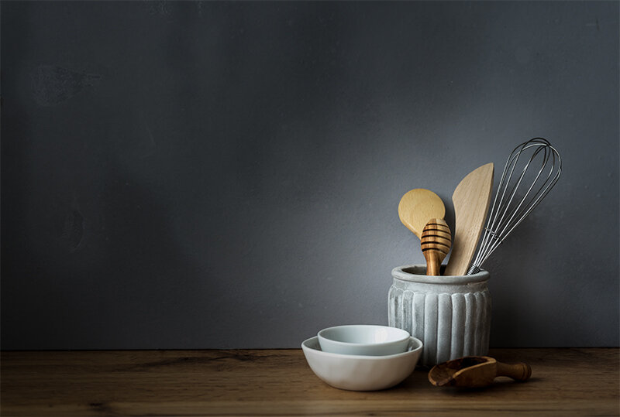

1. How many wooden utensils are visible? 4 (taxonomic) (spoons & spatulas)

2. How many items are contained within another item? 3 (relational) (utensils in the container)

3. If the bowls were made of metal instead of ceramic, how many metal objects would there be? 5 (physical) (bowls & whisk)

## Image 02 (zoo)

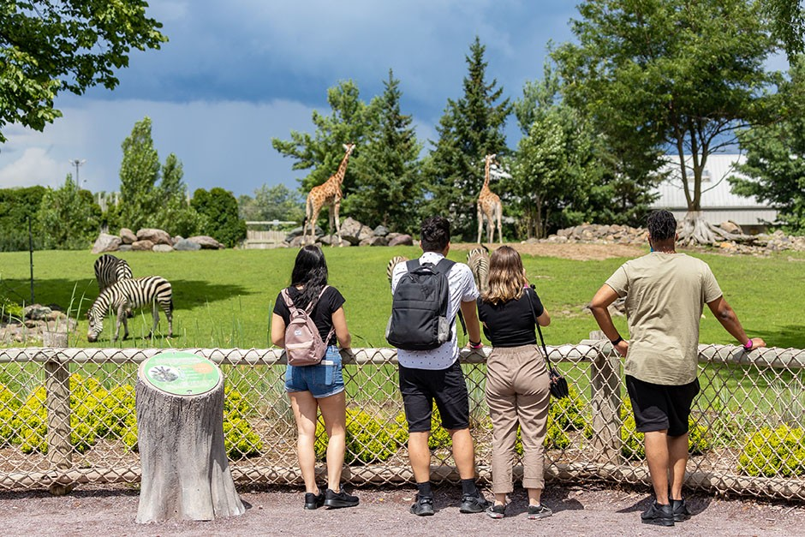

1. How many mammals are visible? 5 (taxonomic) (giraffes and zebras)

2. How many people are looking at the animals? 4 (relational) (people)

3. If the fence were not present, how many animals would be freely roaming? 5 (taxonomic) (giraffes and zebras)

## Image 03 (biking)

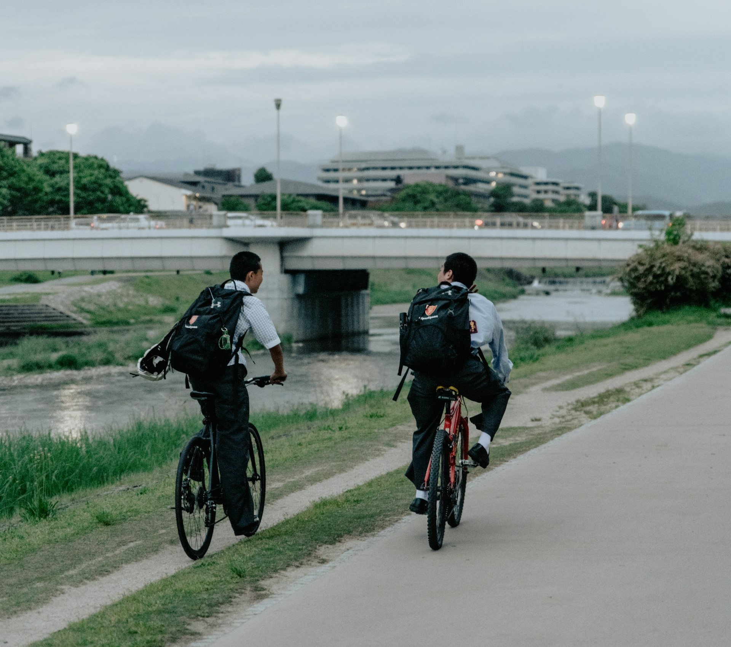

1. How many vehicles with wheels are present? 2 (physical) (bicycles)

2. How many people are carrying backpacks on their backs? 2 (relational) (people)

3. If the river was filled with sand, how many bodies of water would be visible? 0 (physical) (rivers)

## Image 04 (tools)

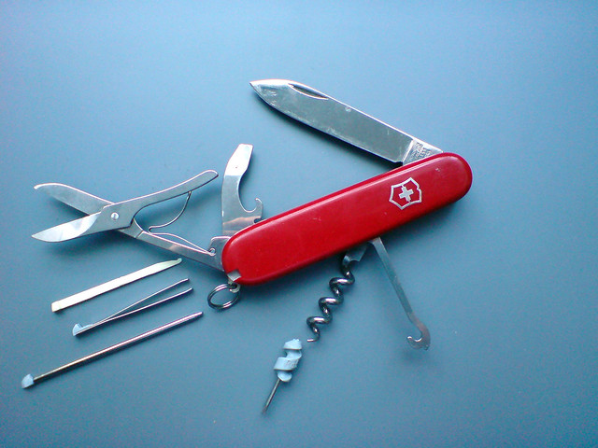

1. How many metal tools are visible? 7 (taxonomic) (tools)

2. How many items can be opened or unfolded? 6 (functional) (tools)

3. If the corkscrew was made of wood instead of metal, how many wooden tools would be visible? 1 (physical) (tools)

## Image 05 (meeting room)

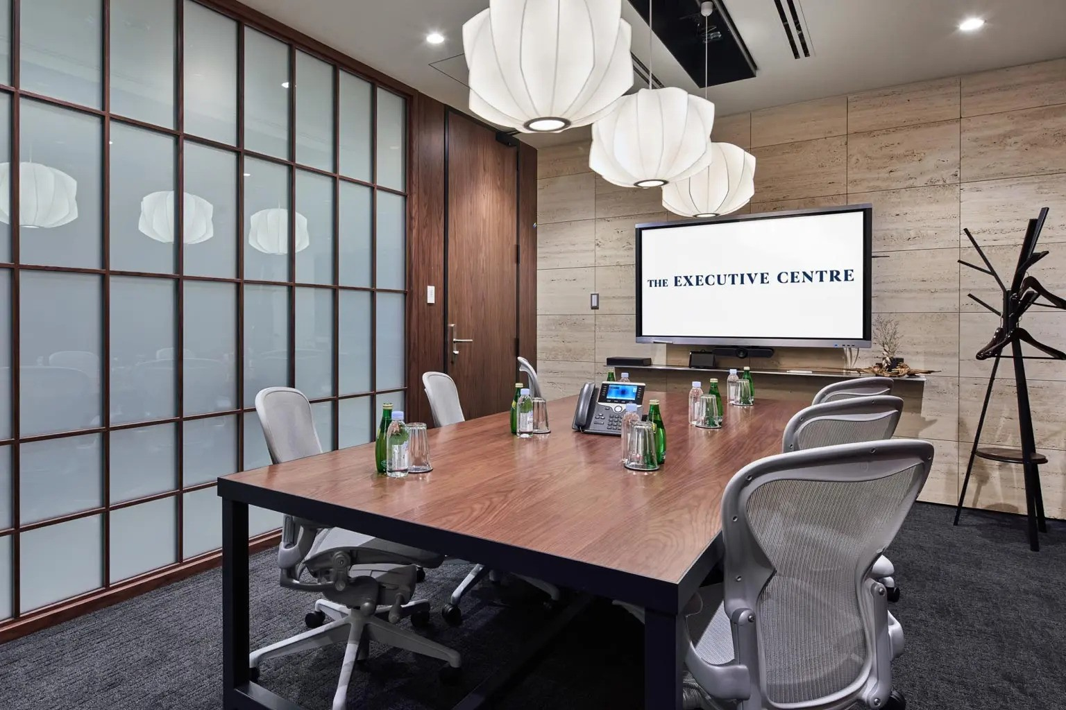

1. How many chairs with wheels are present? 5 (physical) (office chairs)

2. How many items are on top of the table? 7 (relational) (bottles, glasses, phone, notepad)

3. If the lamps were all the same color as the wall, how many white objects would be visible? 0 (physical) (lamps)

## Image 06 (zoo)

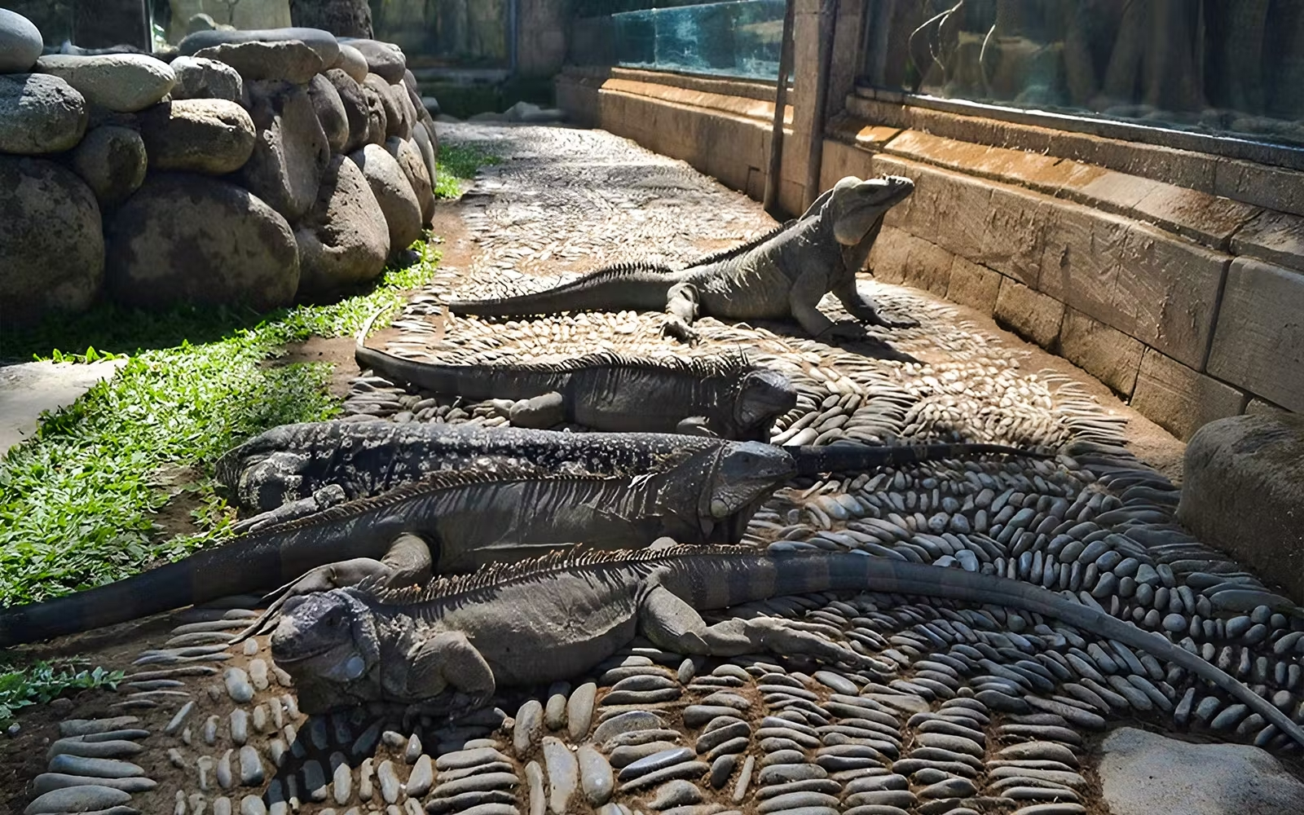

1. How many reptiles are visible? 5 (taxonomic) (iguanas)

2. How many iguanas are lying on top of the stones? 4 (relational) (iguanas)

3. If all the iguanas were blue, how many blue reptiles would be visible? 5 (taxonomic) (iguanas)

## Image 07 (urban)

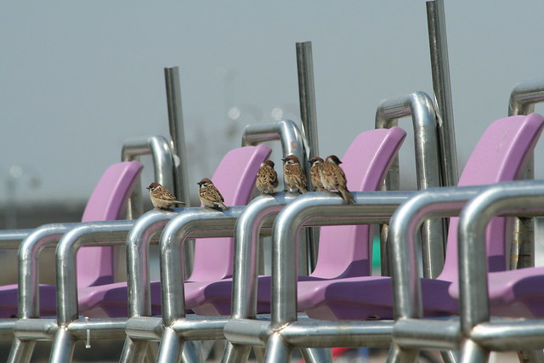

1. How many birds are visible? 5 (taxonomic) (sparrows)

2. How many chairs are arranged in a row? 6 (relational) (purple chairs)

3. If the metal railings were made of wood, how many wooden structures would be visible? 6 (physical) (railings)

## Image 08 (zoo)

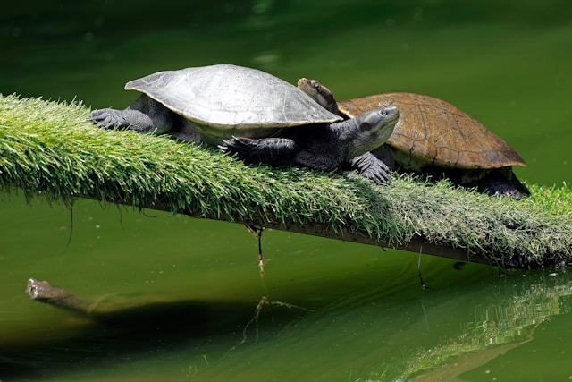

1. How many reptiles are visible? 3 (taxonomic) (turtles)

2. How many turtles are on top of the log? 2 (relational) (turtles)

3. If one more turtle climbed onto the log, how many turtles would be visible? 4 (taxonomic) (turtles)

## Image 09 (market)

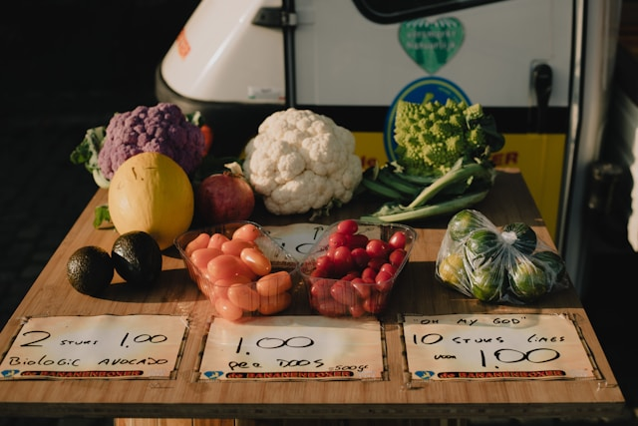

1. How many vegetables are visible? 8 (taxonomic) (cauliflower, broccoli, purple cauliflower, radishes, brussel sprouts, squash, avocado, tomato)

2. How many containers hold food items? 3 (relational) (plastic bags/containers)

3. If all the price tags were removed, how many price tags would still be visible? 0 (physical) (price tags)

## Image 10 (tech)

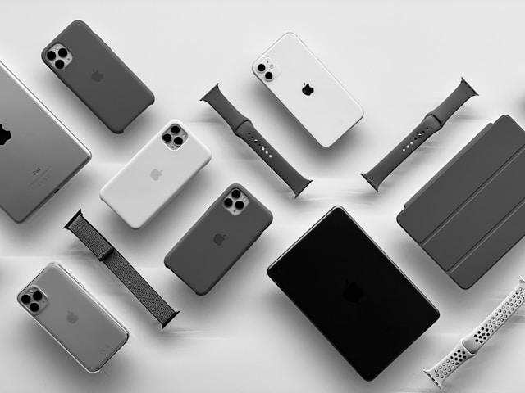

1. How many objects are artifacts? 11 (taxonomic) (Apple products)

2. How many objects can be worn? 3 (functional) (Apple Watch bands)

3. If all the phone cases were removed, how many phones would be visible? 4 (relational) (iPhones)

## Image 11 (meeting room)

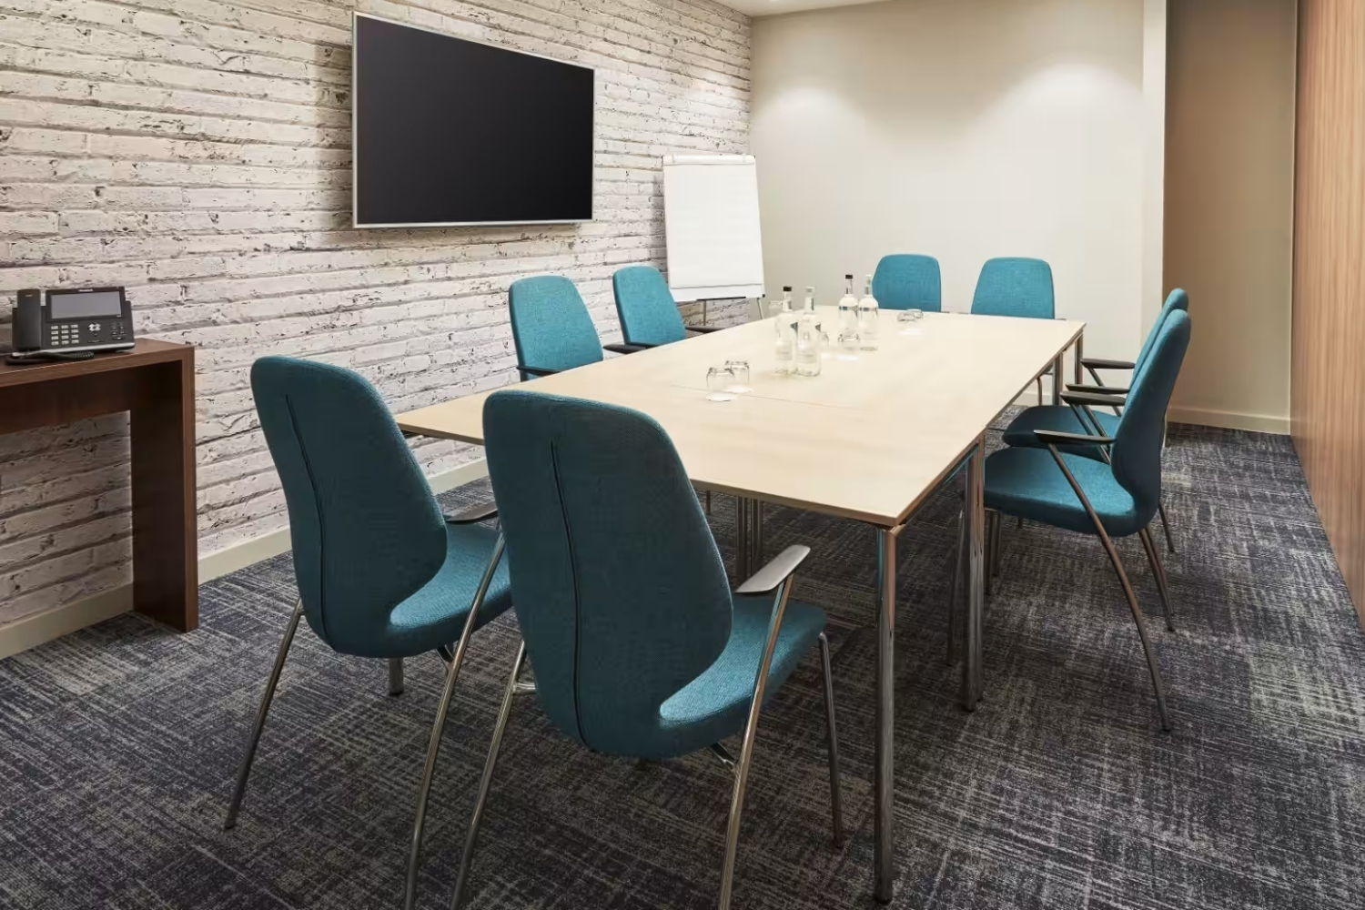

1. How many chairs are visible? 8 (taxonomic) (furniture)

2. How many objects are on top of the table? 4 (relational) (bottles and glasses)

3. If the television was replaced with a whiteboard, how many whiteboards would be visible? 2 (taxonomic) (boards)

## Image 12 (gym)

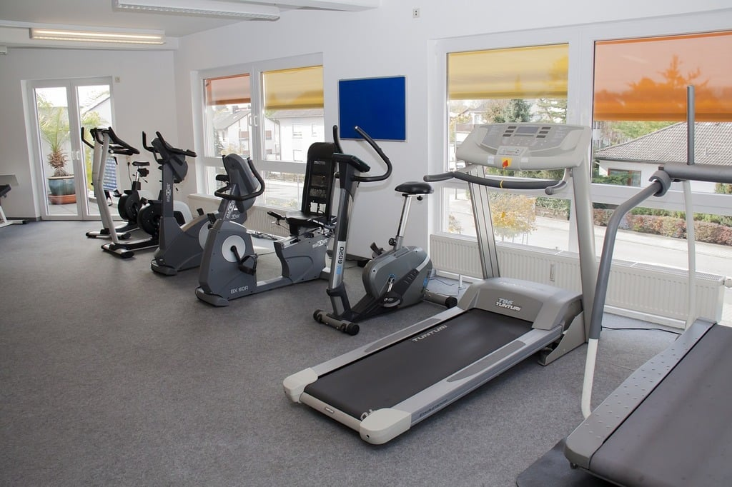

1. How many exercise machines are visible? 4 (taxonomic) (treadmills and bikes)

2. How many objects that need electricity are present? 4 (functional) (exercise machines)

3. If all the windows were removed, how many wall decorations would be visible? 2 (relational) (pictures/posters)

## Image 13 (bedroom)

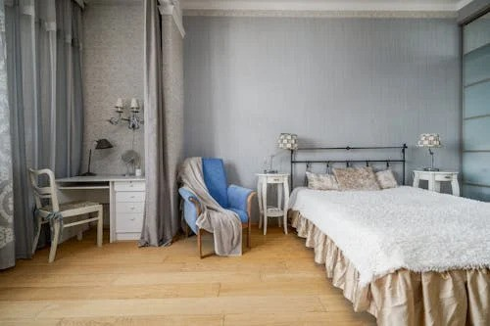

1. How many pieces of furniture are visible? 6 (taxonomic) (bed, chair, desk, nightstands, armchair)

2. How many items are on top of the nightstands? 2 (relational) (lamps)

3. If the curtains were removed, how many wall-mounted light fixtures would be visible? 2 (physical) (sconces)

## Image 14 (classroom)

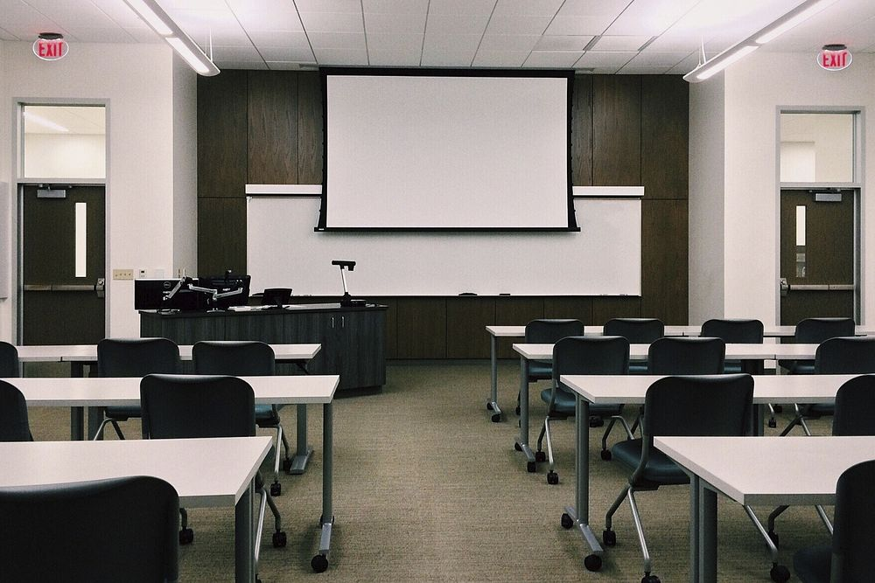

1. How many objects made of metal are present? 24 (physical) (chair legs)

2. How many objects are positioned on top of other objects? 24 (relational) (chairs on floor)

3. If all the chairs were replaced with sofas, how many objects with cushions would be visible? 0 (taxonomic) (sofas)

## Image 15 (garage)

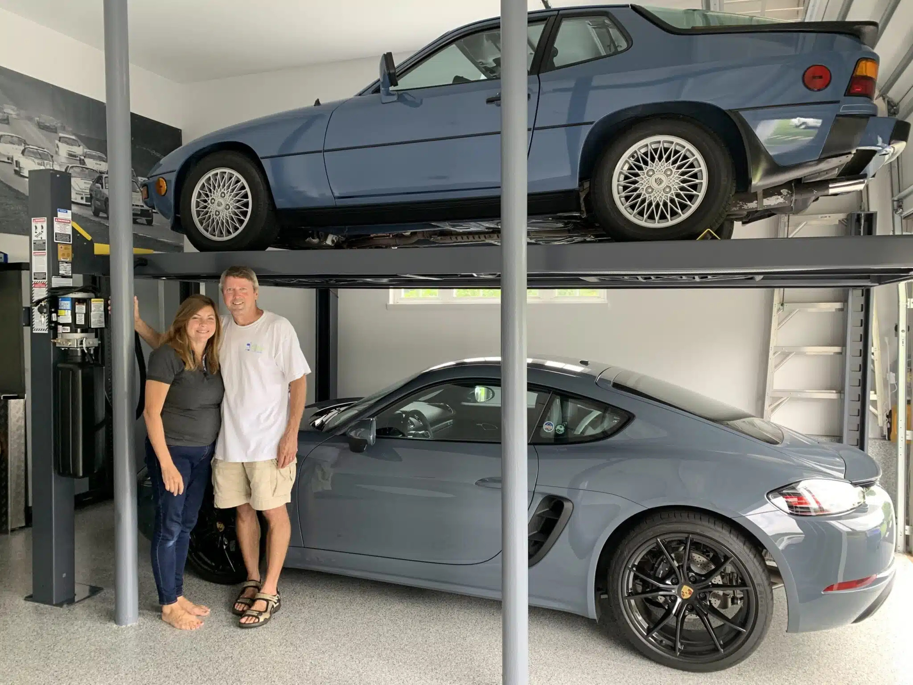

1. How many vehicles are visible? 2 (taxonomic) (cars)

2. How many people are standing together? 1 (relational) (couple)

3. If the top car was not lifted, how many cars would be on the ground? 1 (relational) (cars)

## Image 16 (garage)

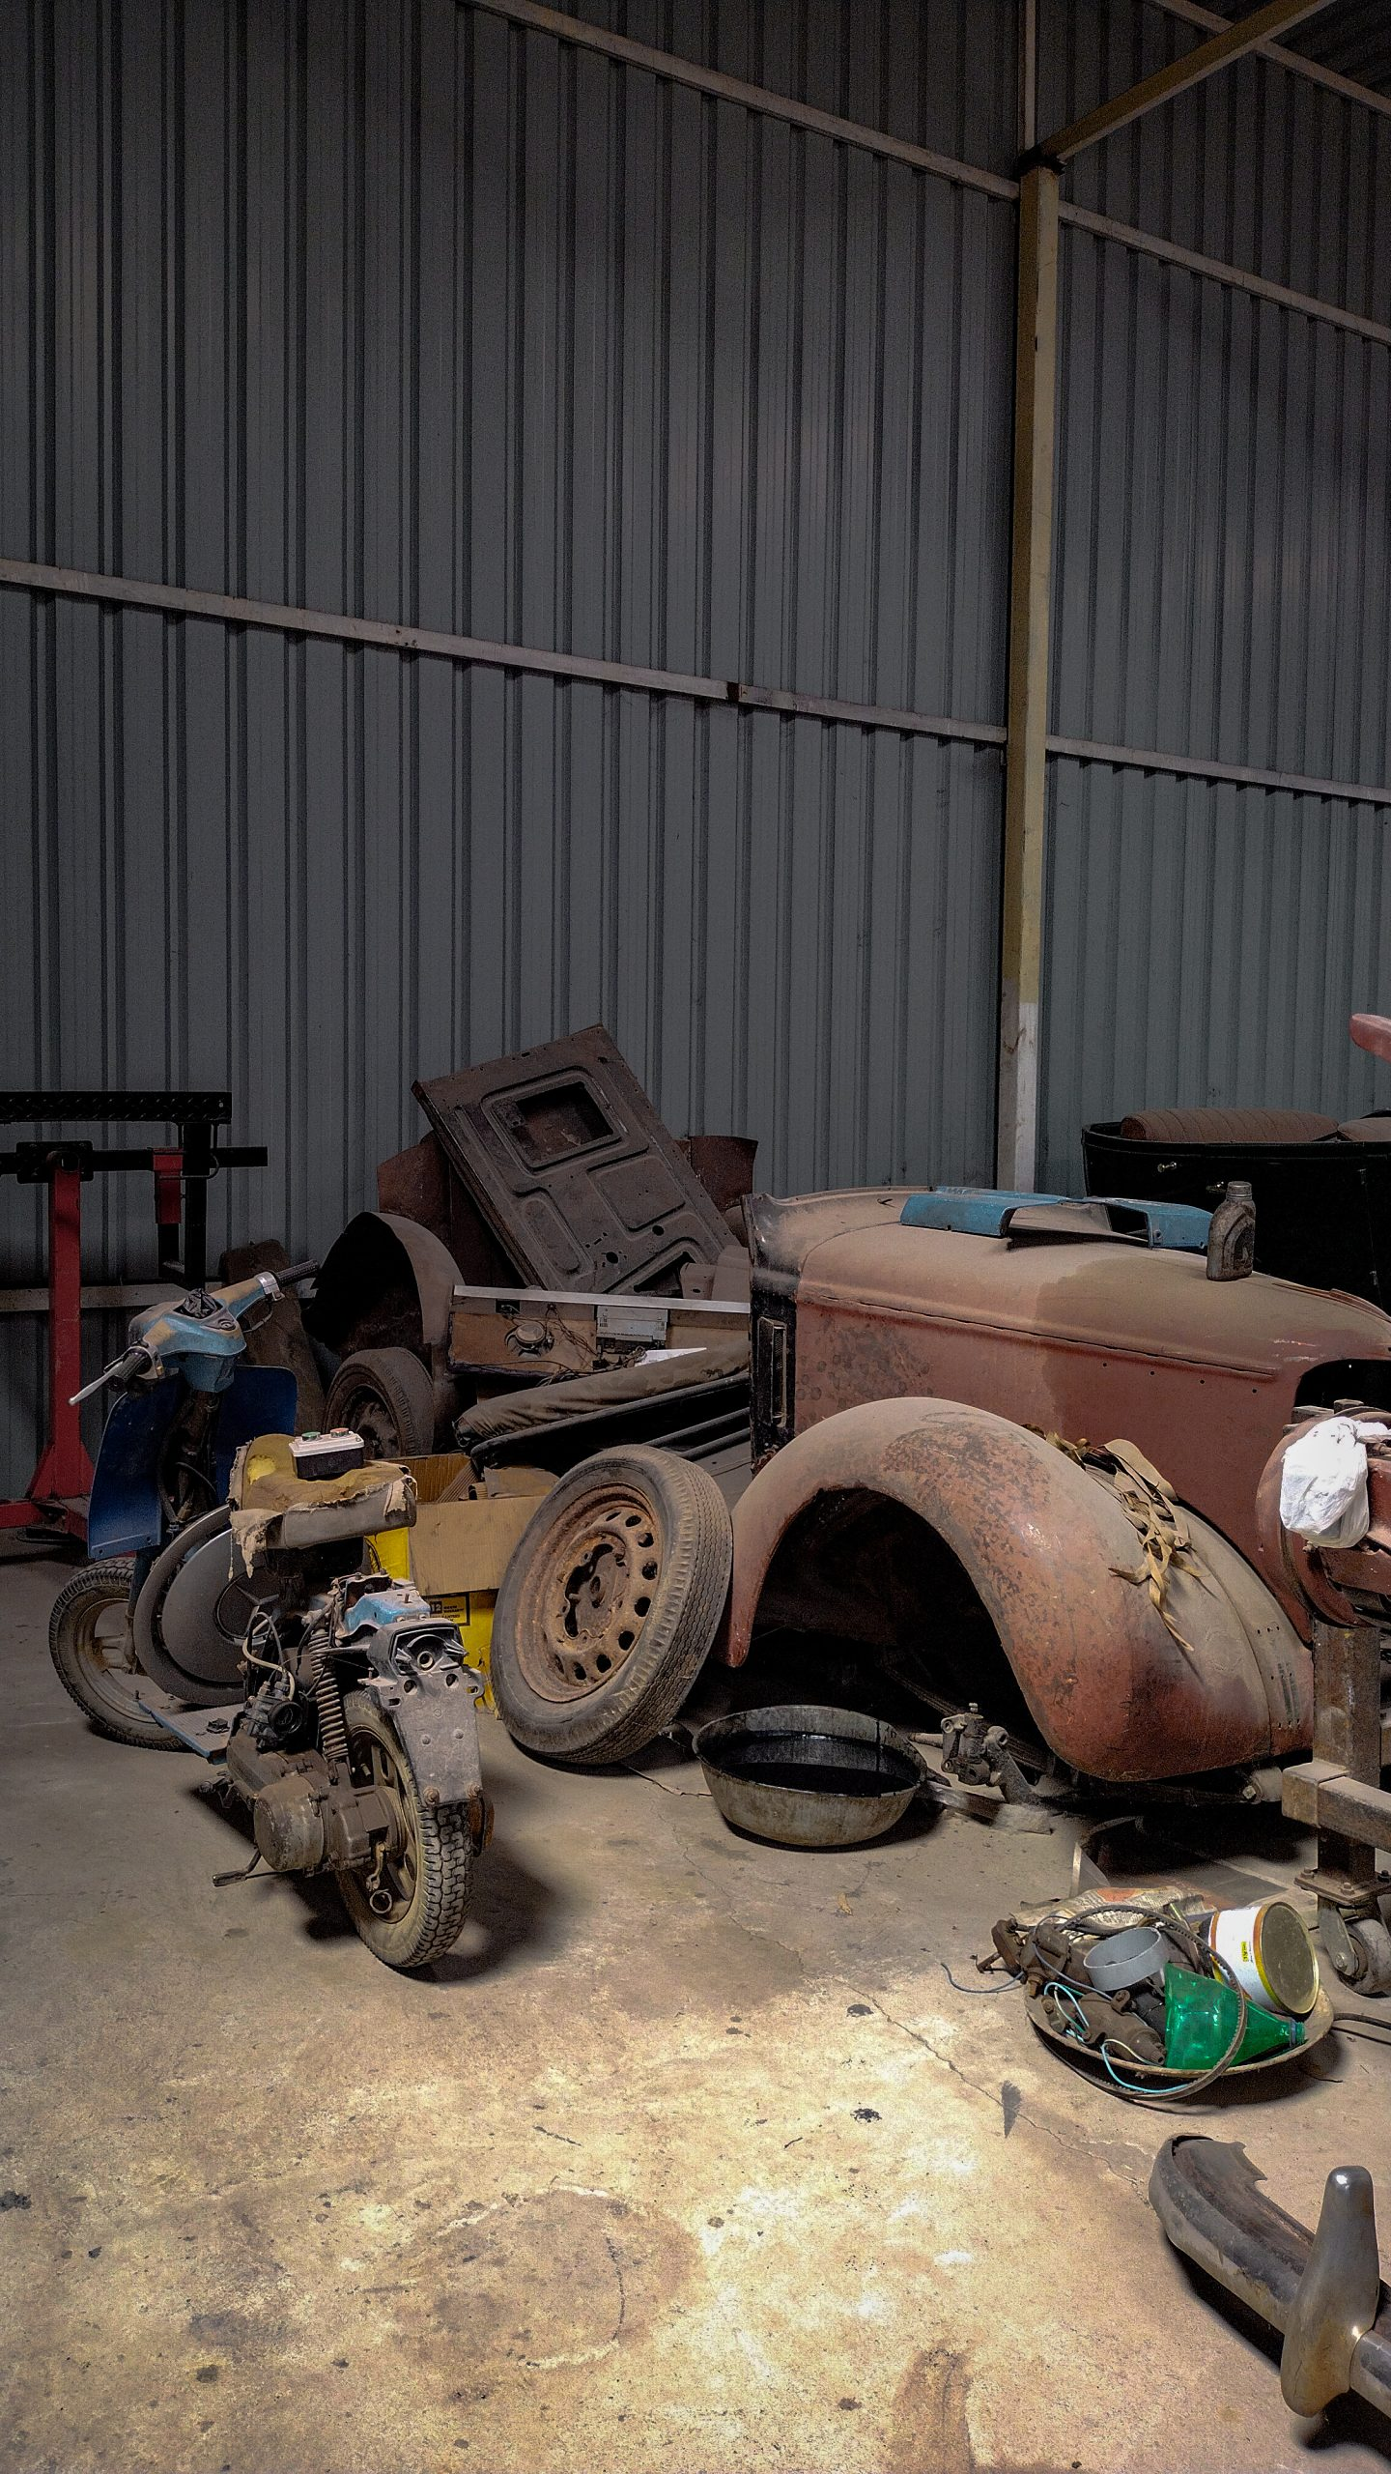

1. How many vehicles are present? 3 (taxonomic) (motorcycle, scooter, car parts)

2. How many items are stacked on top of other items? 4 (relational) (tires, car parts)

3. If all the metal parts were painted blue, how many objects would be blue? 7 (physical) (car parts, motorcycle parts, welding mask)

## Image 17 (beach cleanup)

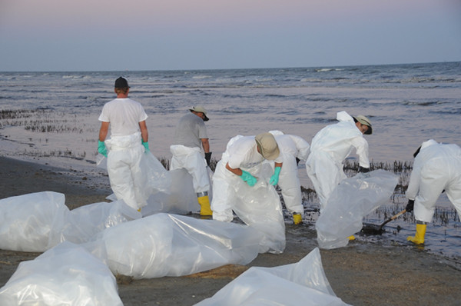

1. How many people wearing protective suits are visible? 6 (taxonomic) (humans)

2. How many plastic bags being held are visible? 6 (relational) (bags)

3. If all the people were not wearing gloves, how many hands would be visible? 12 (physical) (hands)

## Image 18 (camping)

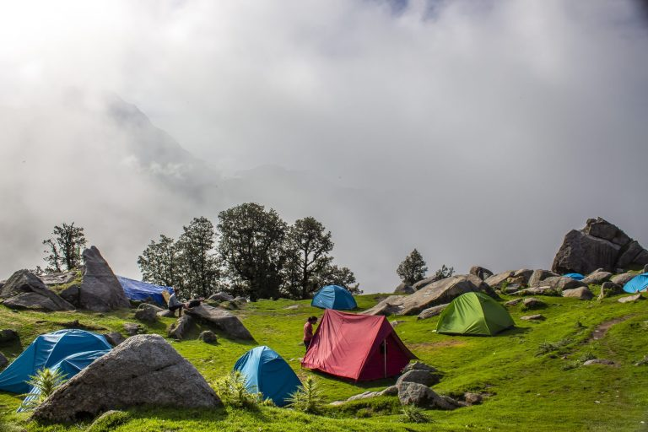

1. How many tents are visible? 6 (taxonomic) (artifacts)

2. How many tents are positioned on the grass? 6 (relational) (tents)

3. If all the rocks were removed, how many tents would still be visible? 6 (physical) (tents)

## Image 19 (gardening)

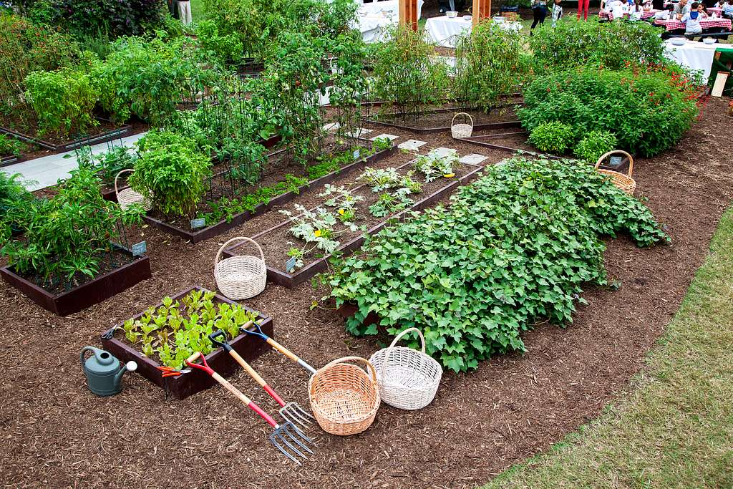

1. How many raised garden beds are visible? 6 (taxonomic) (garden beds)

2. How many items used for gardening are present? 5 (functional) (watering can, two garden forks, two baskets)

3. If all the plants were removed from the garden, how many baskets would remain? 4 (physical) (baskets)

## Image 20 (library)



1. How many books are visible? 15 (taxonomic) (books)

2. How many items are stacked on top of each other? 3 (relational) (books)

3. If all the pencils were removed from the jar, how many pencils would be missing? 8 (physical) (pencils)

## Image 21 (wardrobe)

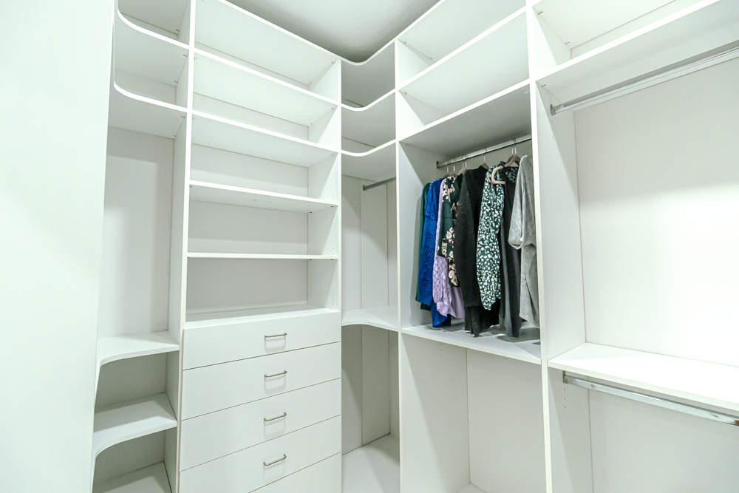

1. How many items are made of wood? 0 (physical) (visible objects)

2. How many items are hanging from a rod? 8 (relational) (clothes)

3. If all the drawers were open, how many drawer fronts would be visible? 5 (physical) (drawer fronts)

## Image 22 (wardrobe)

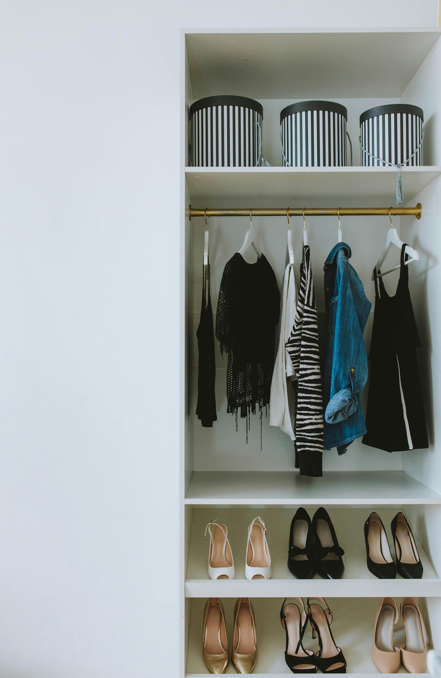

1. How many items are artifacts? 12 (taxonomic) (clothes and boxes)

2. How many pairs of shoes are visible? 6 (relational) (shoes)

3. If the striped boxes were all solid black, how many striped items would be visible? 1 (physical) (sweater)

## Image 23 (wardrobe)

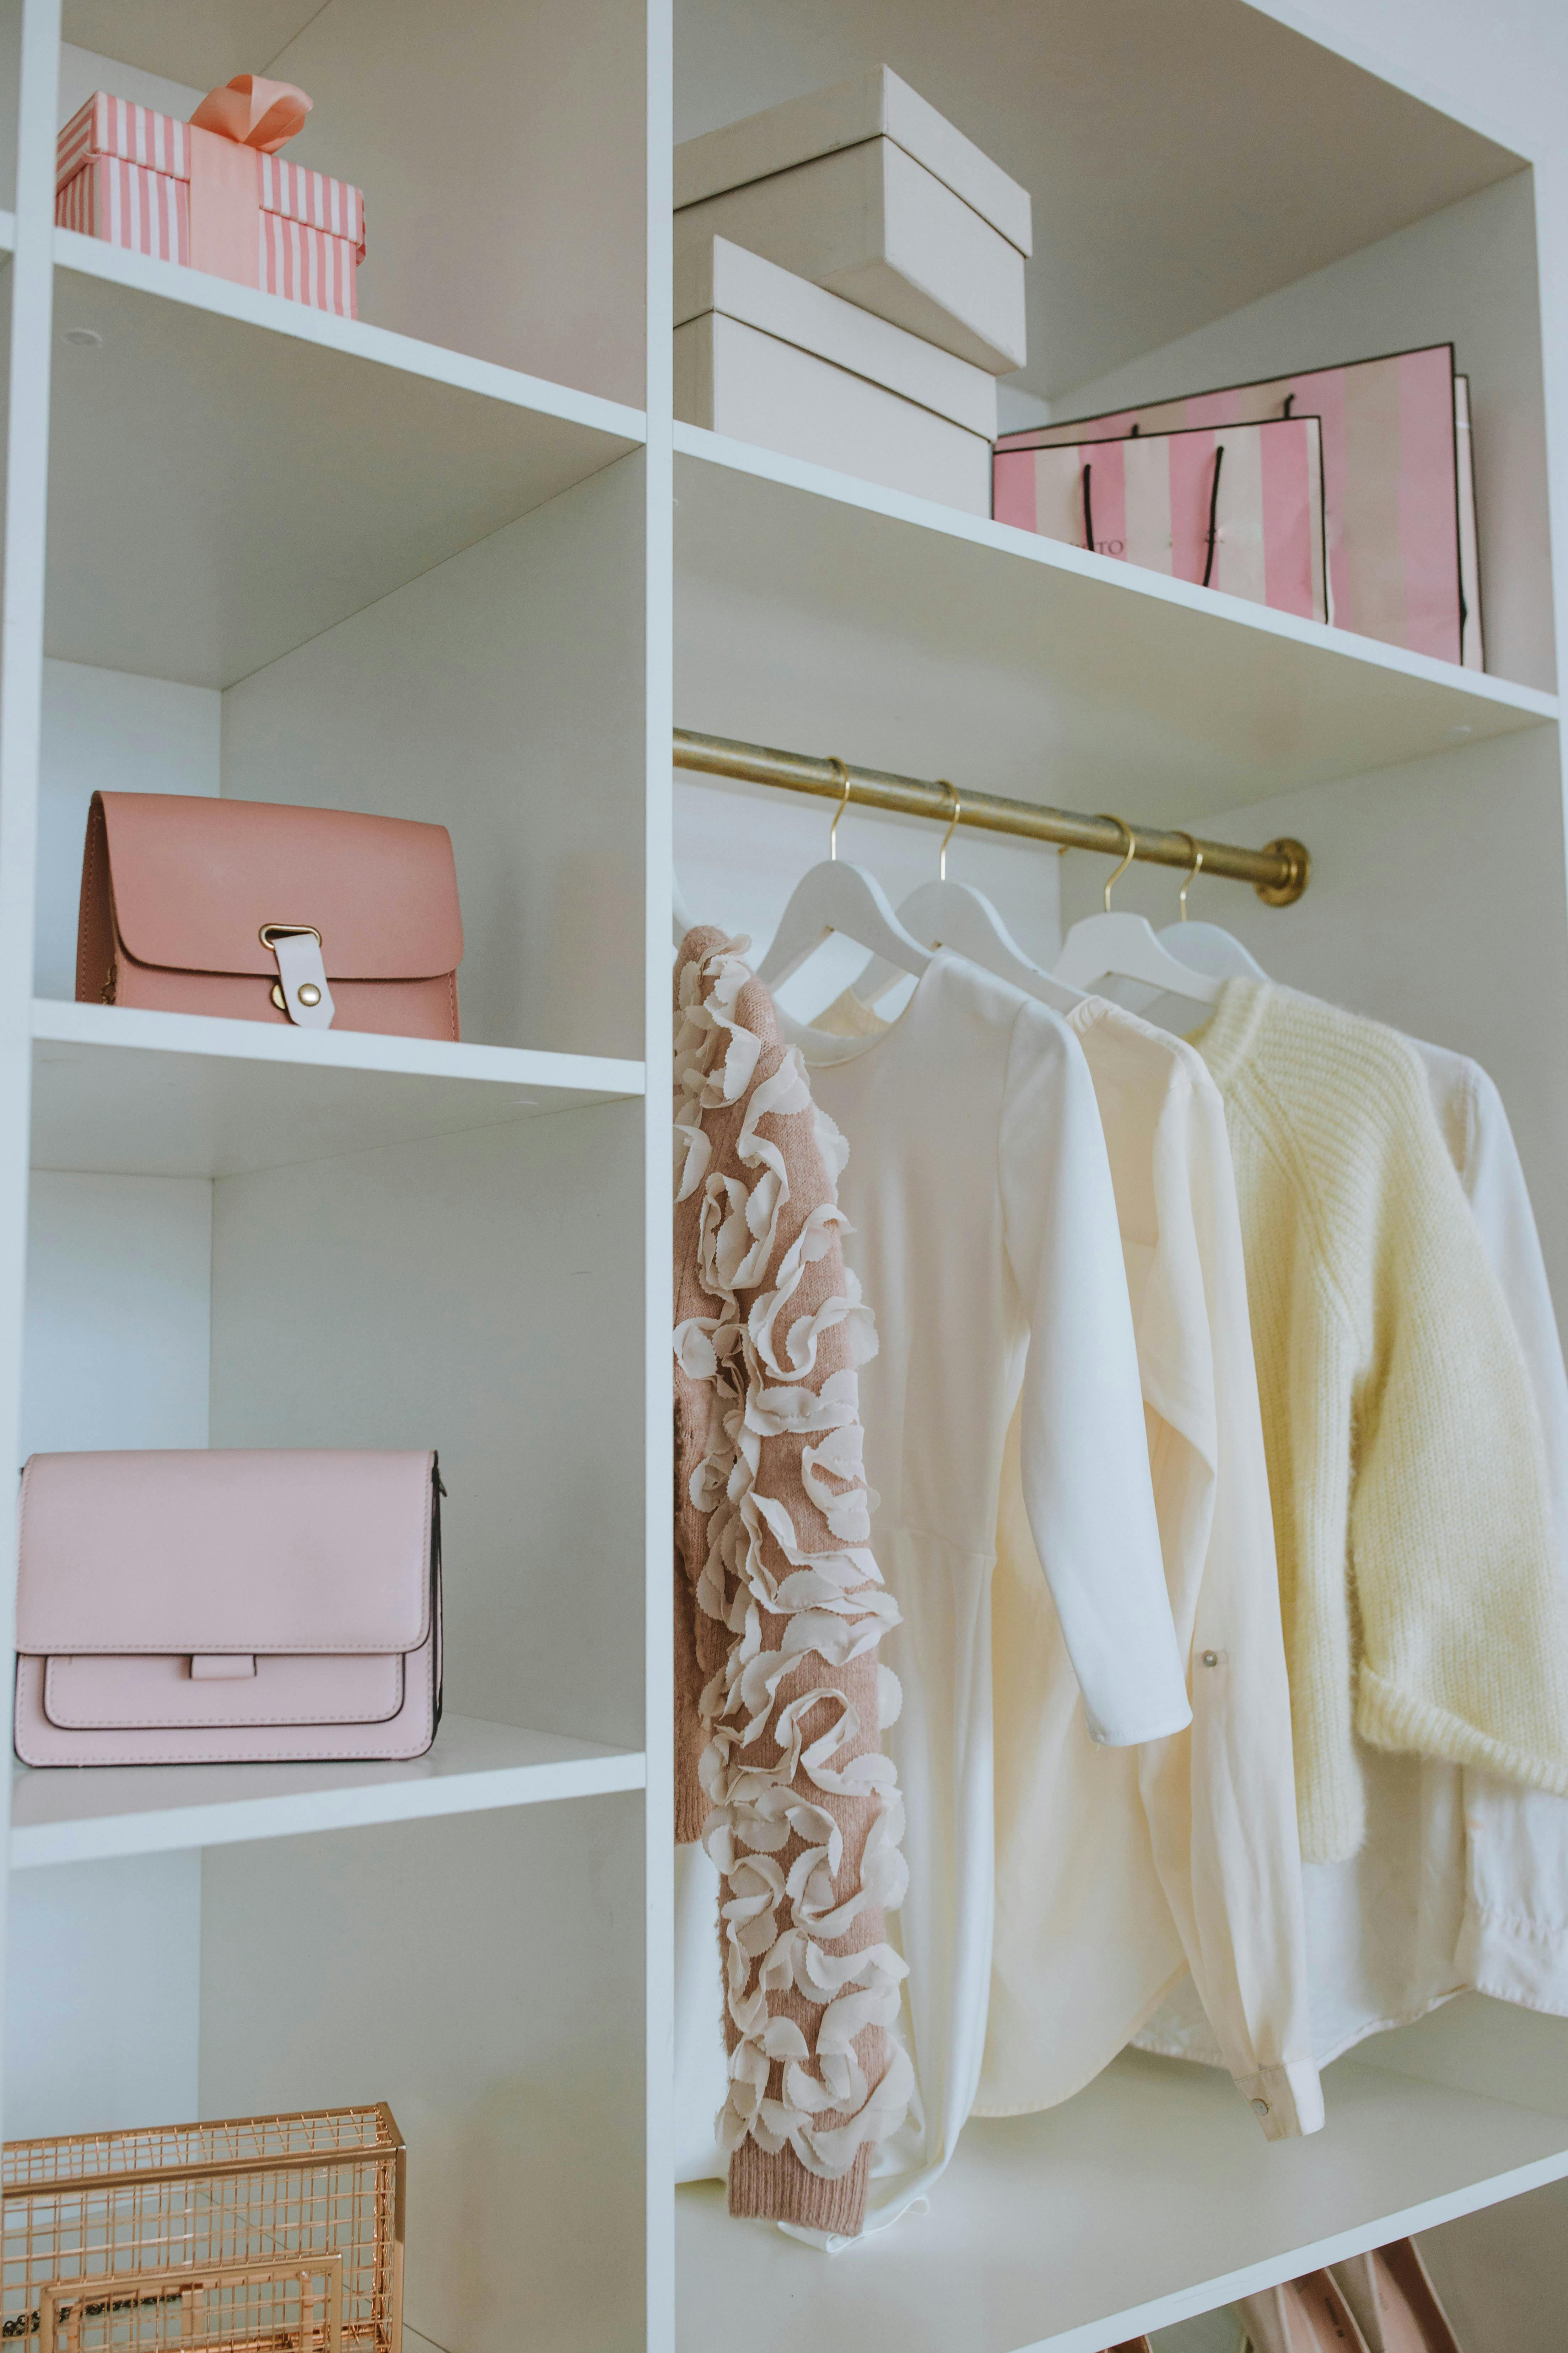

1. How many purses are visible? 2 (taxonomic) (purses)

2. How many items are hanging from the rod? 3 (relational) (clothes)

3. If the boxes were all the same color pink, how many pink objects would there be? 6 (physical) (objects)

## Image 24 (home setup)

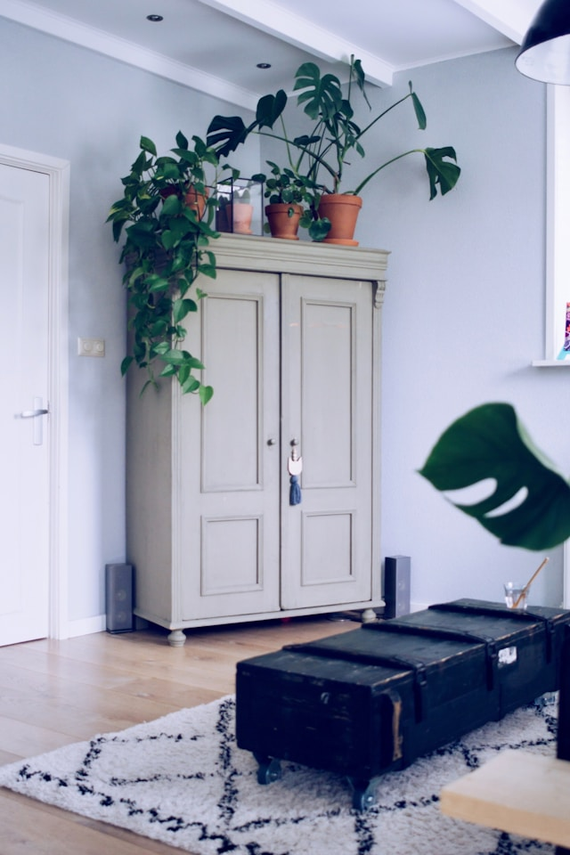

1. How many plants are visible? 5 (taxonomic) (plants)

2. How many items are on top of the wardrobe? 4 (relational) (pots/containers)

3. If the trunk was not on wheels, how many items with wheels would be visible? 0 (physical) (items with wheels)

## Image 25 (wardrobe)

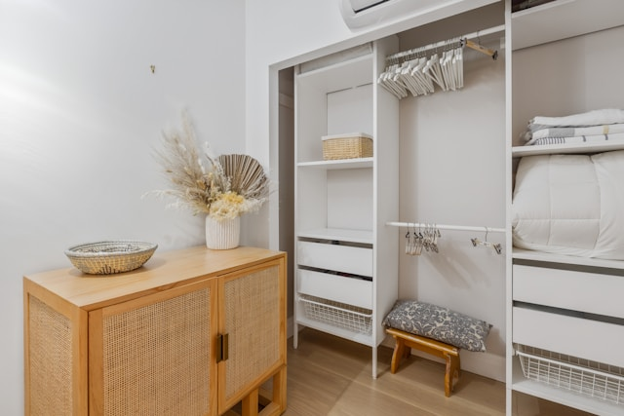

1. How many items made of wood are present? 3 (physical) (cabinet, stool, woven basket)

2. How many items are located inside the closet? 7 (relational) (baskets, hangers, folded items)

3. If the woven baskets were removed from the closet, how many baskets would be visible? 1 (physical) (woven basket on cabinet)

## Image 26 (wardrobe)

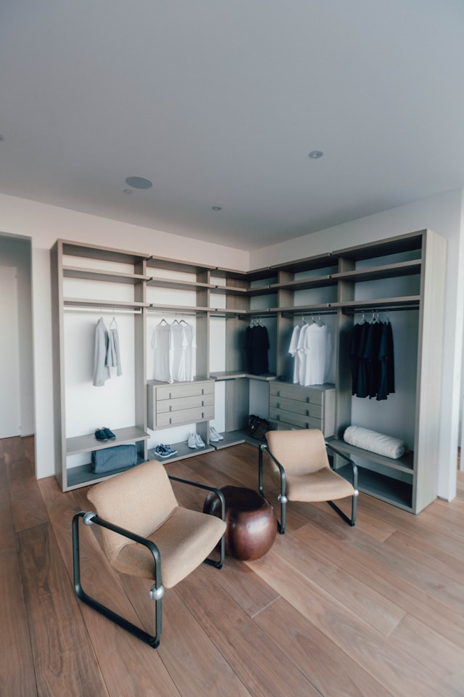

1. How many items of furniture are present? 3 (taxonomic) (chairs)

2. How many items are hanging from a rod? 15 (relational) (clothes)

3. If all the shoes were removed from the floor, how many shoes would be missing? 3 (physical) (shoes)

## Image 27 (wardrobe)

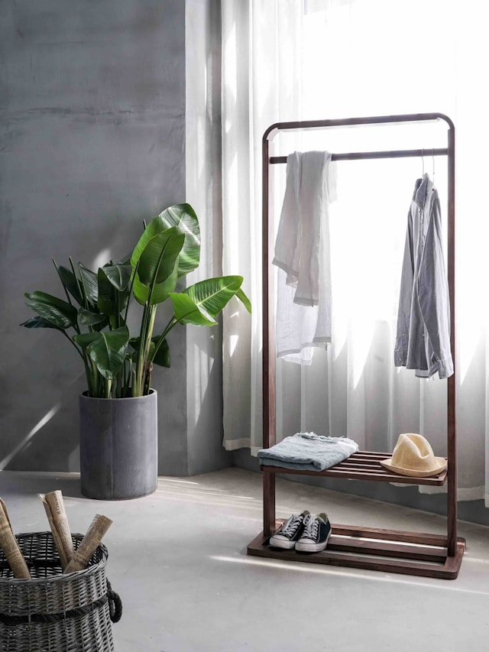

1. How many items made of metal are present? 1 (physical) (clothing rack)

2. How many items are located on top of the clothing rack? 3 (relational) (clothes and hat)

3. If the plant was not in the pot, how many pots are visible? 0 (taxonomic) (pots)

## Image 28 (wardrobe)

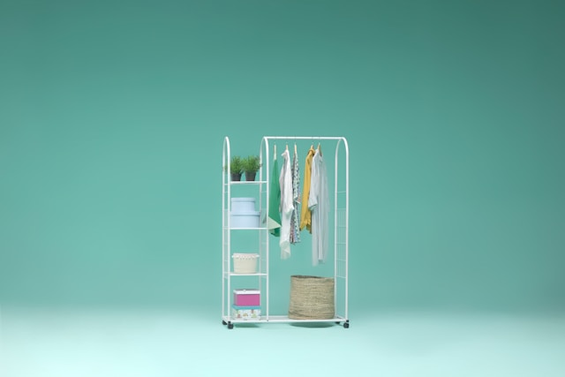

1. How many items made of metal are present? 2 (physical) (clothing racks)

2. How many items are inside other items? 3 (relational) (boxes/baskets)

3. If the plants were removed from the shelf, how many shelves would be empty? 2 (functional) (shelves)

## Image 29 (home setup)

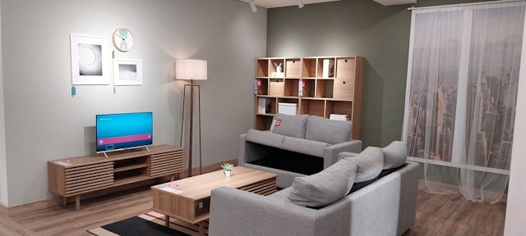

1. How many pieces of furniture are present? 6 (taxonomic) (sofas, TV stand, bookshelf, coffee table, floor lamp, side table)

2. How many objects are on top of other objects? 3 (relational) (TV on TV stand, plant on coffee table, items on bookshelf)

3. If the curtains were a different color, how many curtains would be visible? 2 (physical) (curtains)

## Image 30 (wardrobe)

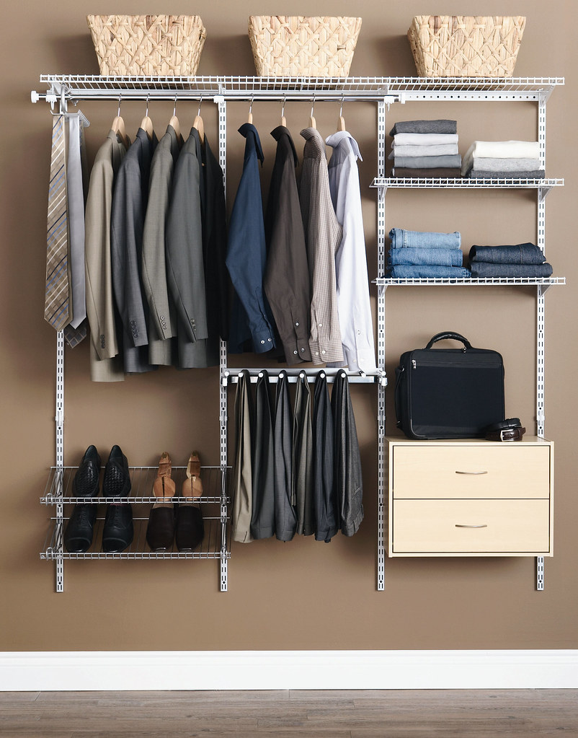

1. How many items are made of metal? 3 (physical) (shelving units)

2. How many items are hanging? 7 (relational) (clothes)

3. If all the baskets were empty, how many woven items would be visible? 3 (taxonomic) (baskets)

## Image 31 (salon)

[ERROR: Could not add image image31.jpg - ]

## Image 32 (salon)

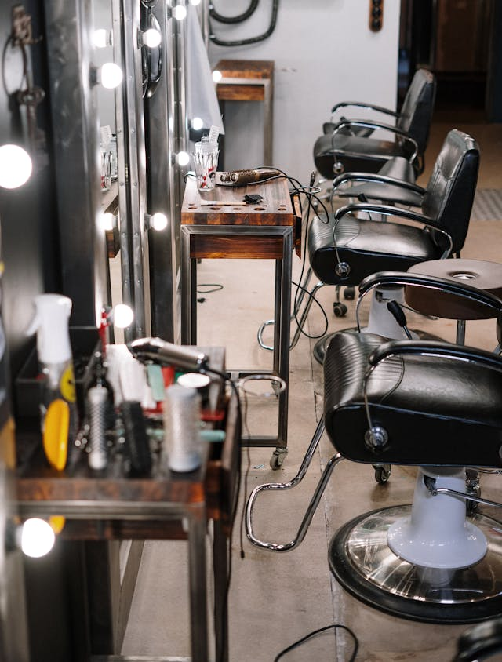

1. How many chairs are visible? 3 (taxonomic) (furniture)

2. How many items on top of the trolley can hold liquid? 2 (functional) (spray bottles)

3. If all the hair styling tools were removed, how many metal objects would remain? 4 (physical) (chair bases/frames)

## Image 33 (salon)



1. How many chairs with wheels are present? 6 (physical) (hair salon chairs)

2. How many stations with mirrors are visible? 4 (relational) (hair styling stations)

3. If the pink chairs were black, how many black chairs would be visible? 8 (taxonomic) (chairs)

## Image 34 (salon)



1. How many chairs are visible? 3 (taxonomic) (furniture)

2. How many mirrors are reflecting something? 2 (relational) (mirrors)

3. If all the product bottles were removed from the shelves, how many shelves would be visible? 4 (physical) (shelves)

## Image 35 (salon)

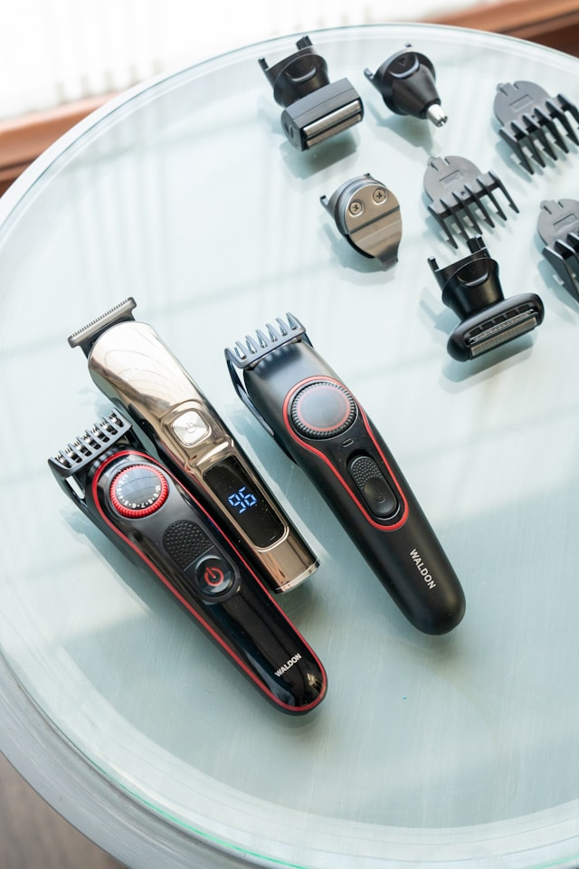

1. How many objects made of plastic are present? 3 (physical) (hair trimmers)

2. How many objects that can cut are visible? 7 (functional) (hair trimmers and shaver heads)

3. If all the shaver heads were removed, how many full hair trimmers would be visible? 2 (relational) (hair trimmers)

## Image 36 (salon)

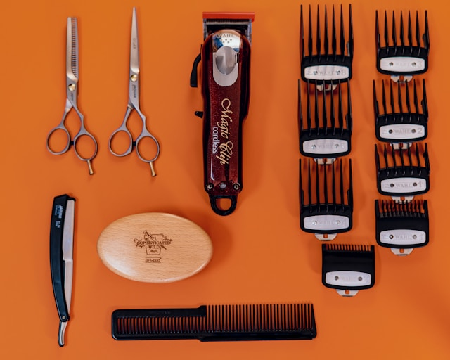

1. How many tools made of metal are present? 9 (physical) (scissors, clippers, razor, combs)

2. How many items are used for cutting hair? 5 (functional) (clippers, scissors)

3. If all the clipper guards were blue, how many items would be blue? 8 (taxonomic) (clipper guards)

## Image 37 (salon)



1. How many chairs are visible? 4 (taxonomic) (furniture)

2. How many people are actively using tools? 2 (functional) (hair stylists)

3. If all the plastic barriers were removed, how many open spaces would there be between the chairs? 2 (relational) (spaces)

## Image 38 (salon)



1. How many chairs with wheels are present? 3 (physical) (salon chairs)

2. How many items are on top of the counter? 7 (relational) (bottles and plants)

3. If all the plants were removed, how many mirrors would be visible? 2 (taxonomic) (mirrors)

## Image 39 (salon)

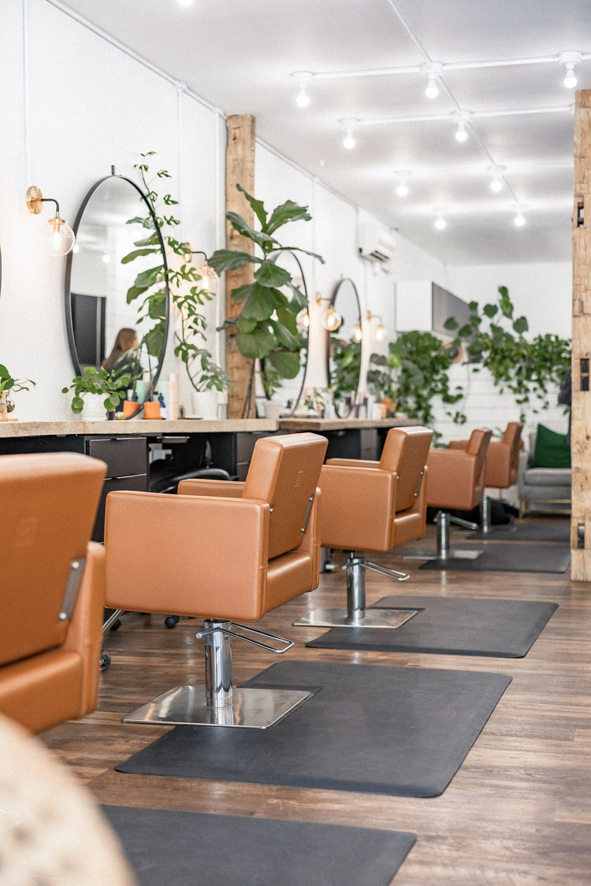

1. How many chairs are visible? 6 (taxonomic) (furniture)

2. How many items are positioned on top of black mats? 6 (relational) (chairs)

3. If all the plants were removed, how many mirrors would be visible? 3 (taxonomic) (objects)

## Image 40 (salon)

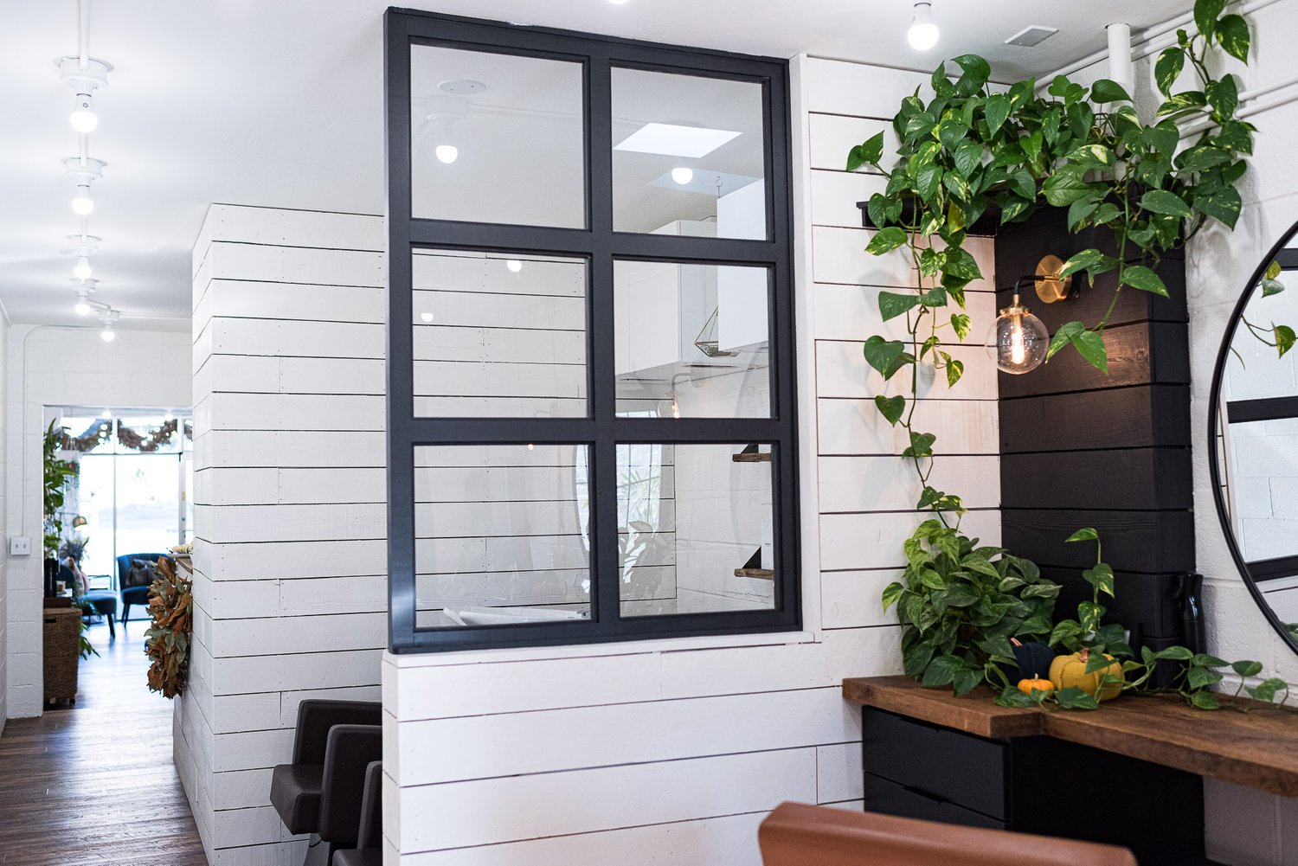

1. How many objects made of glass are present? 6 (physical) (window panes)

2. How many plants are on top of furniture? 2 (relational) (potted plants)

3. If all the lights were removed, how many light fixtures would be visible? 0 (functional) (light fixtures)

## Image 41 (gym)



1. How many people are visible? 2 (taxonomic) (humans)

2. How many objects with handles are visible? 3 (functional) (exercise equipment)

3. If the weight plates were all the same size, how many would be on the weight rack? 6 (physical) (weight plates)

## Image 42 (gym)



1. How many treadmills are visible? 3 (taxonomic) (exercise machines)

2. How many objects that need electricity are present? 3 (functional) (treadmills)

3. If the windows were removed, how many visible objects would be made of glass? 0 (physical) (window panes)

## Image 43 (gym)



1. How many pieces of exercise equipment are visible? 3 (taxonomic) (treadmill, rowing machine, weight machine)

2. How many objects that require manual power are visible? 2 (functional) (rowing machine, weight machine)

3. If the windows were removed, how many visible objects would be blocking the view outside? 3 (relational) (exercise equipment)

## Image 44 (gym)



1. How many people are visible? 2 (taxonomic) (humans)

2. How many objects with handles are visible? 2 (functional) (treadmills)

3. If the treadmills were replaced with stationary bikes, how many objects would have wheels? 2 (physical) (treadmills)

## Image 45 (meeting room)

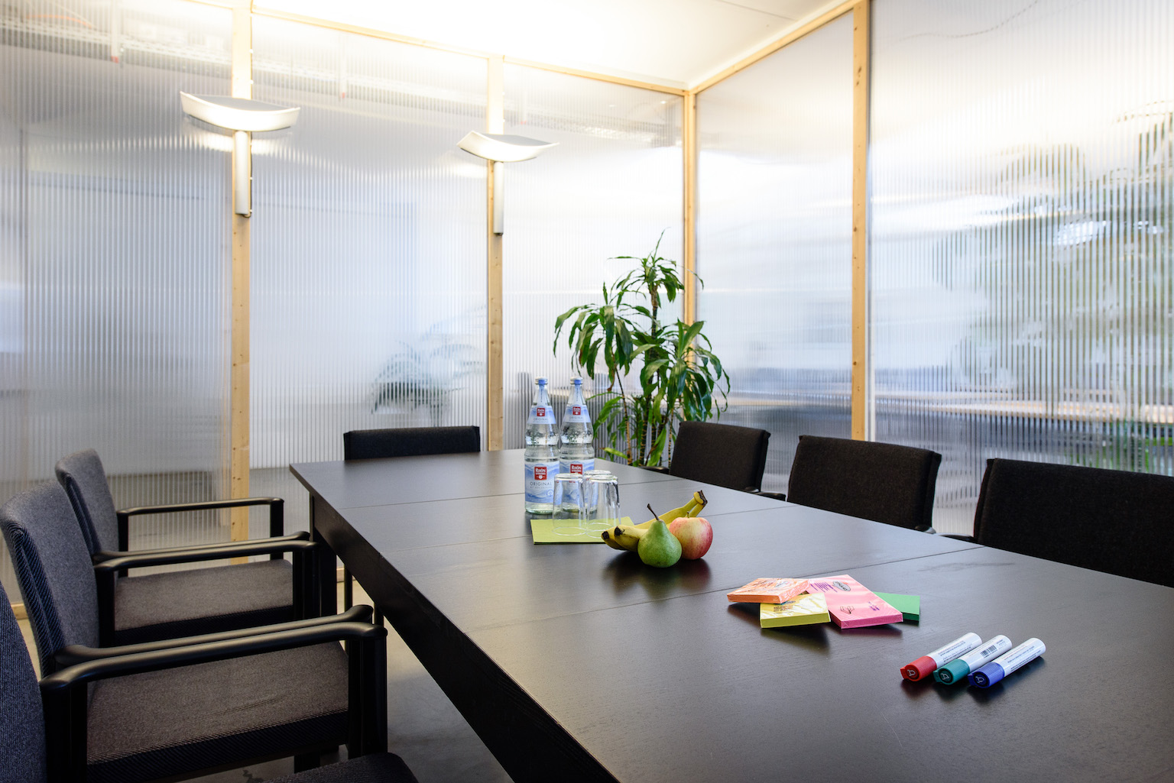

1. How many chairs are visible? 6 (taxonomic) (furniture)

2. How many items are on top of the table? 7 (relational) (objects)

3. If the plant was not present, how many biological items would be visible? 0 (taxonomic) (plants)

## Image 46 (meeting room)

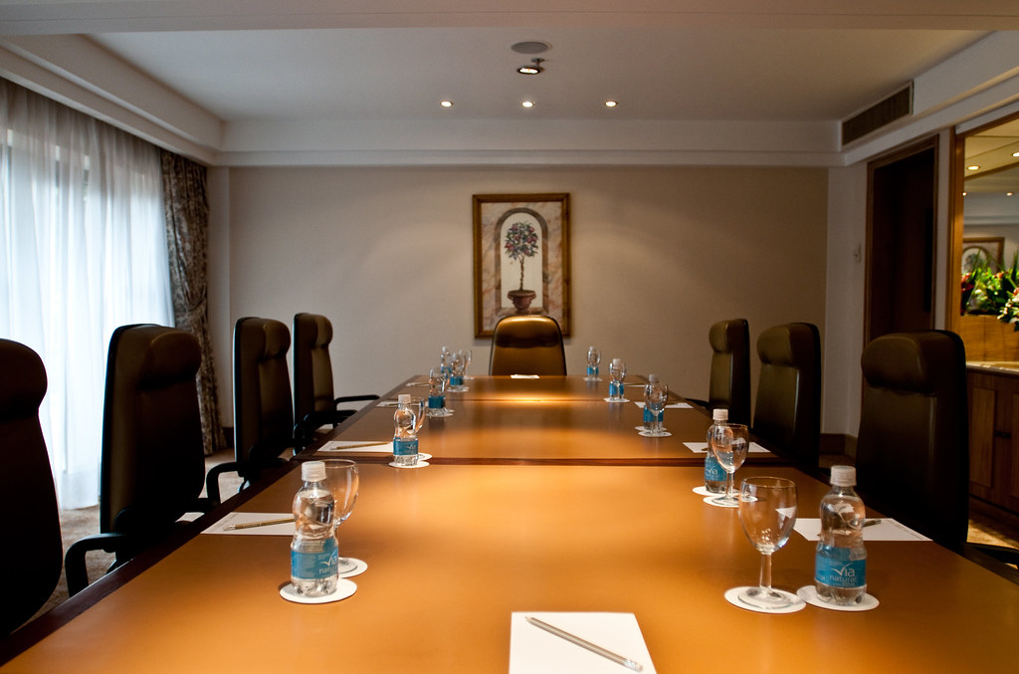

1. How many chairs are visible? 8 (taxonomic) (furniture)

2. How many items can hold liquid are present? 8 (functional) (bottles and glasses)

3. If all the water bottles were replaced with juice boxes, how many containers would be on the table? 8 (functional) (containers)

## Image 47 (meeting room)

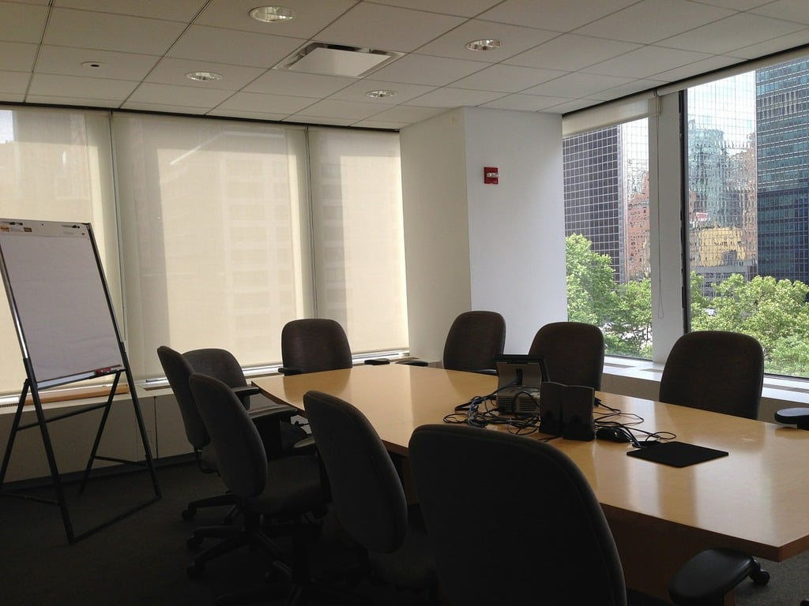

1. How many objects made of wood are present? 1 (physical) (table)

2. How many objects are positioned on top of the table? 5 (relational) (items)

3. If all the chairs were removed from the room, how many chairs would be visible? 8 (taxonomic) (chairs)

## Image 48 (meeting room)

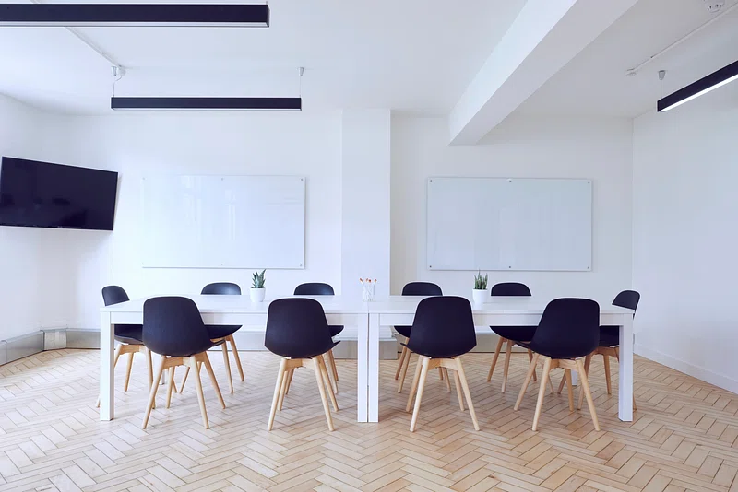

1. How many chairs are present? 8 (taxonomic) (furniture)

2. How many objects are positioned on top of the tables? 2 (relational) (vases)

3. If all the light fixtures were removed from the ceiling, how many light fixtures would be visible? 0 (physical) (lights)

## Image 49 (meeting room)

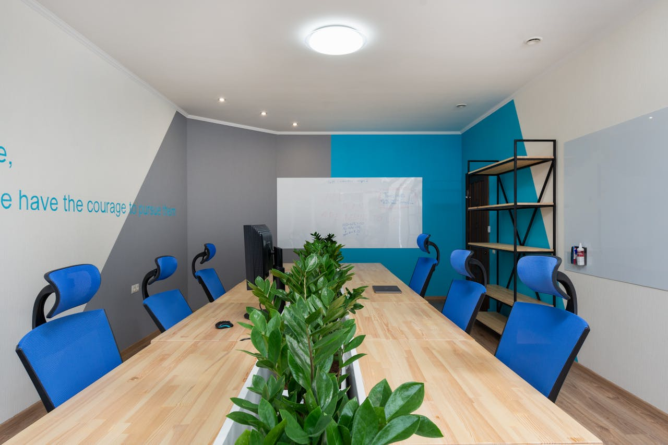

1. How many chairs are visible? 8 (taxonomic) (furniture)

2. How many items are on top of the table? 5 (relational) (objects)

3. If the plants were not present, how many computer monitors would be visible? 2 (taxonomic) (electronics)

## Image 50 (meeting room)



1. How many chairs are visible? 5 (taxonomic) (furniture)

2. How many items are on top of the table? 7 (relational) (objects)

3. If the plant was not present, how many plants would be visible? 0 (taxonomic) (plants)

## Image 51 (meeting room)

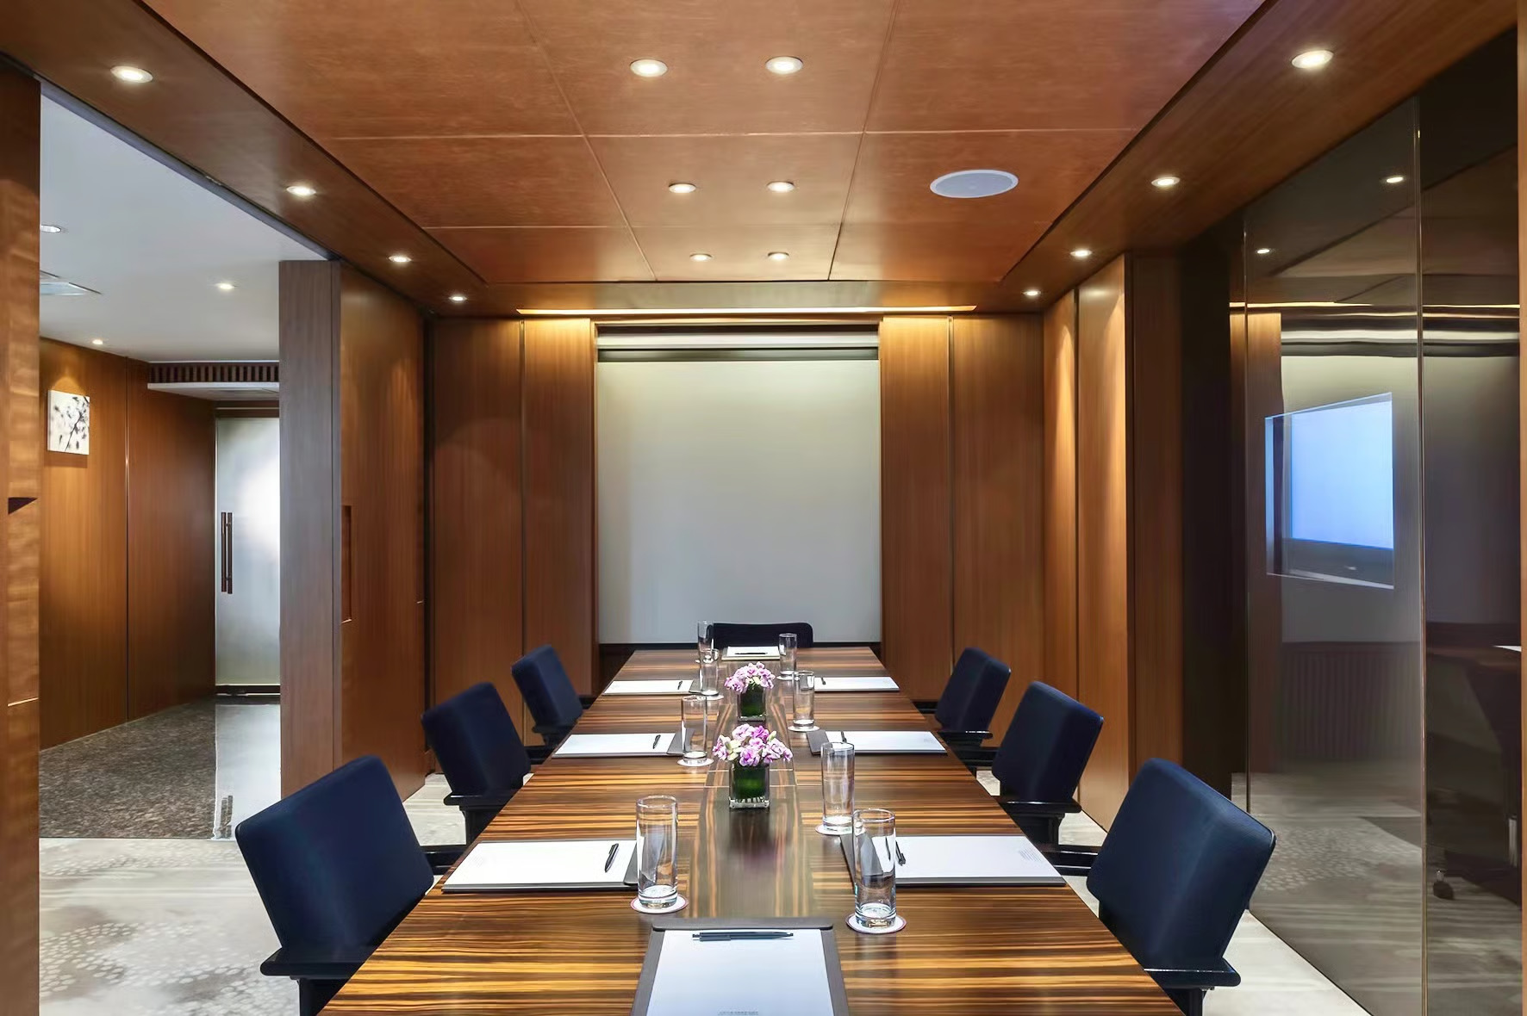

1. How many chairs are visible? 8 (taxonomic) (furniture)

2. How many items are on top of the table? 6 (relational) (objects)

3. If the flowers were replaced with books, how many objects would be on the table? 7 (functional) (objects)

## Image 52 (meeting room)



1. How many chairs are visible? 4 (taxonomic) (furniture)

2. How many items are on top of the table? 5 (relational) (objects)

3. If the television was a painting, how many wall decorations would be visible? 1 (taxonomic) (decorations)

## Image 53 (meeting room)

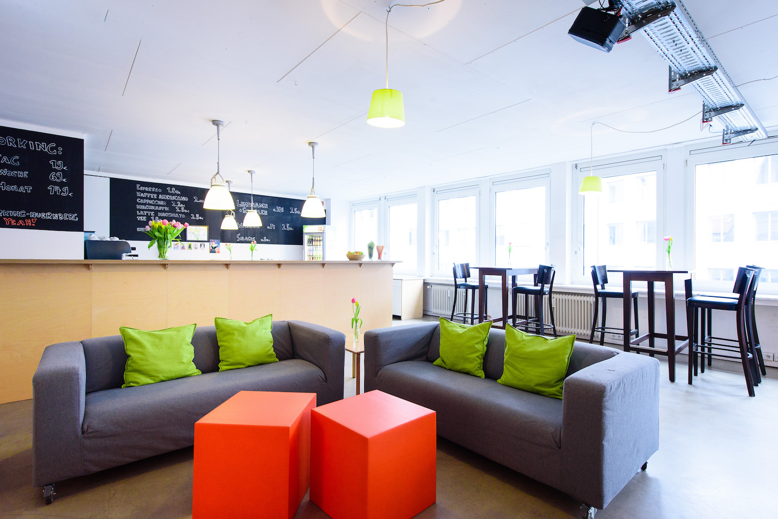

1. How many pieces of furniture are present? 8 (taxonomic) (sofas, stools, table, counter)

2. How many items are on top of other items? 3 (relational) (flowers on counter, items on counter, items on table)

3. If all the green pillows were removed, how many pillows would be visible? 0 (physical) (pillows)

## Image 54 (meeting room)



1. How many people are visible? 5 (taxonomic) (humans)

2. How many items are on top of the table? 6 (relational) (objects)

3. If the whiteboard was not present, how many wooden wall panels would be visible? 10 (physical) (panels)

## Image 55 (meeting room)

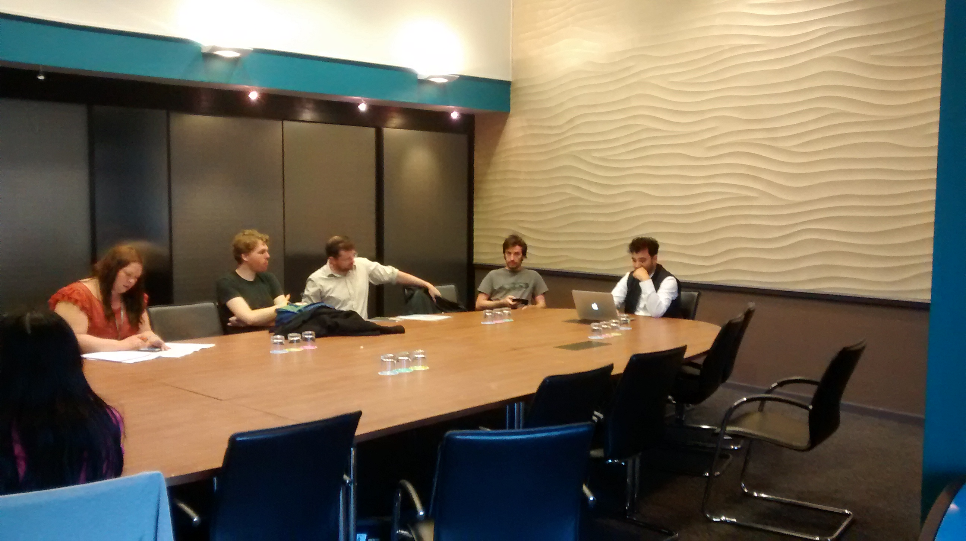

1. How many chairs are visible? 8 (taxonomic) (furniture)

2. How many people are seated around the table? 5 (relational) (individuals)

3. If all the water bottles were full, how many liquid-holding objects would there be? 6 (functional) (bottles)

## Image 56 (meeting room)



1. How many chairs are visible? 6 (taxonomic) (furniture)

2. How many items are on top of the table? 1 (relational) (paper)

3. If the bookshelf was filled with books, how many objects would be visible on the shelves? 10 (physical) (books)

## Image 57 (meeting room)

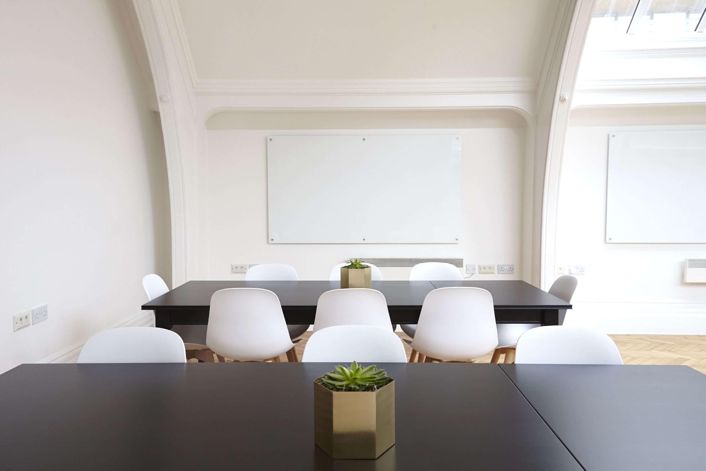

1. How many chairs are visible? 10 (taxonomic) (furniture)

2. How many objects are on top of the tables? 2 (relational) (plants)

3. If all the whiteboards were replaced with windows, how many windows would be visible? 2 (taxonomic) (architectural elements)

## Image 58 (meeting room)

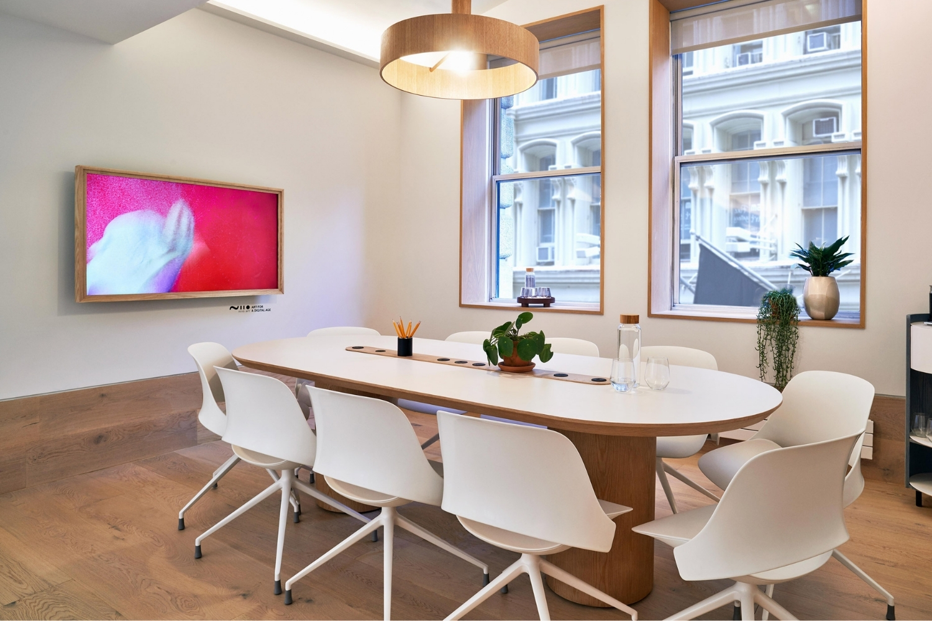

1. How many chairs with legs are present? 8 (taxonomic) (chairs)

2. How many items are on top of the table? 5 (relational) (items)

3. If the plant in the pot was a different color, how many green plants would be visible? 2 (taxonomic) (plants)

## Image 59 (meeting room)

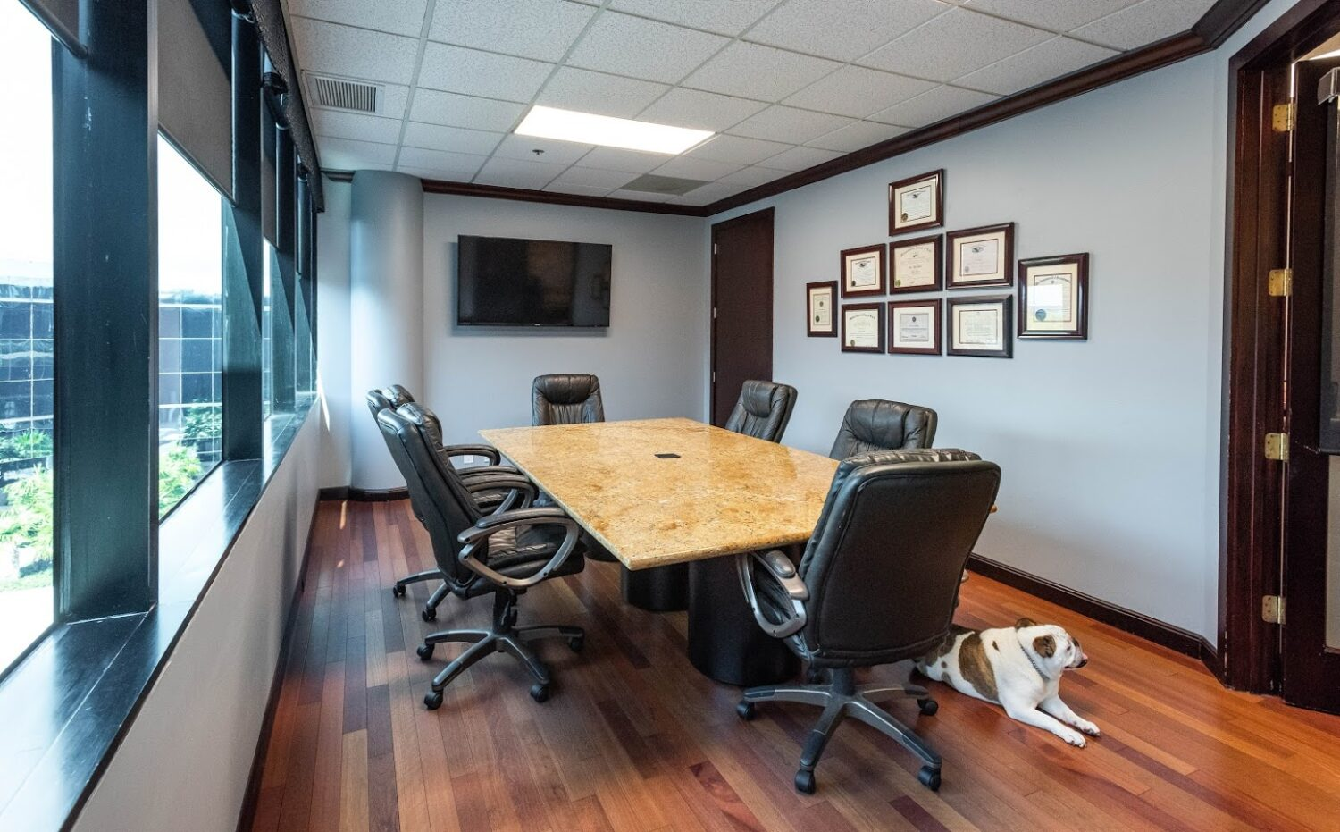

1. How many chairs with wheels are present? 6 (physical) (office chairs)

2. How many items are on top of the table? 1 (relational) (tablecloth)

3. If the dog was not present, how many mammals would be visible? 0 (taxonomic) (mammals)

## Image 60 (home setup)

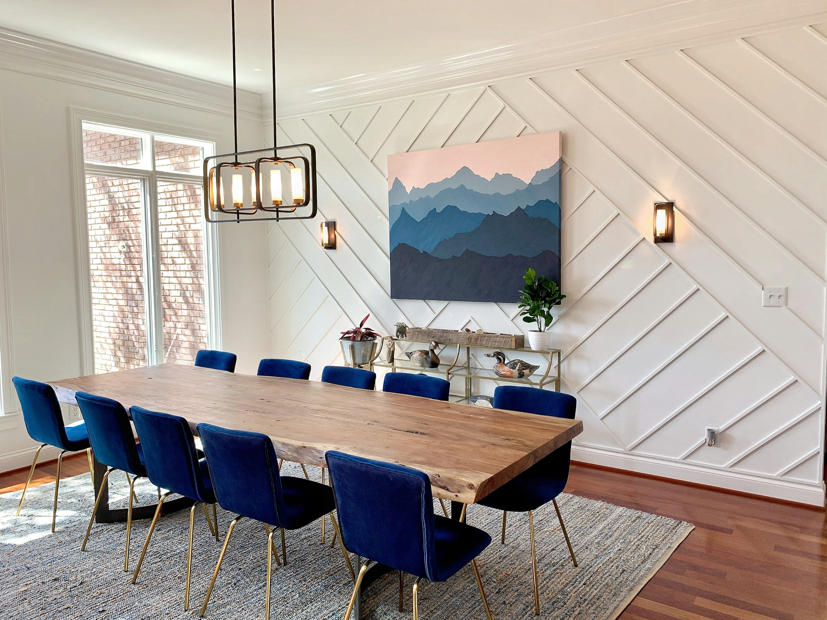

1. How many chairs are visible? 10 (taxonomic) (furniture)

2. How many light fixtures are hanging from the ceiling? 1 (functional) (lighting)

3. If the painting was replaced with a mirror, how many reflective surfaces would be visible? 1 (physical) (surfaces)

## Image 61 (meeting room)

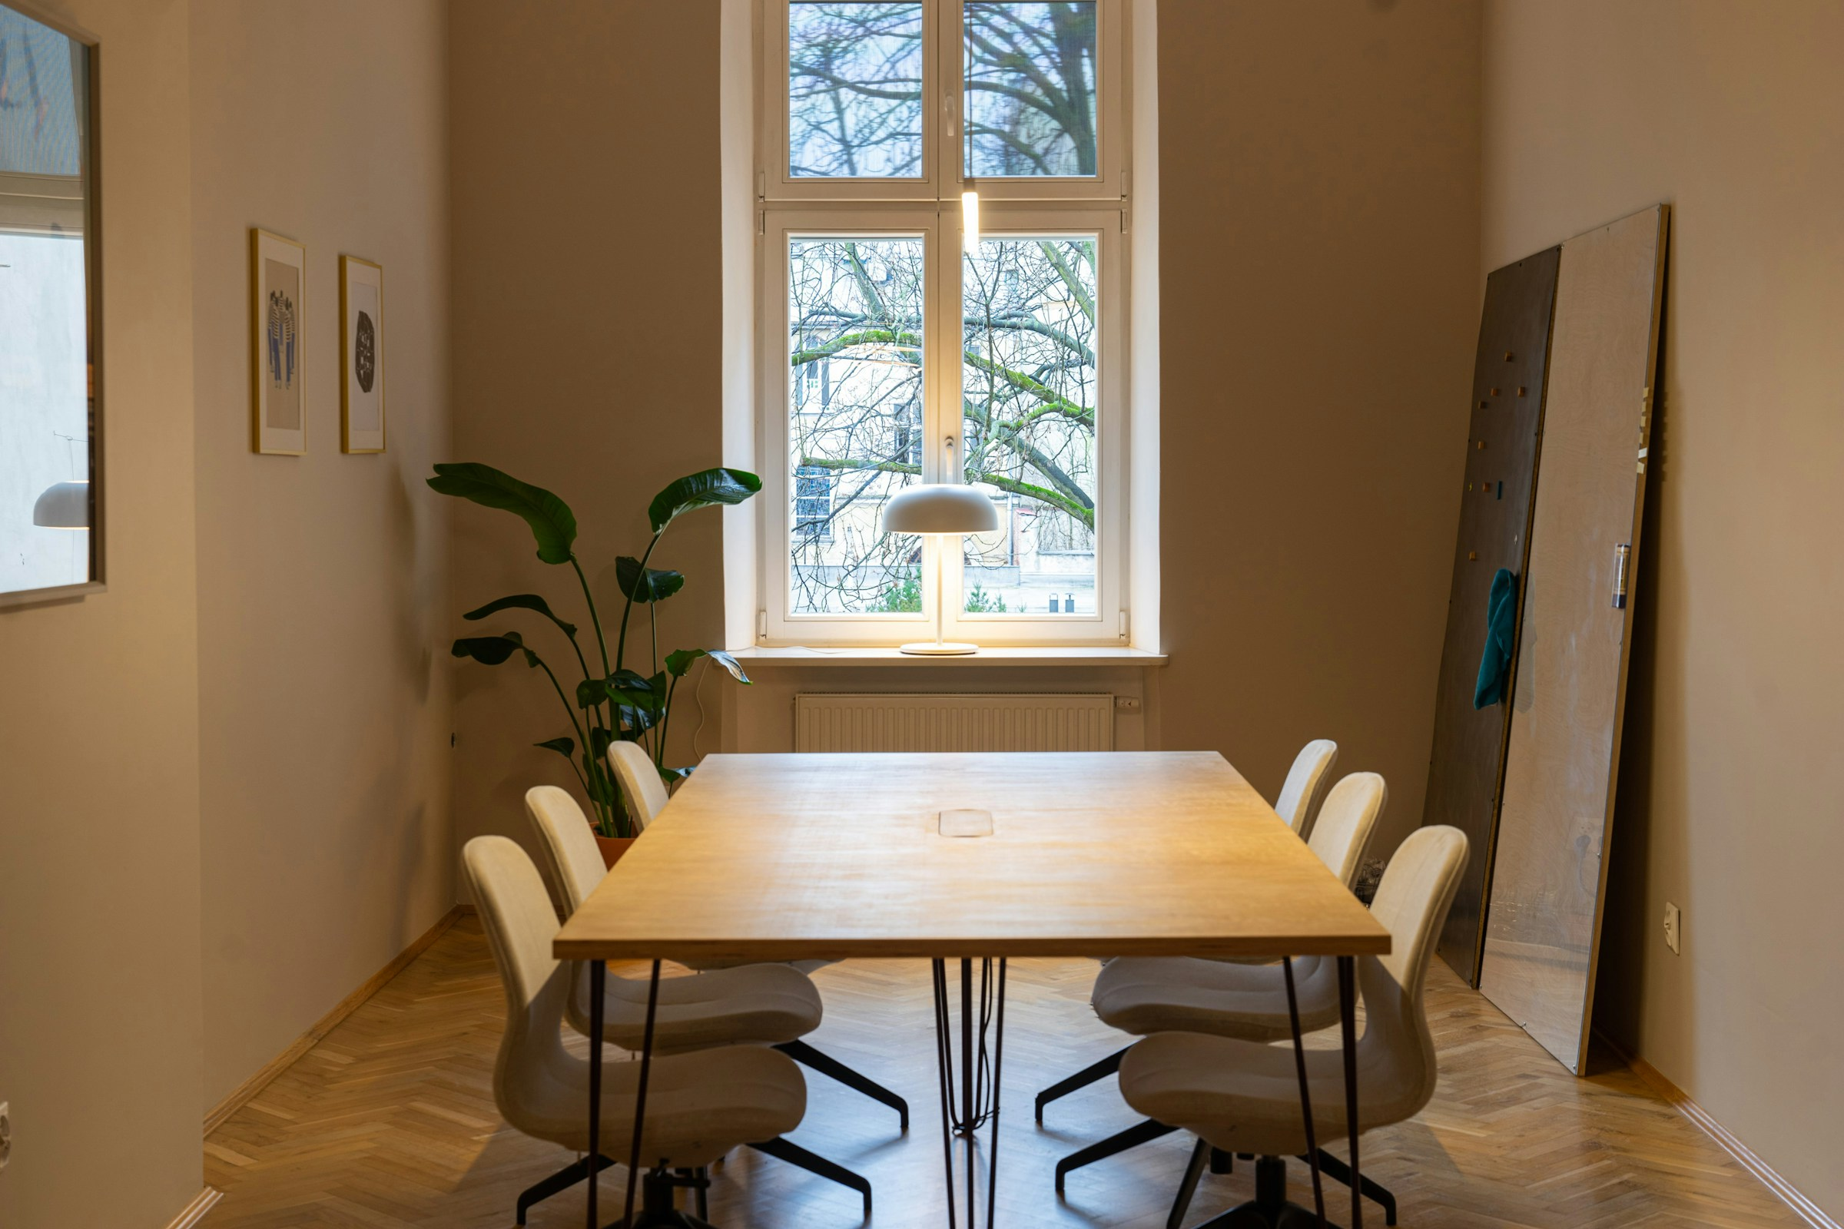

1. How many chairs with legs are present? 5 (taxonomic) (chairs)

2. How many objects are on top of the table? 1 (relational) (lamp)

3. If the plant was not present, how many large objects would be visible next to the window? 1 (physical) (door)

## Image 62 (meeting room)

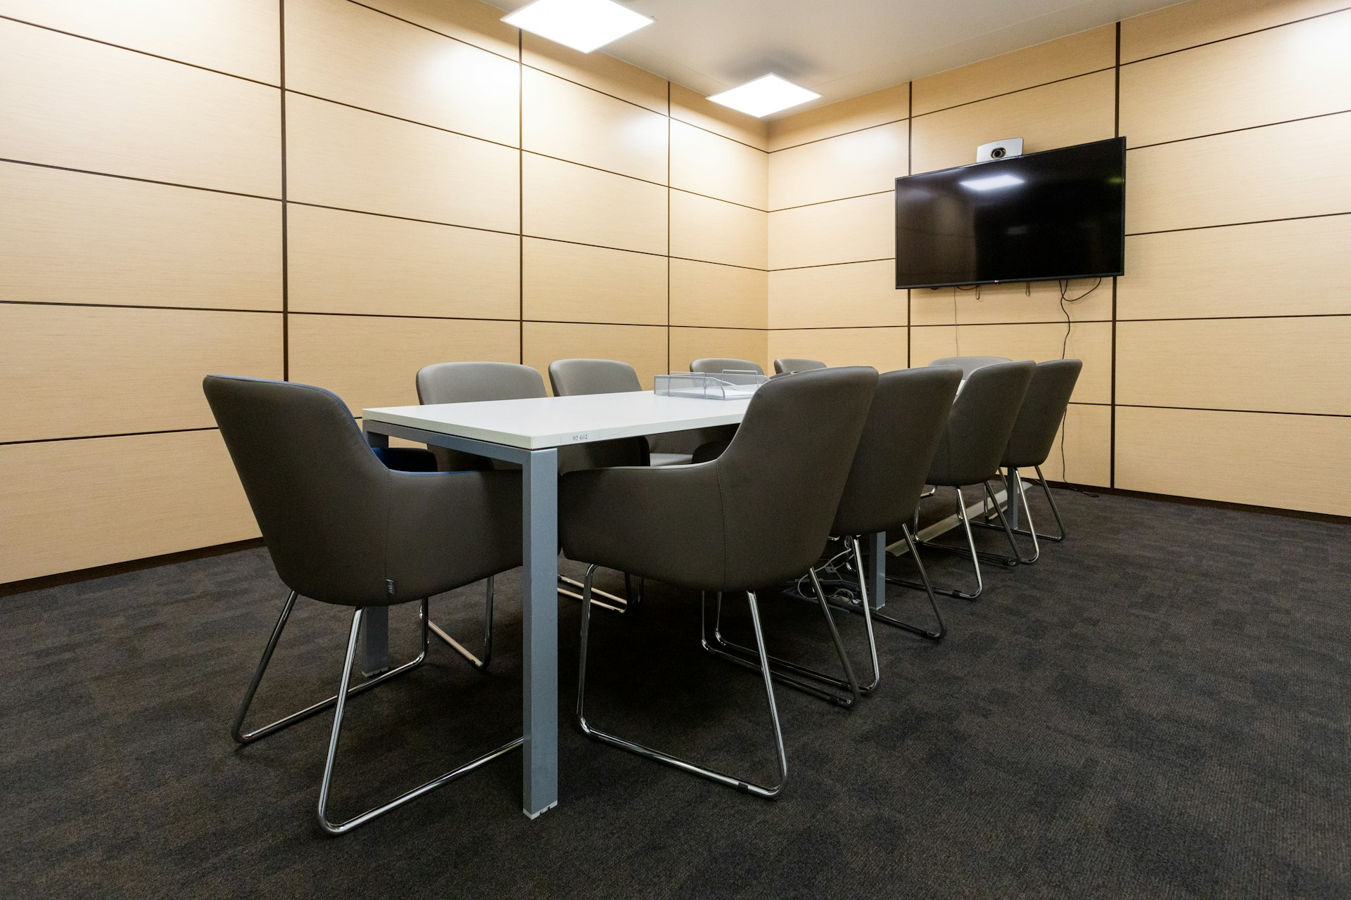

1. How many chairs are visible? 8 (taxonomic) (furniture)

2. How many objects are on top of the table? 2 (relational) (microphone and papers)

3. If the television was replaced with a window, how many windows would be visible? 1 (taxonomic) (windows)

## Image 63 (meeting room)



1. How many chairs are visible? 4 (taxonomic) (furniture)

2. How many items are on top of the table? 2 (relational) (objects)

3. If the television was replaced with a window, how many sources of light would be visible? 2 (physical) (lights)

## Image 64 (meeting room)

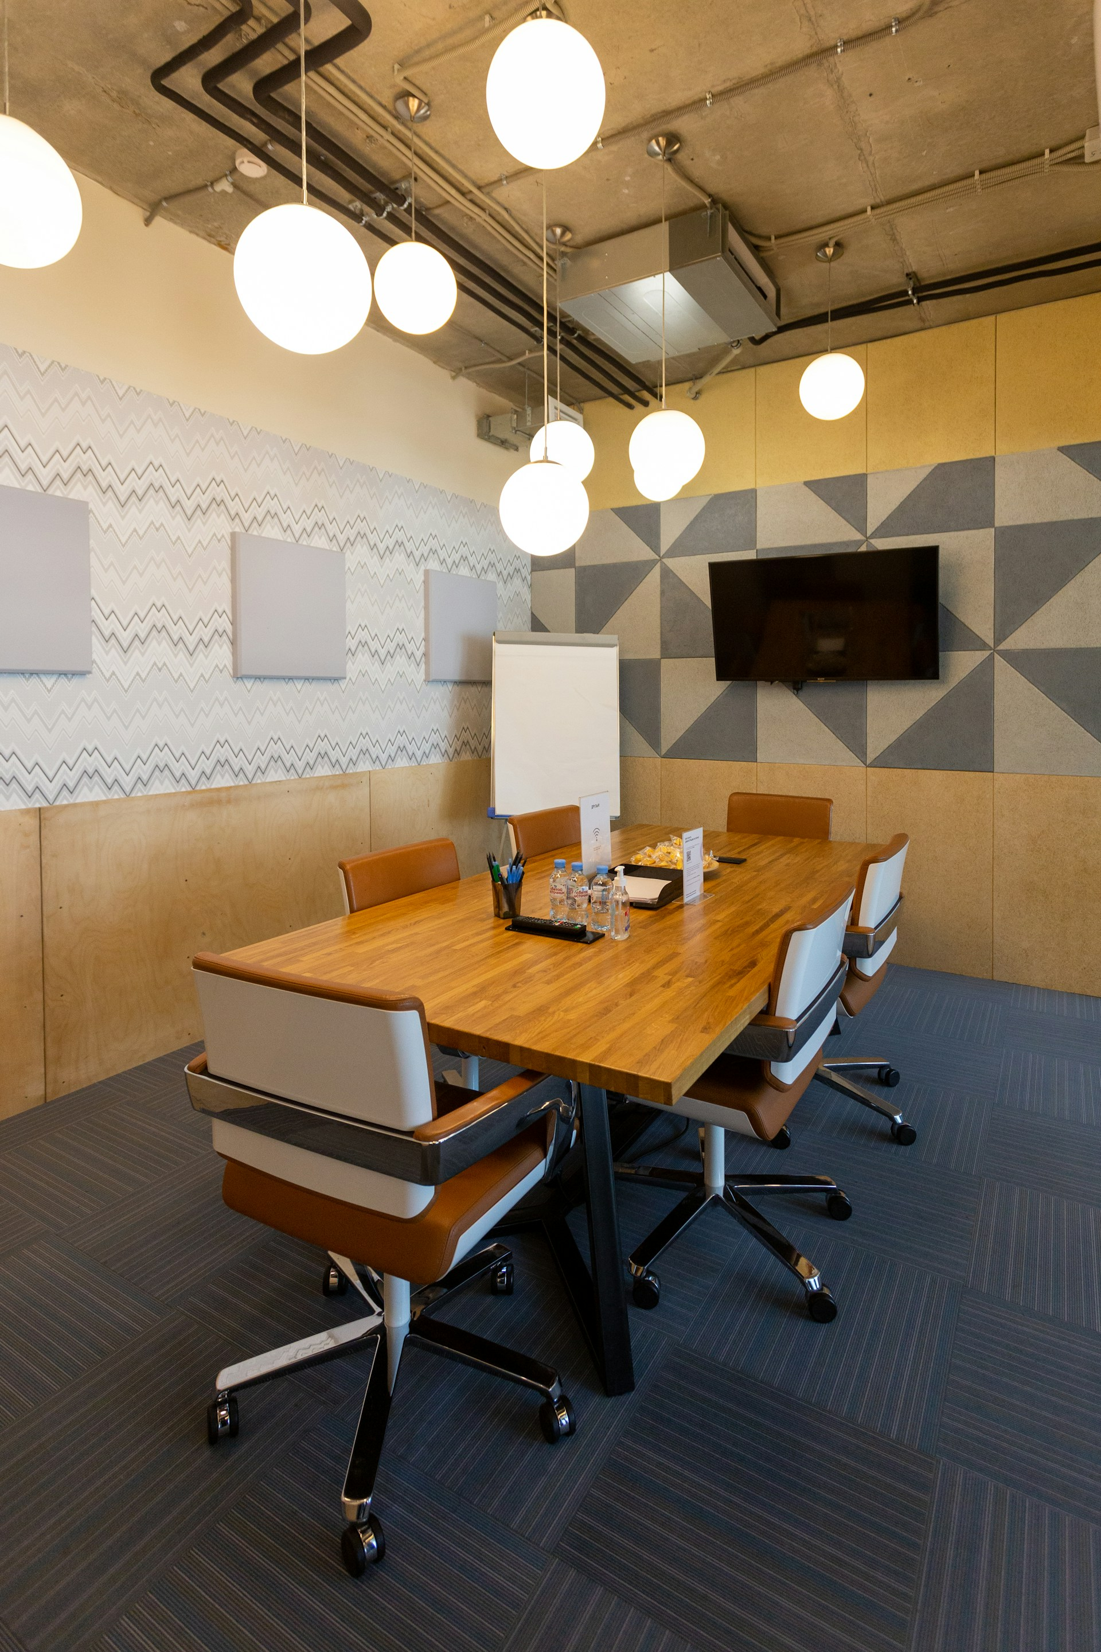

1. How many chairs with wheels are present? 6 (physical) (chairs)

2. How many items are on top of the table? 5 (relational) (items)

3. If all the lights were removed from the ceiling, how many lights would be visible? 0 (physical) (lights)

## Image 65 (beach cleanup)

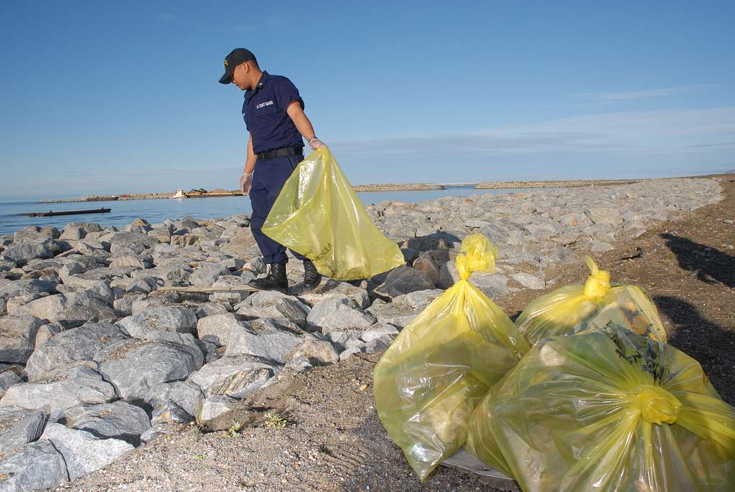

1. How many yellow plastic bags are visible? 5 (physical) (bags)

2. How many items appear to be holding collected materials? 5 (functional) (bags)

3. If the person in the image was not present, how many bags would still be visible? 5 (relational) (bags)

## Image 66 (beach cleanup)

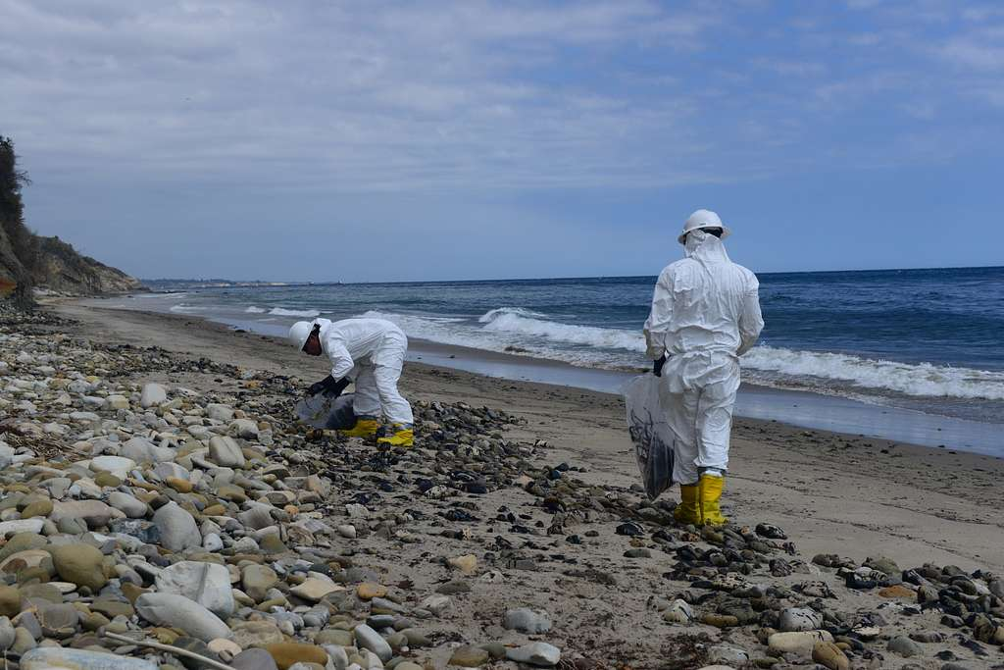

1. How many people wearing protective suits are visible? 2 (taxonomic) (humans)

2. How many items being used to collect debris are visible? 2 (functional) (bags)

3. If the waves were not present, how many visible areas of sand would there be? 3 (relational) (sand areas)

## Image 67 (beach cleanup)

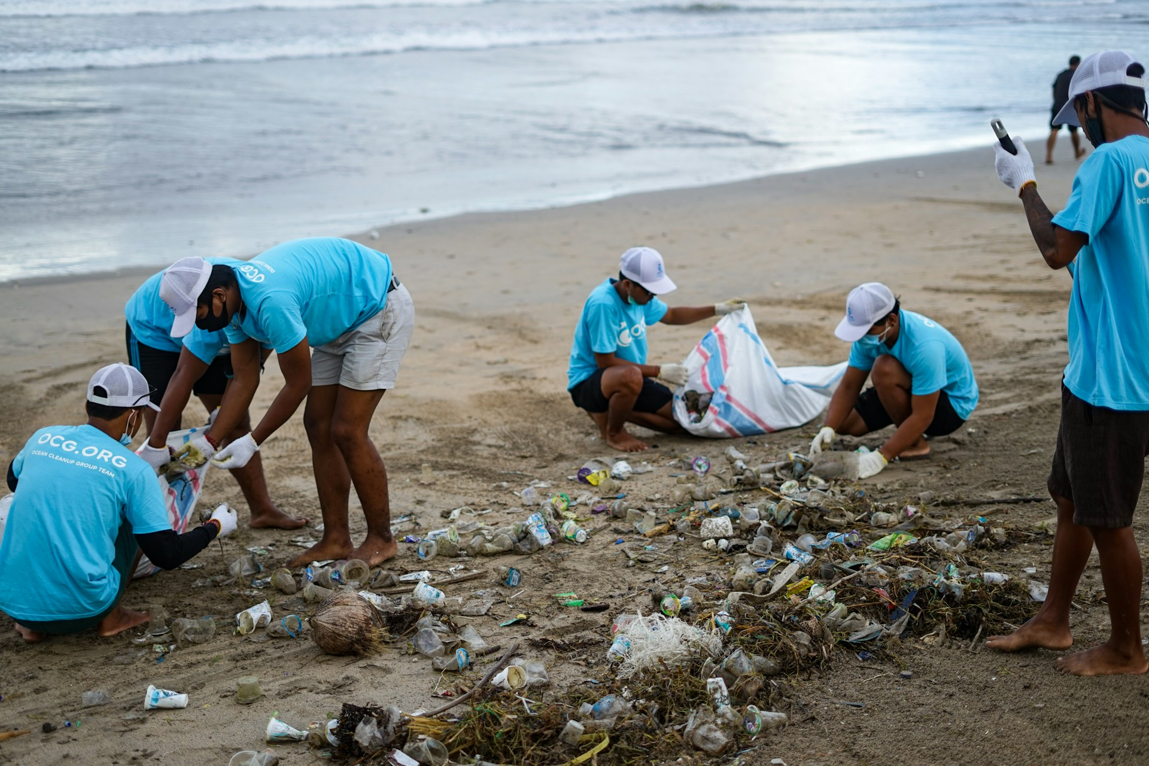

1. How many plastic items are visible? 45 (physical) (bottles, containers, wrappers)

2. How many people are actively collecting trash? 6 (relational) (volunteers)

3. If all the trash was removed, how many coconuts would be visible? 1 (taxonomic) (coconut)

## Image 68 (beach cleanup)

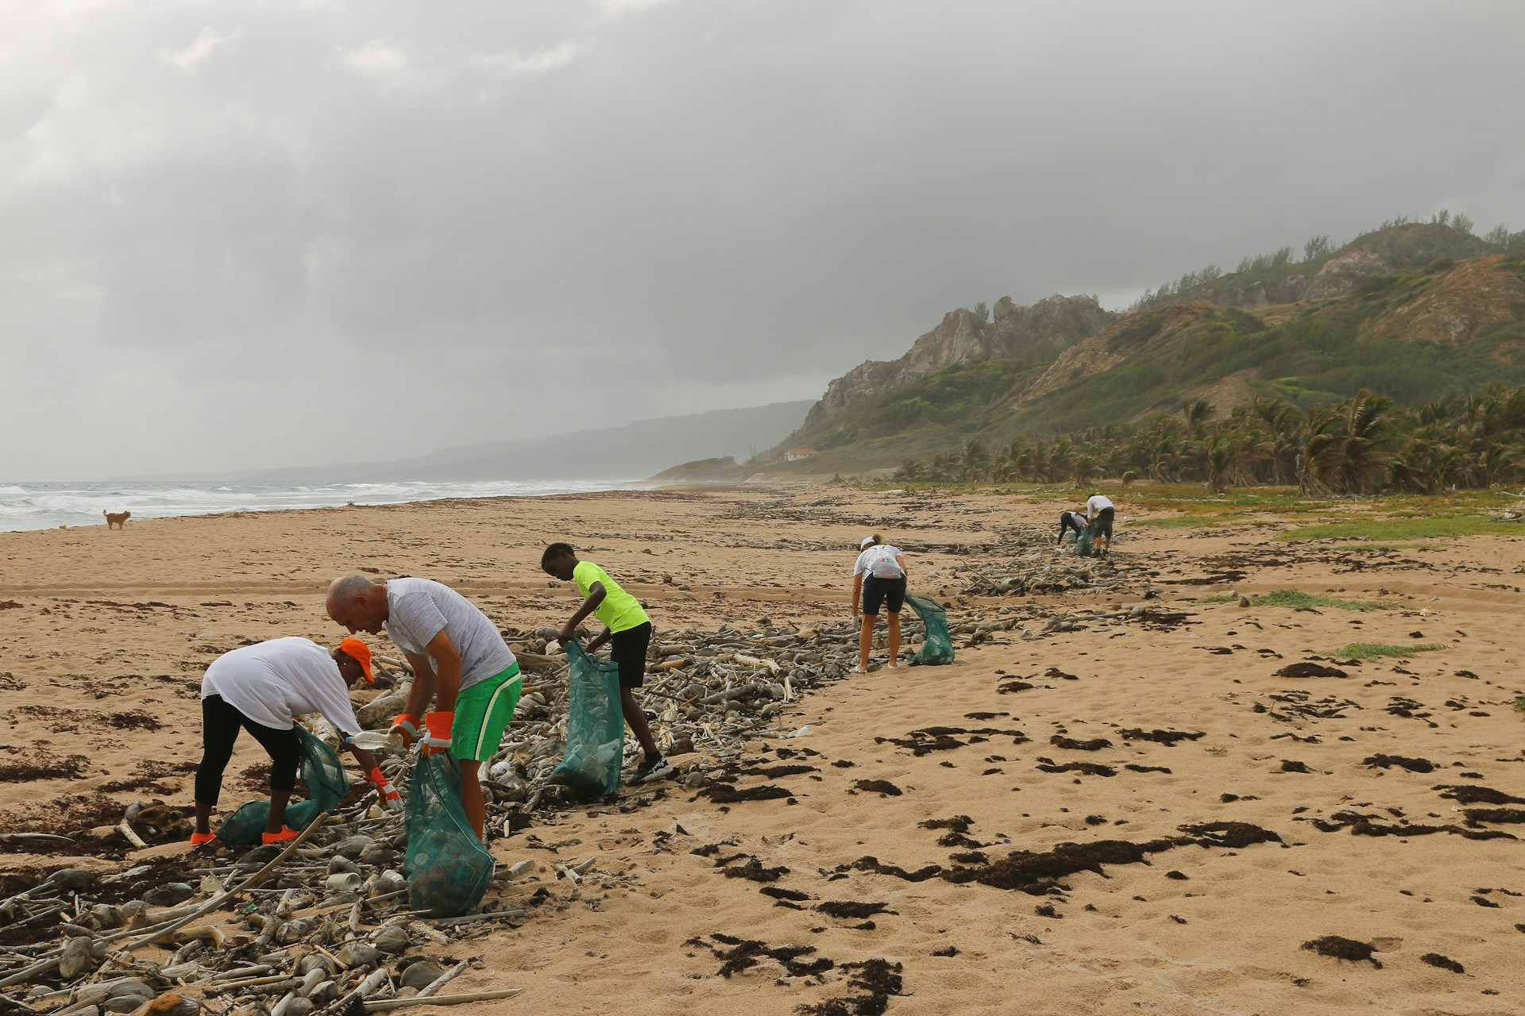

1. How many people are visible? 6 (taxonomic) (humans)

2. How many people are holding bags? 4 (relational) (people and bags)

3. If all the debris on the beach were removed, how many people would still be visible? 6 (taxonomic) (humans)

## Image 69 (beach cleanup)



1. How many people are wearing hats? 8 (taxonomic) (people)

2. How many people are holding bags? 7 (functional) (people)

3. If all the boats were blue, how many boats would be visible? 10 (physical) (boats)

## Image 70 (beach cleanup)

[ERROR: Could not add image image70.jpg - ]

## Image 71 (garage)

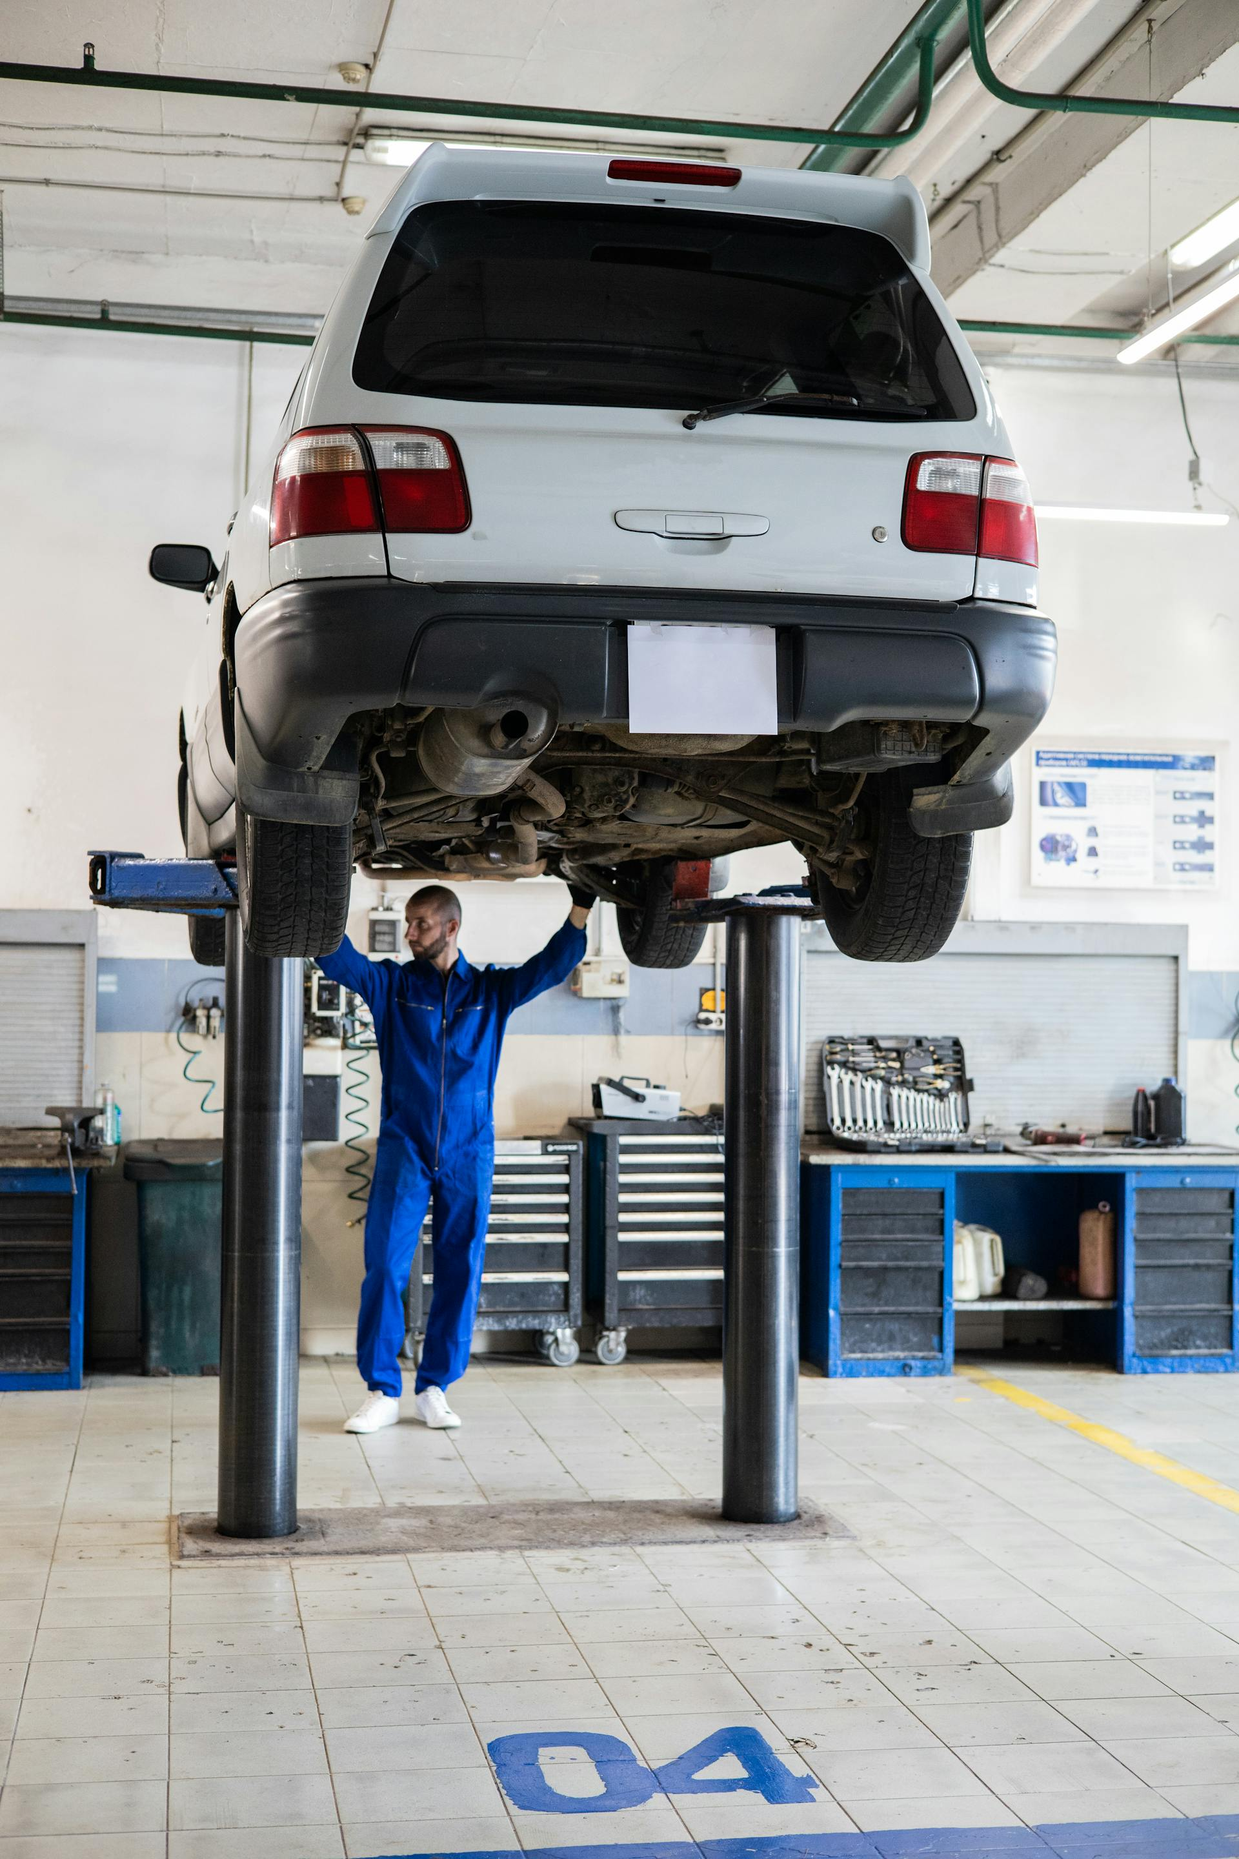

1. How many vehicles are visible? 1 (taxonomic) (car)

2. How many tool chests are visible? 2 (functional) (tool chests)

3. If the car were painted red, how many red objects would be visible? 1 (physical) (car)

## Image 72 (garage)

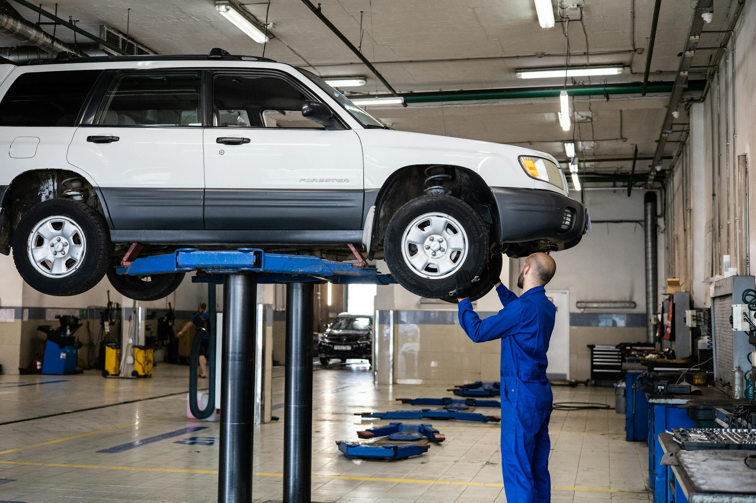

1. How many vehicles are visible? 2 (taxonomic) (cars)

2. How many support posts are holding up the vehicle? 4 (structural) (posts)

3. If the mechanic wasn't working on the car, how many people would be visible? 0 (relational) (people)

## Image 73 (library)

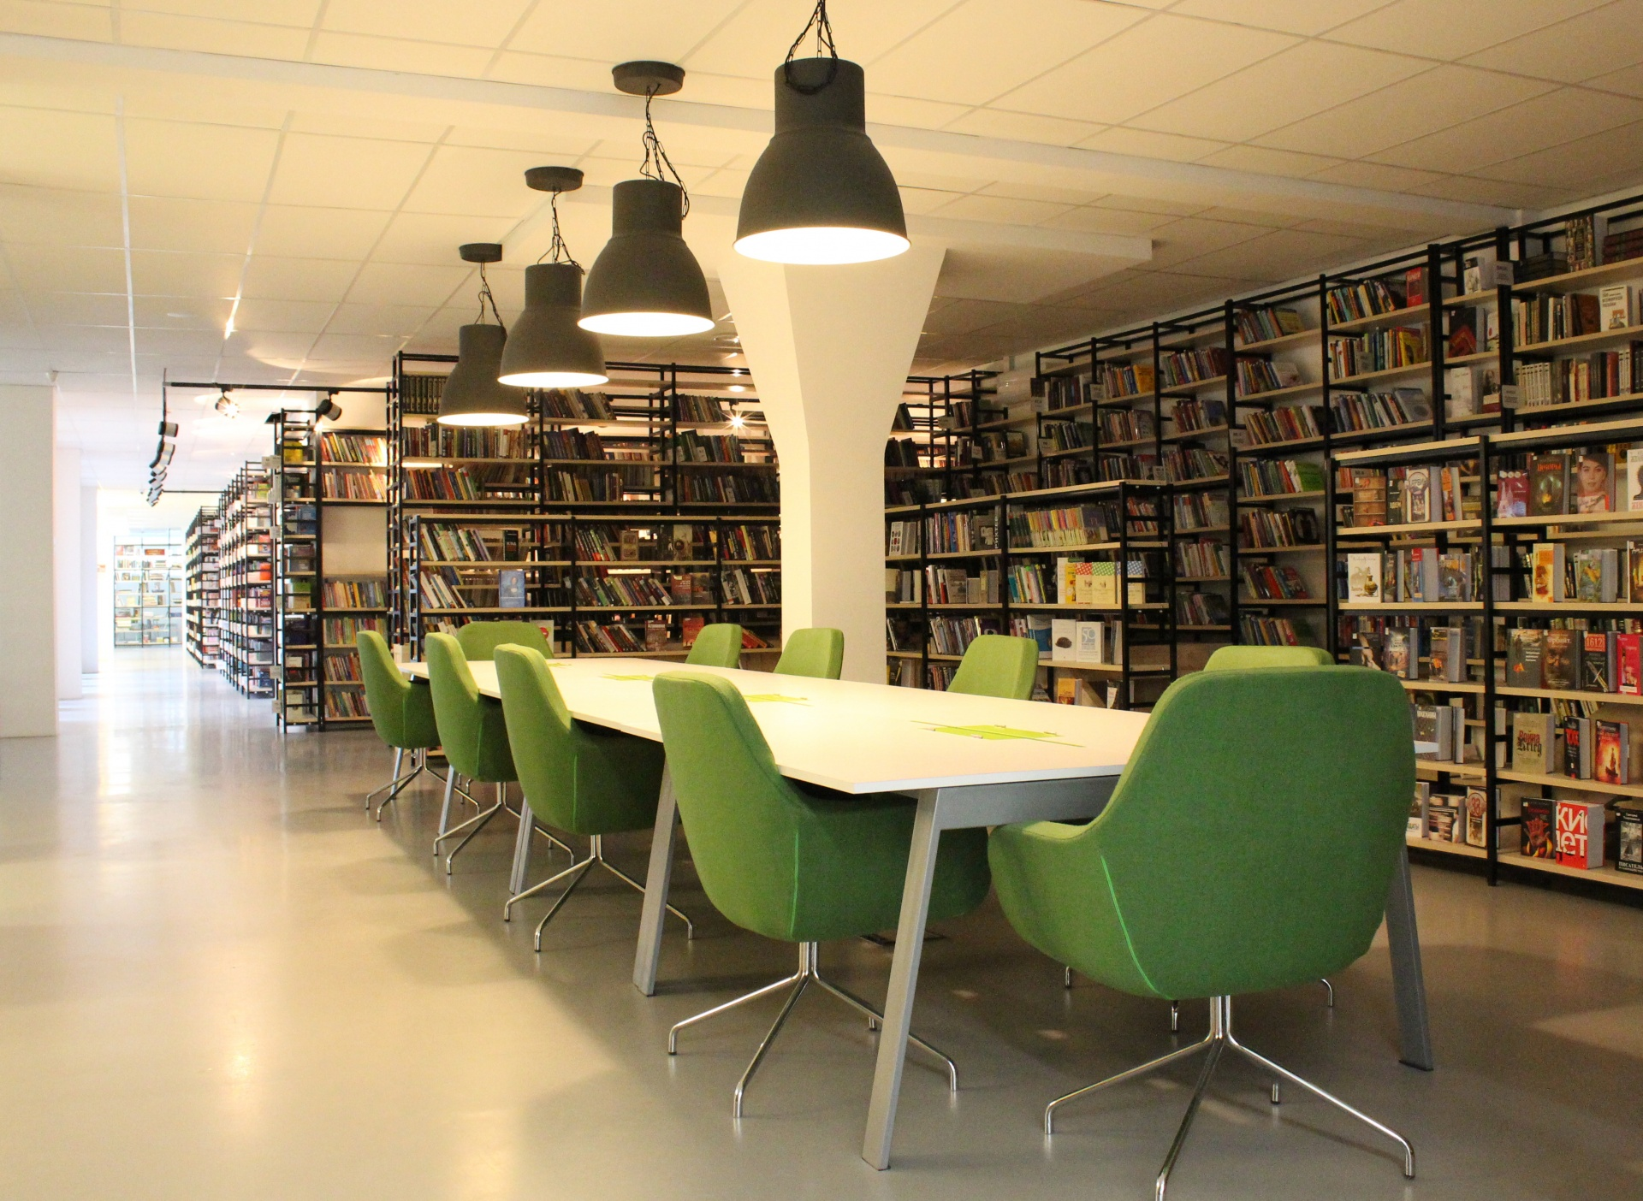

1. How many chairs are visible? 8 (taxonomic) (furniture)

2. How many lamps are hanging from the ceiling? 4 (functional) (light sources)

3. If all the books were removed from the shelves, how many shelves would be visible? 10 (physical) (shelves)

## Image 74 (library)

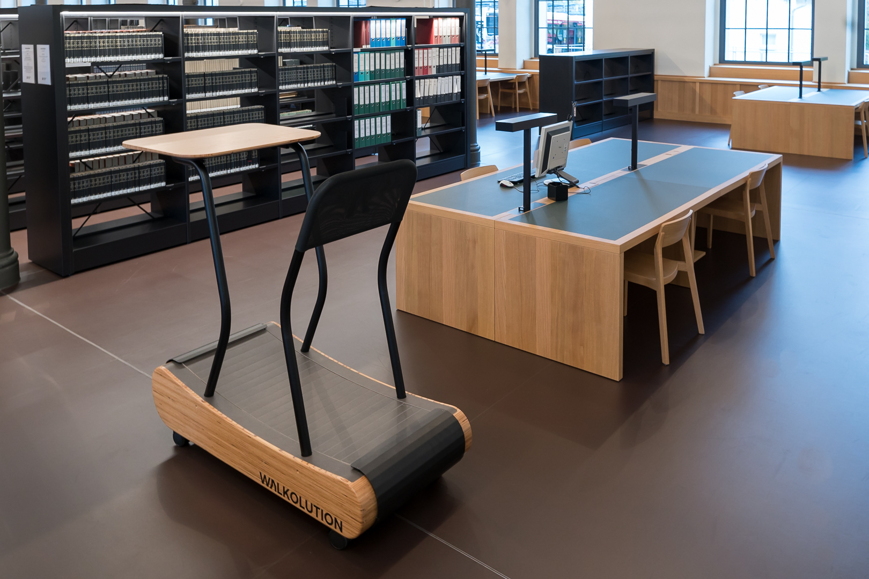

1. How many objects made of wood are present? 5 (physical) (tables/desks)

2. How many objects are on top of other objects? 2 (relational) (laptop/items on desk)

3. If all the books were removed from the shelves, how many shelves would be visible? 6 (taxonomic) (shelves)

## Image 75 (library)

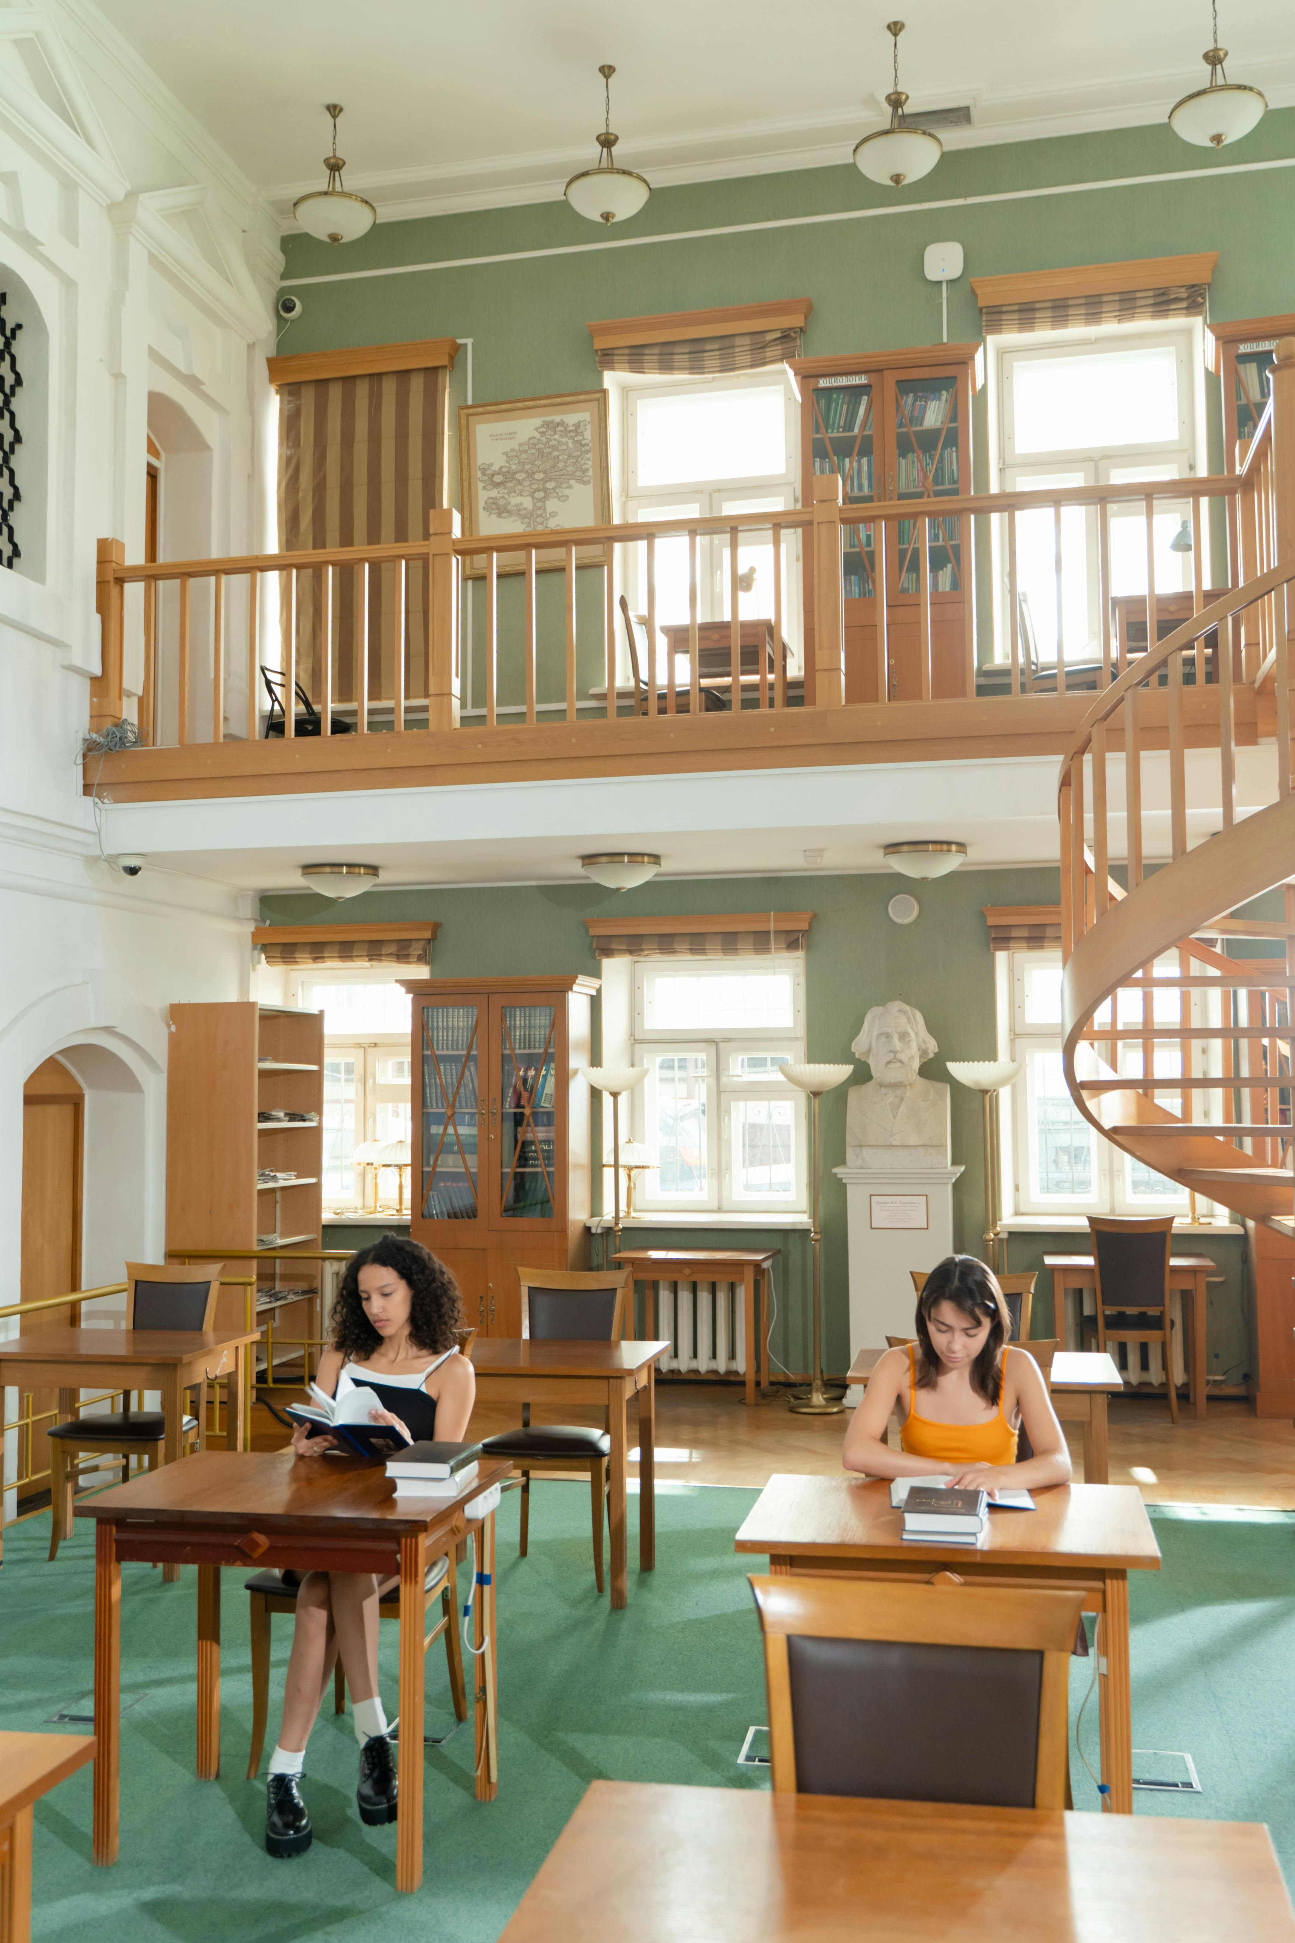

1. How many chairs are visible? 7 (taxonomic) (furniture)

2. How many tables have books on top of them? 2 (relational) (tables and books)

3. If all the bookshelves were empty, how many wooden cabinets would be visible? 4 (physical) (cabinets)

## Image 76 (library)

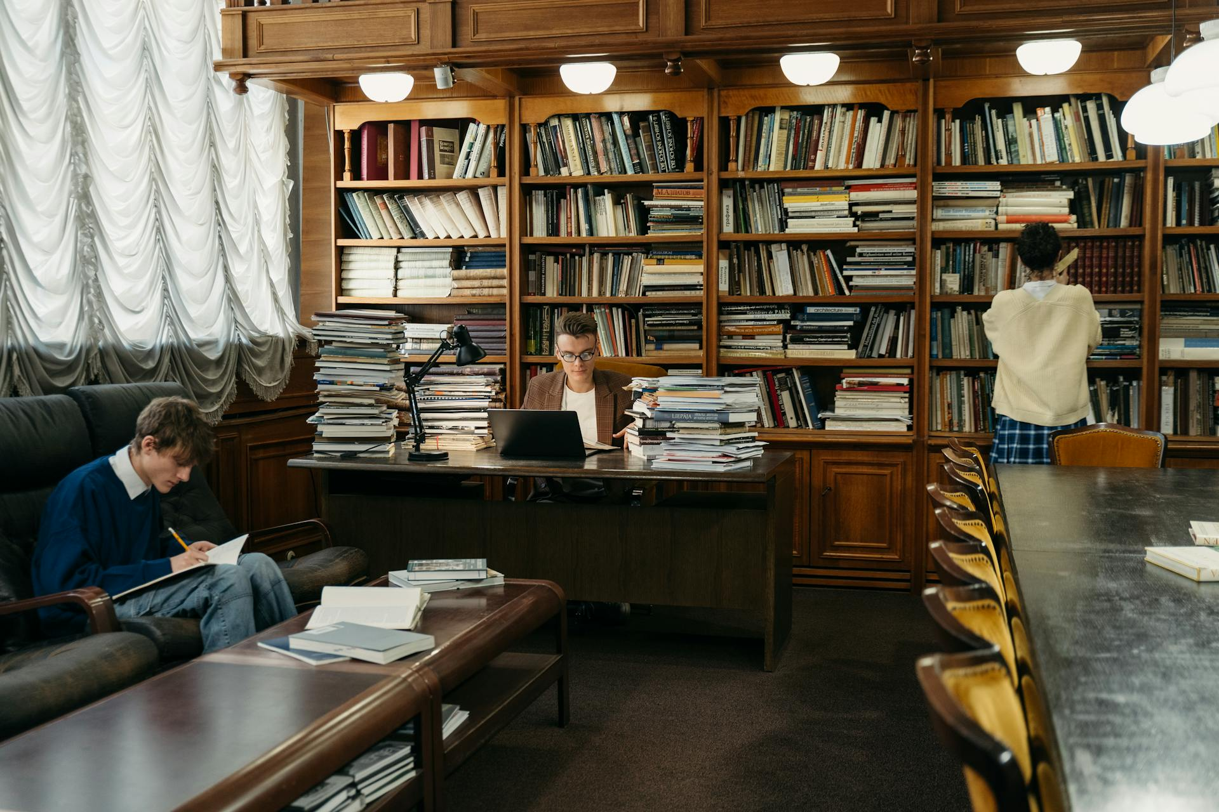

1. How many chairs are visible? 8 (taxonomic) (furniture)

2. How many stacks of books are on the desk? 4 (relational) (book stacks)

3. If all the lamps were removed, how many light sources would be visible? 0 (functional) (lamps)

## Image 77 (library)

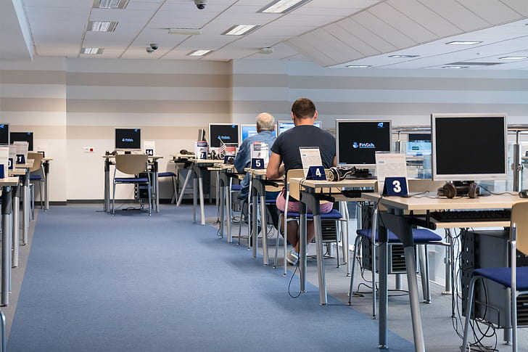

1. How many objects made of metal are present? 22 (physical) (computer stands)

2. How many workstations with headphones are visible? 6 (functional) (computer workstations)

3. If all the chairs were removed, how many computer monitors would be visible? 8 (relational) (computer monitors)

## Image 78 (tools)

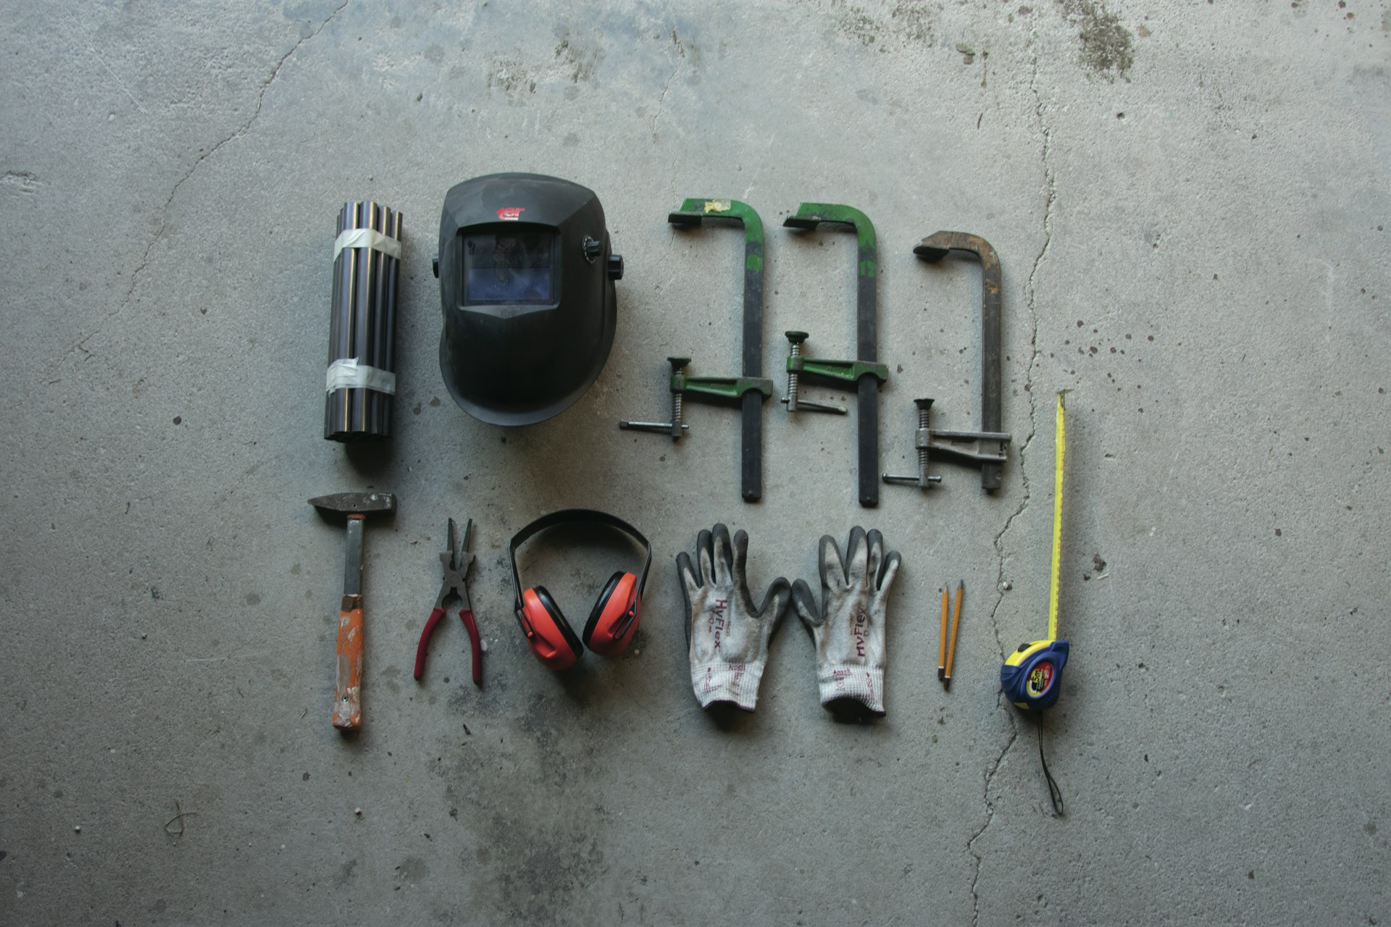

1. How many tools made of metal are present? 7 (physical) (hammer, pliers, clamps, welding helmet, tape measure, metal rods)

2. How many items are designed to be worn? 2 (functional) (earmuffs, gloves)

3. If the welding helmet was replaced with a hat, how many headwear items would be visible? 1 (relational) (hat)

## Image 79 (tools)



1. How many tools made of metal are present? 6 (physical) (saw, trowel, nails, hammer, wrench, clamp)

2. How many items are designed to protect the user? 3 (functional) (helmet, goggles, welding mask)

3. If the red clamp were blue, how many red objects would be visible? 2 (taxonomic) (helmet, welding mask)

## Image 80 (construction)

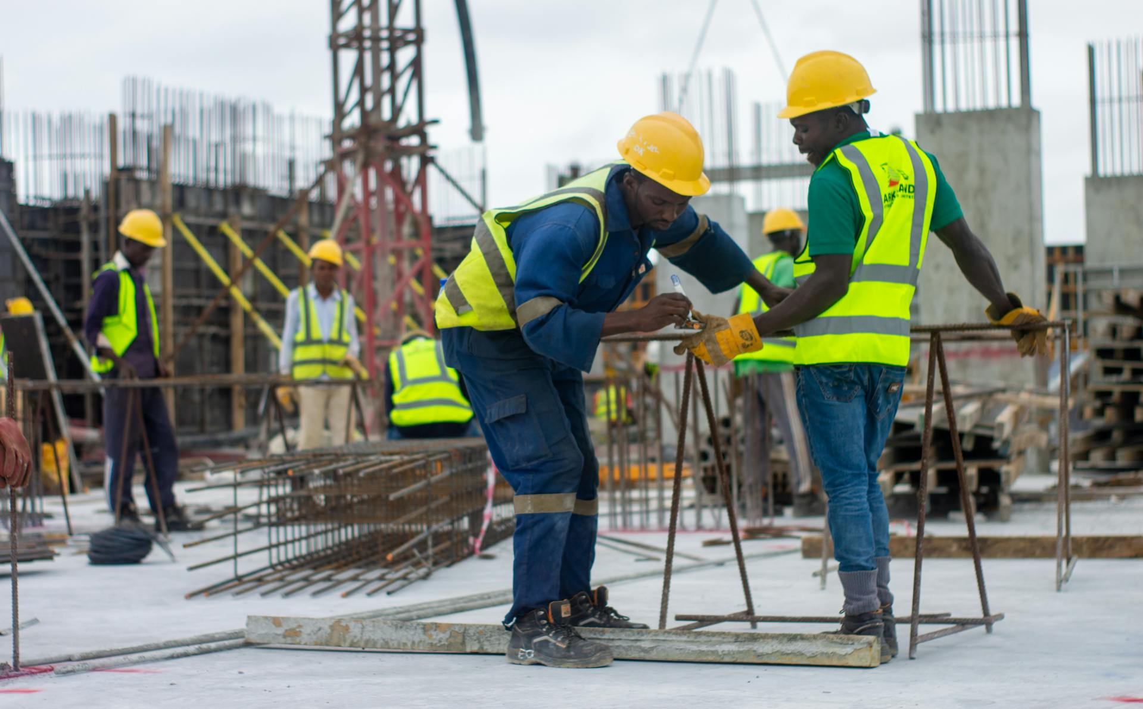

1. How many people wearing yellow hard hats are present? 5 (taxonomic) (people)

2. How many people are standing next to each other? 2 (relational) (construction workers)

3. If all the rebar were made of plastic instead of metal, how many objects would be flexible? 6 (physical) (rebar)

## Image 81 (driveway)

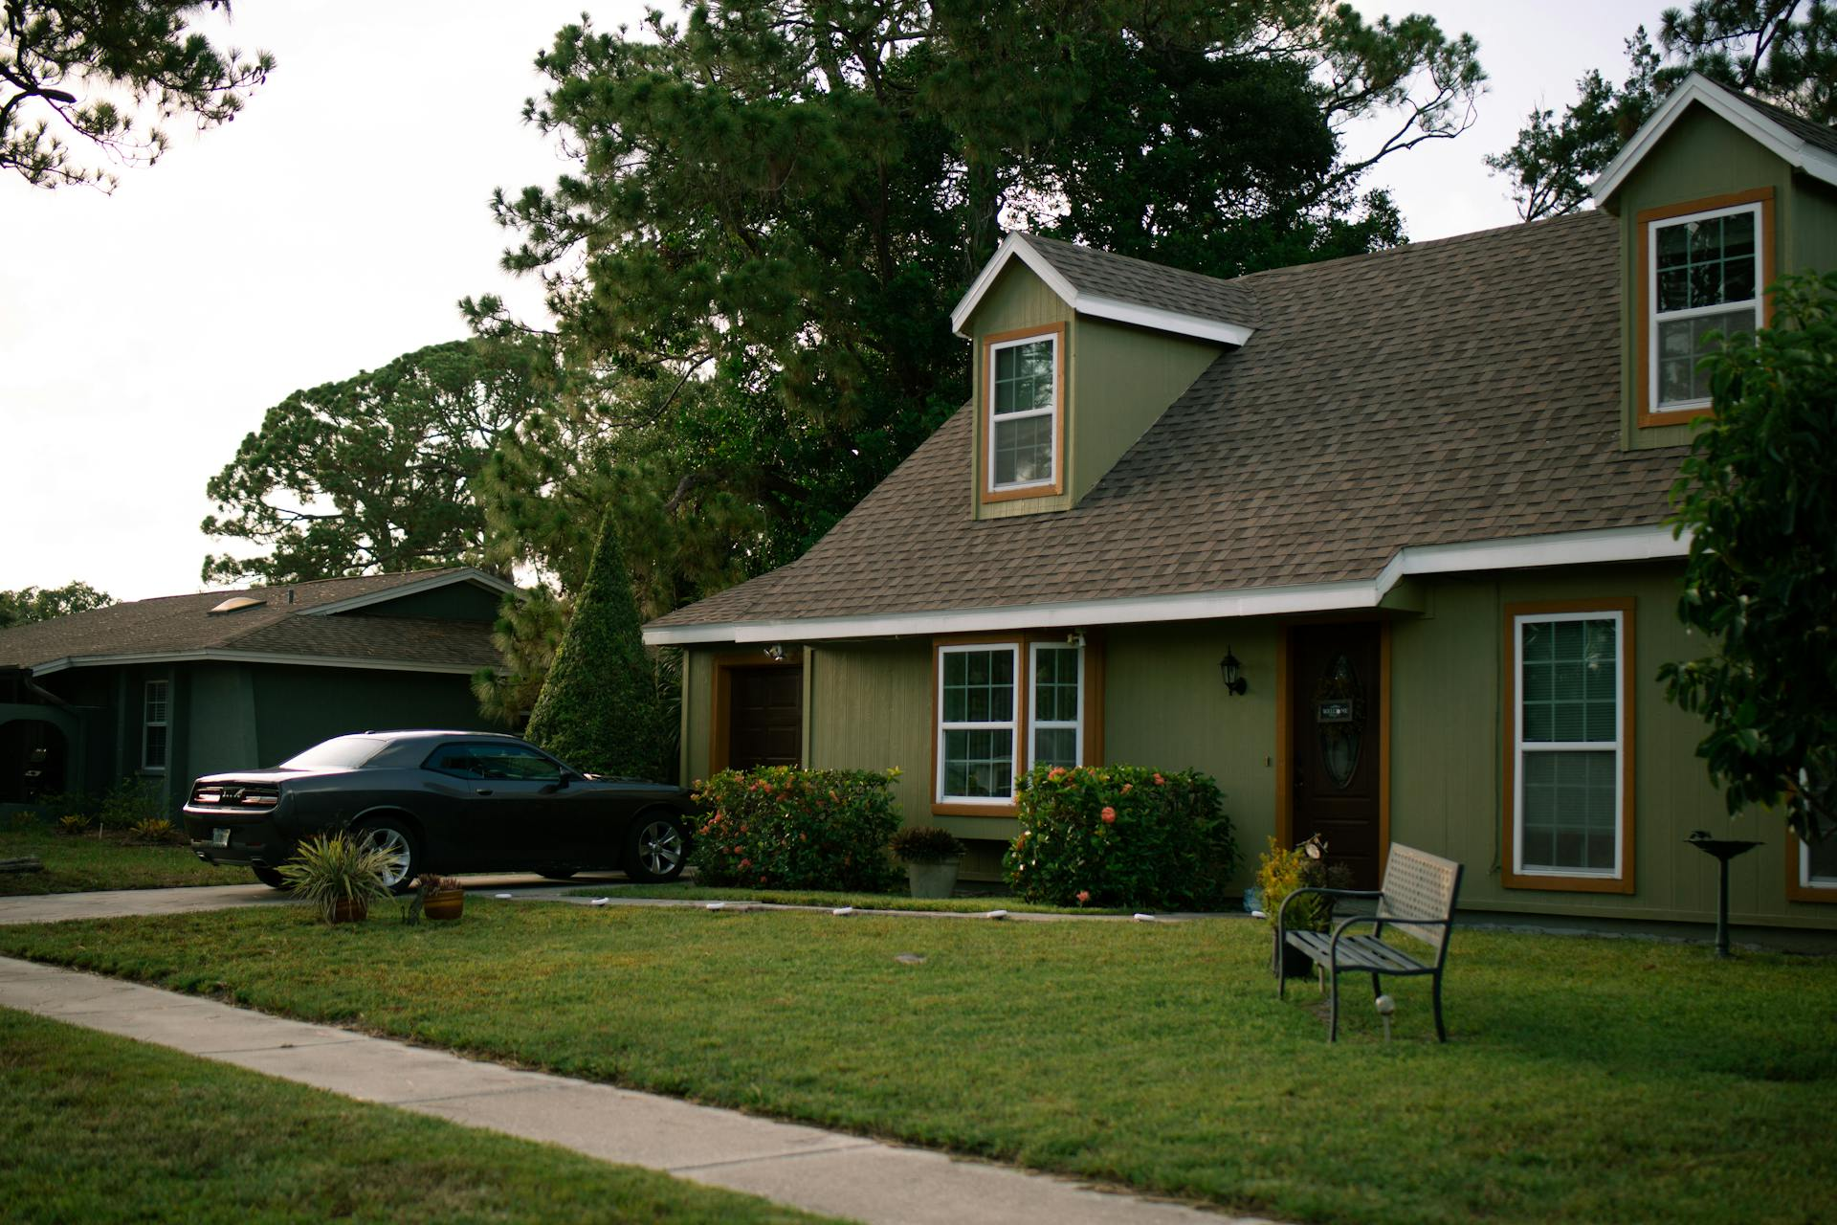

1. How many vehicles are present? 1 (taxonomic) (car)

2. How many objects that can provide seating are visible? 1 (functional) (bench)

3. If the trees were removed, how many windows would be visible? 5 (physical) (windows)

## Image 82 (urban)

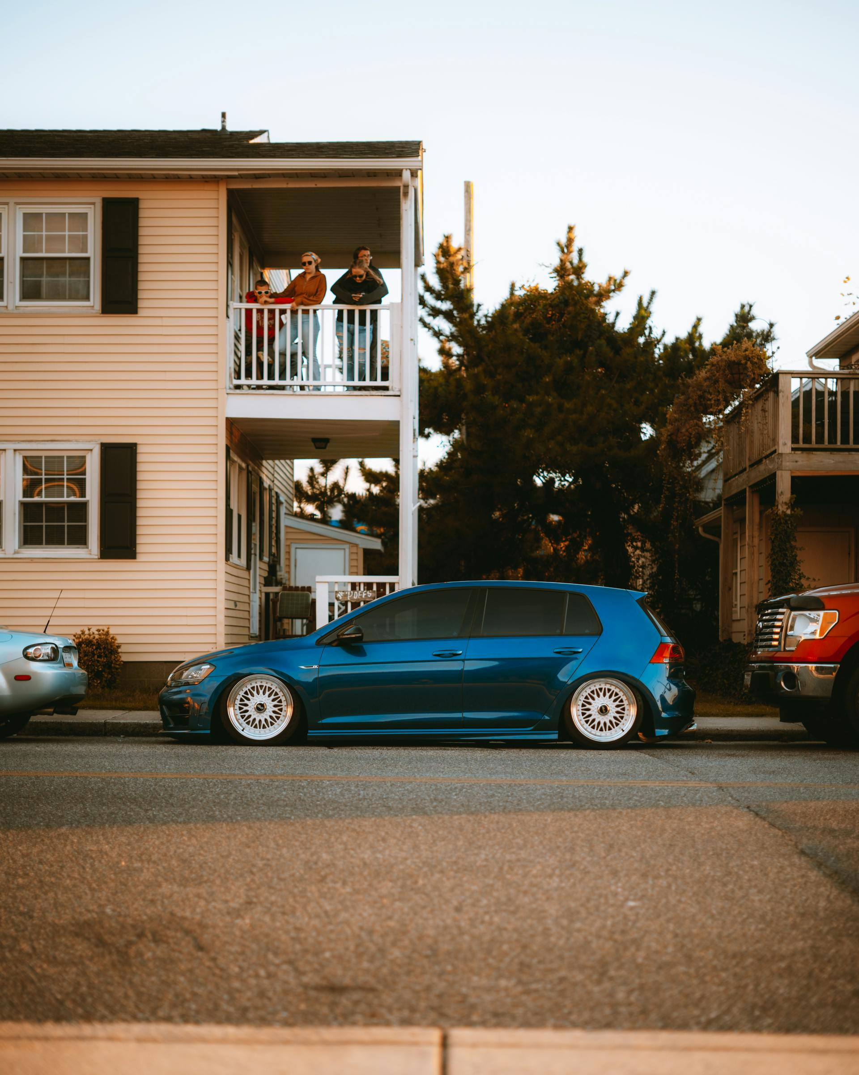

1. How many vehicles are visible? 3 (taxonomic) (cars)

2. How many people are standing on the balcony? 2 (relational) (people)

3. If the blue car had a spoiler, how many cars would have a spoiler? 1 (functional) (cars)

## Image 83 (driveway)

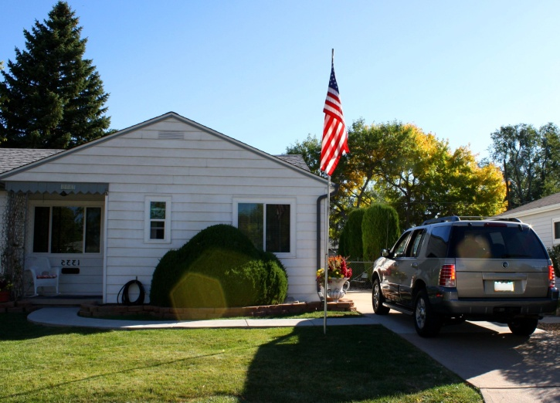

1. How many vehicles are present? 1 (taxonomic) (SUV)

2. How many items are positioned on top of other items? 2 (relational) (flowers in pots)

3. If the American flag was a different color, how many flags would be visible? 1 (taxonomic) (flag)

## Image 84 (urban)

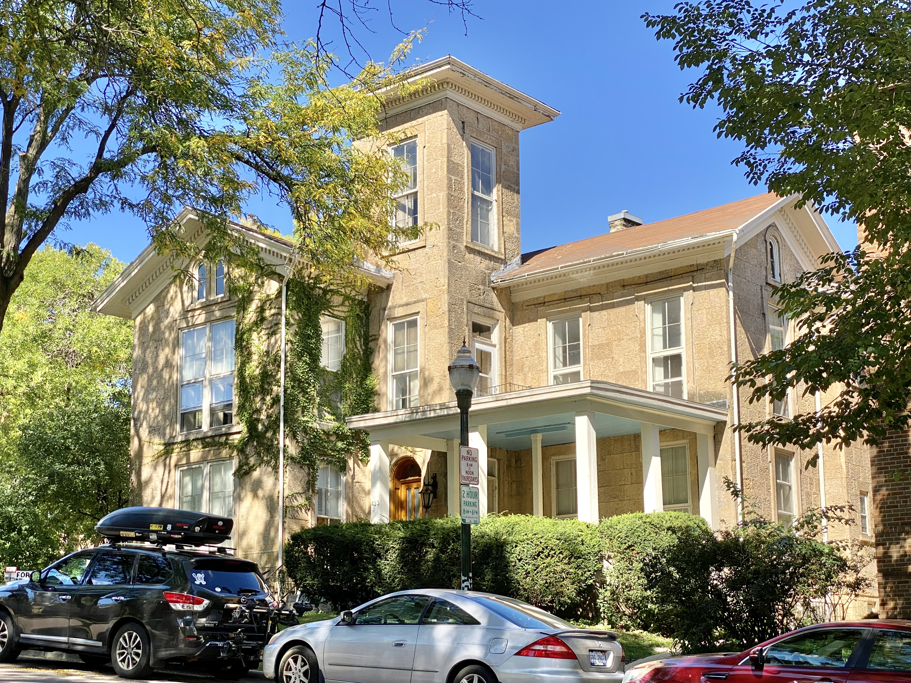

1. How many vehicles are visible? 3 (taxonomic) (cars)

2. How many windows are visible on the first floor? 6 (physical) (windows)

3. If all the trees were removed, how many bushes would be visible? 2 (taxonomic) (bushes)

## Image 85 (driveway)

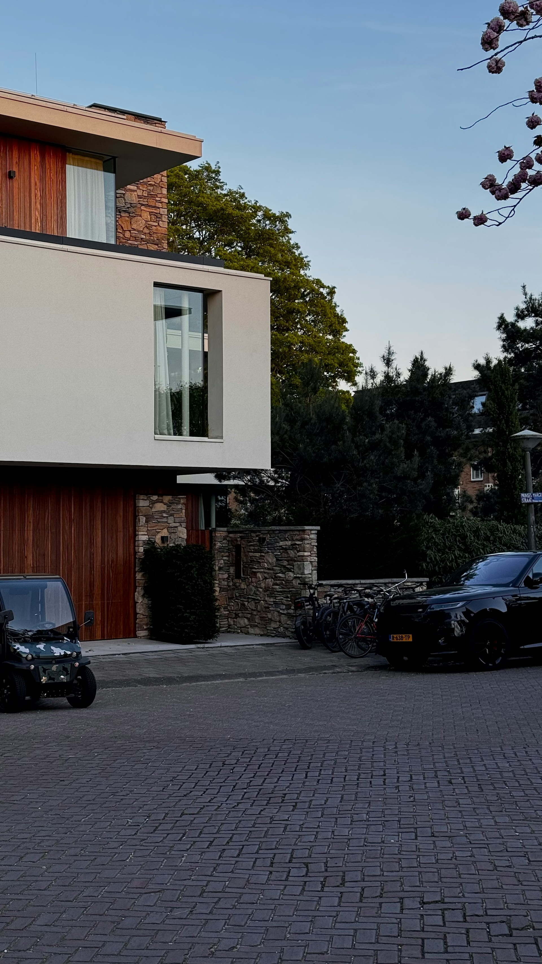

1. How many vehicles are visible? 3 (taxonomic) (cars and golf cart)

2. How many windows are present? 4 (functional) (windows)

3. If the bushes were removed, how many doors would be visible? 2 (relational) (doors)

## Image 86 (driveway)

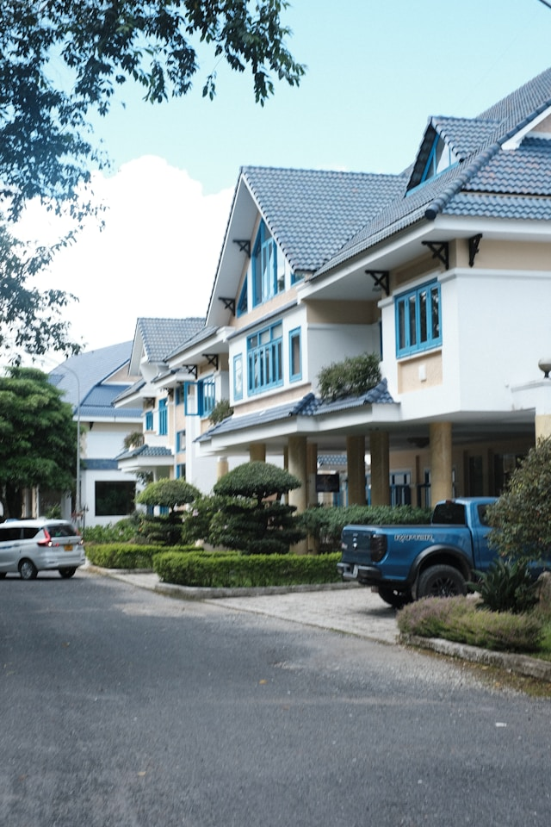

1. How many vehicles are visible? 2 (taxonomic) (cars and truck)

2. How many houses are connected to each other? 4 (relational) (houses)

3. If all the bushes were trees, how many trees would there be? 8 (taxonomic) (trees and bushes)

## Image 87 (urban)

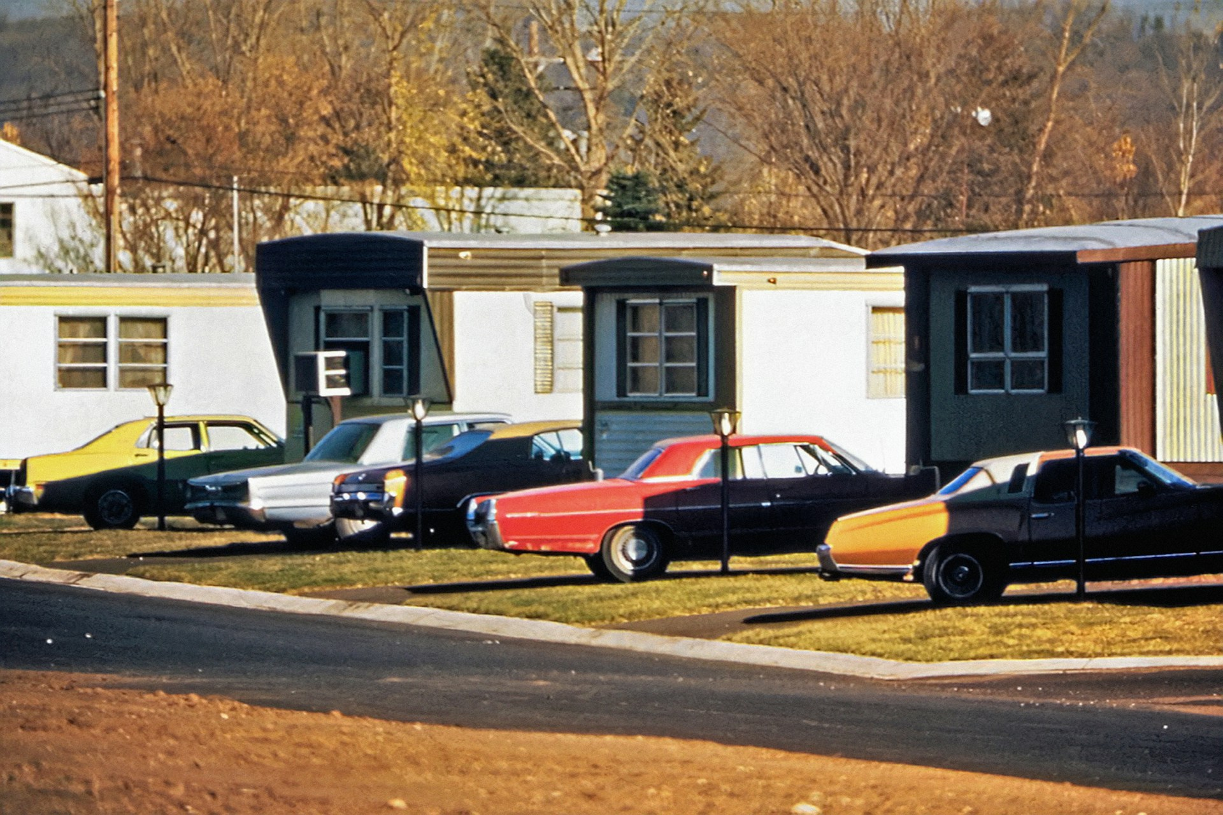

1. How many vehicles are visible? 6 (taxonomic) (cars)

2. How many buildings are next to each other? 5 (relational) (mobile homes)

3. If all the cars were red, how many red vehicles would there be? 7 (taxonomic) (cars)

## Image 88 (urban)

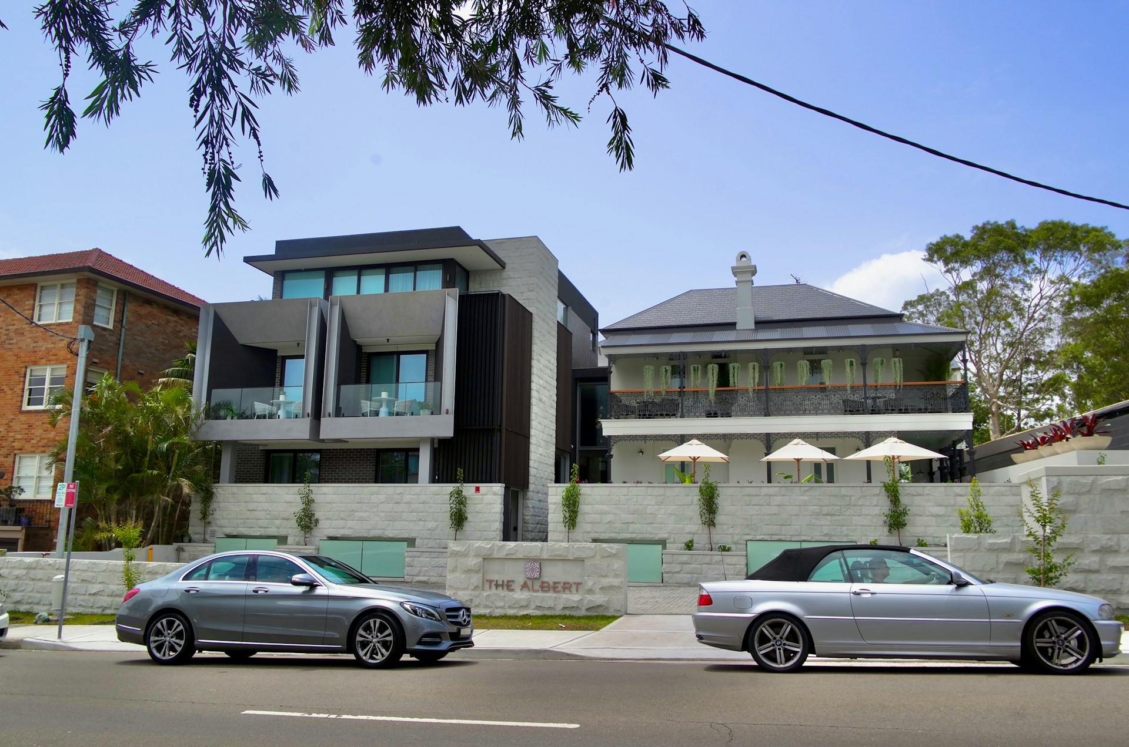

1. How many vehicles are present? 2 (taxonomic) (cars)

2. How many umbrellas are visible providing shade? 3 (functional) (umbrellas)

3. If the trees were removed, how many buildings would be visible? 3 (taxonomic) (buildings)

## Image 89 (urban)

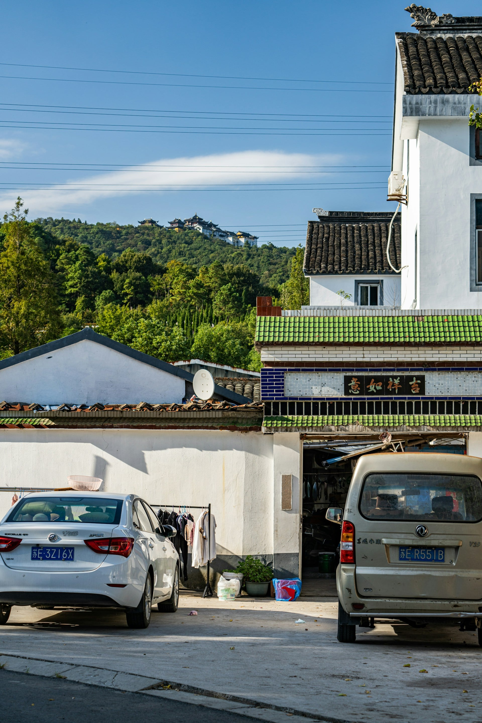

1. How many vehicles are present? 2 (taxonomic) (cars)

2. How many objects are positioned on top of the wall? 2 (relational) (antennas)

3. If the clothes hanging on the line were removed, how many items of clothing would be missing? 8 (physical) (clothes)

## Image 90 (driveway)

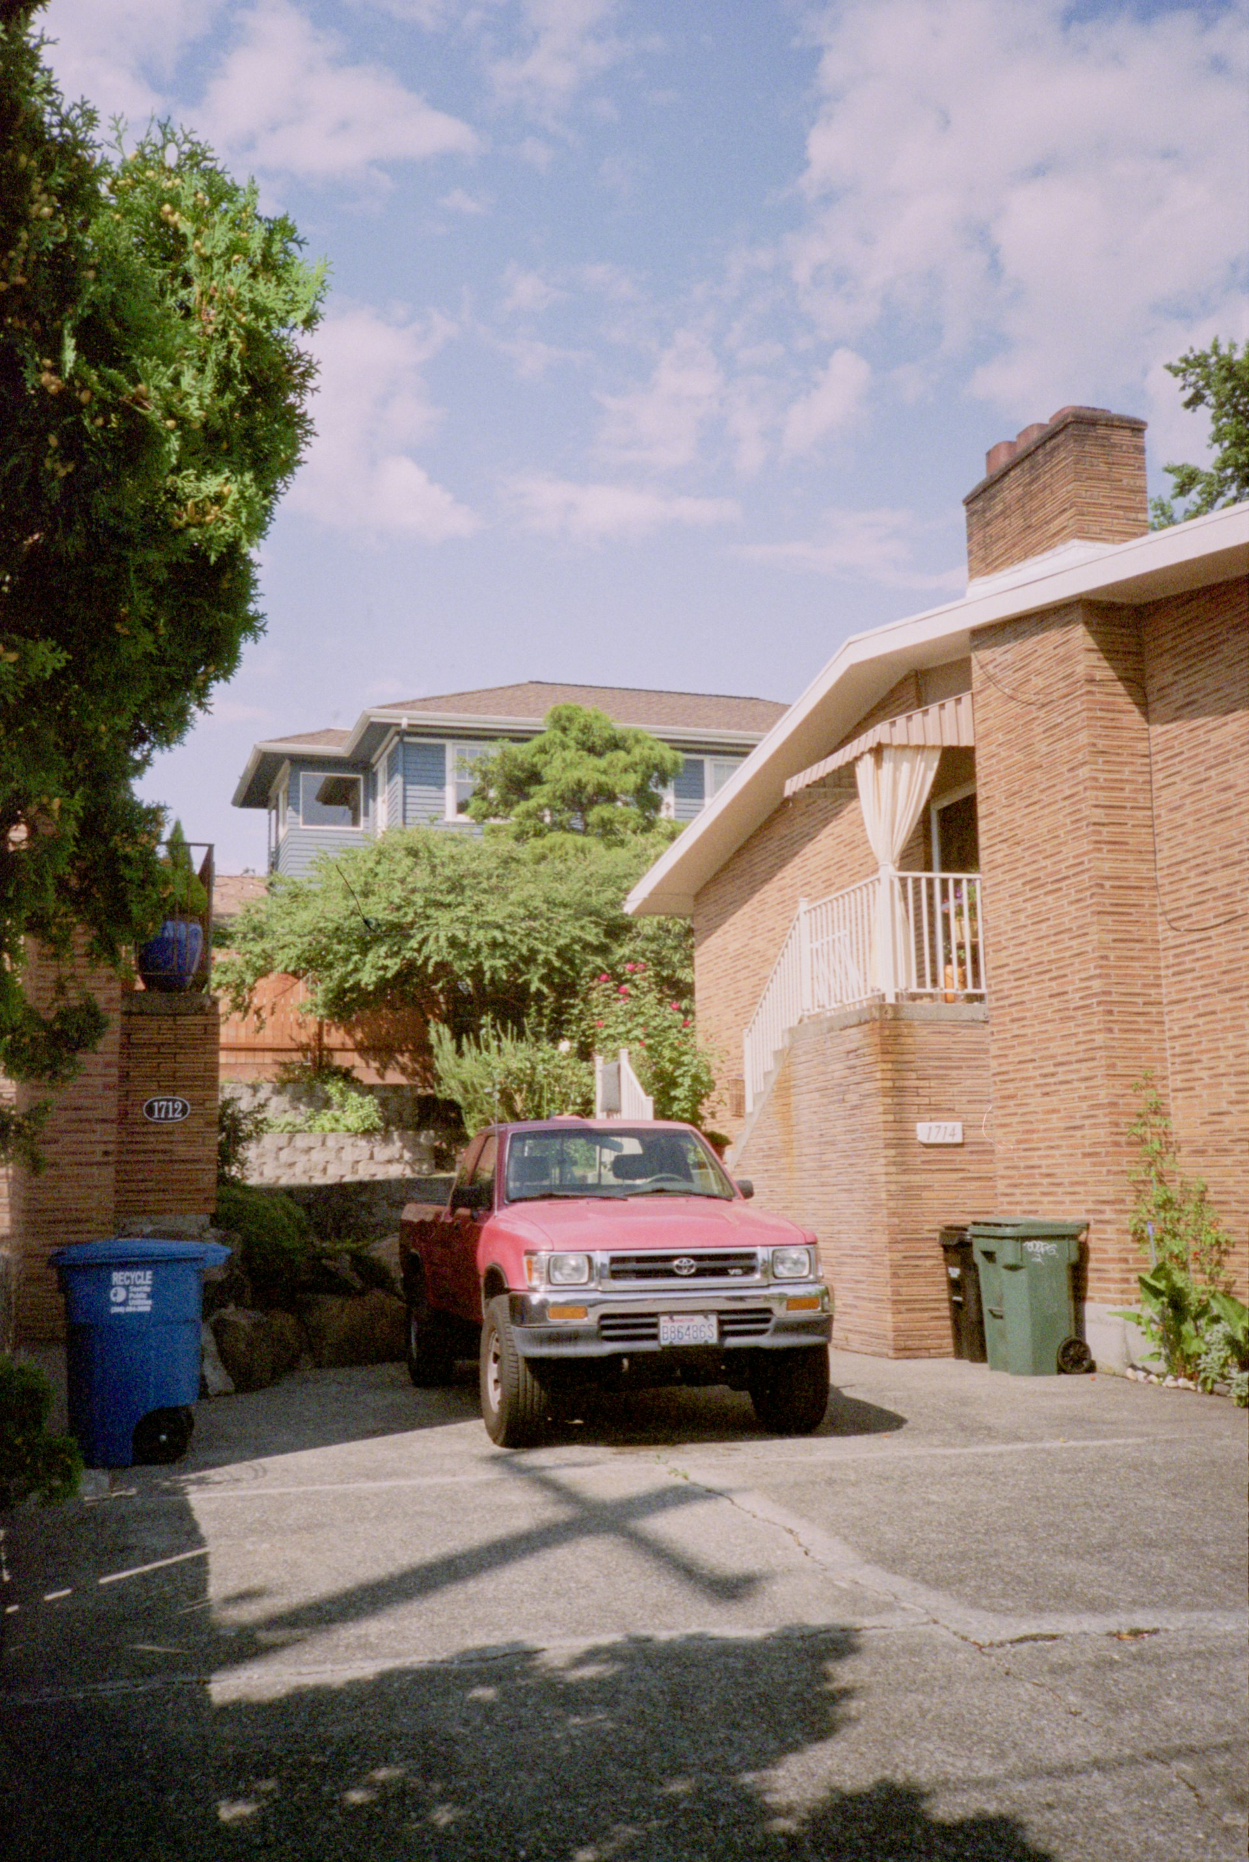

1. How many vehicles are present? 1 (taxonomic) (truck)

2. How many containers are visible outside? 3 (functional) (trash bins)

3. If the bushes were removed, how many house numbers would be visible? 2 (physical) (house numbers)

## Image 91 (zoo)

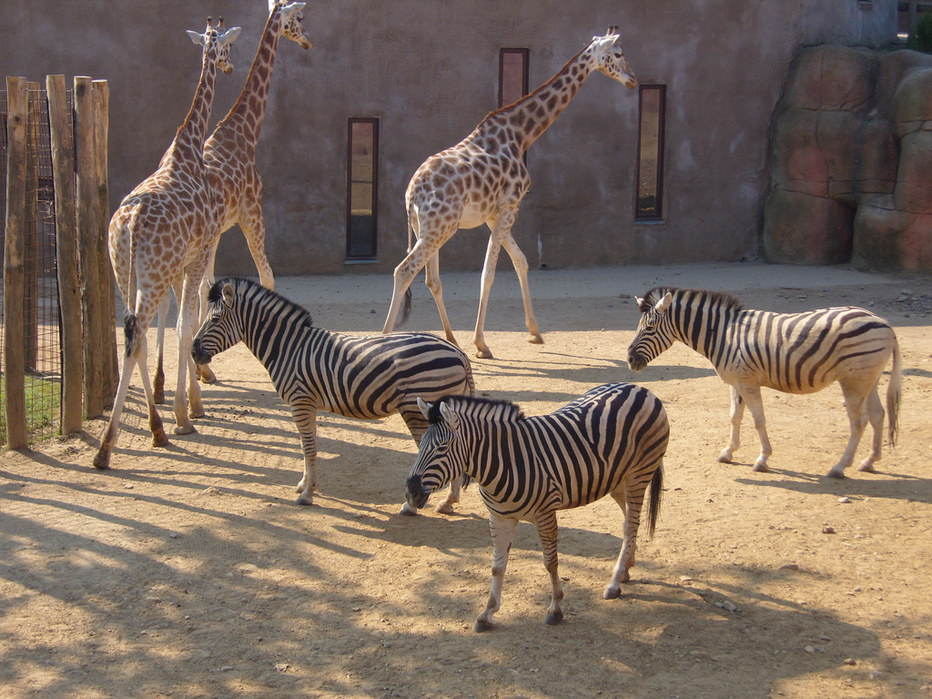

1. How many mammals are visible? 5 (taxonomic) (giraffes and zebras)

2. How many animals are standing next to each other? 3 (relational) (zebras)

3. If the giraffes were the same height as the zebras, how many animals would be the same height? 5 (taxonomic) (giraffes and zebras)

## Image 92 (zoo)

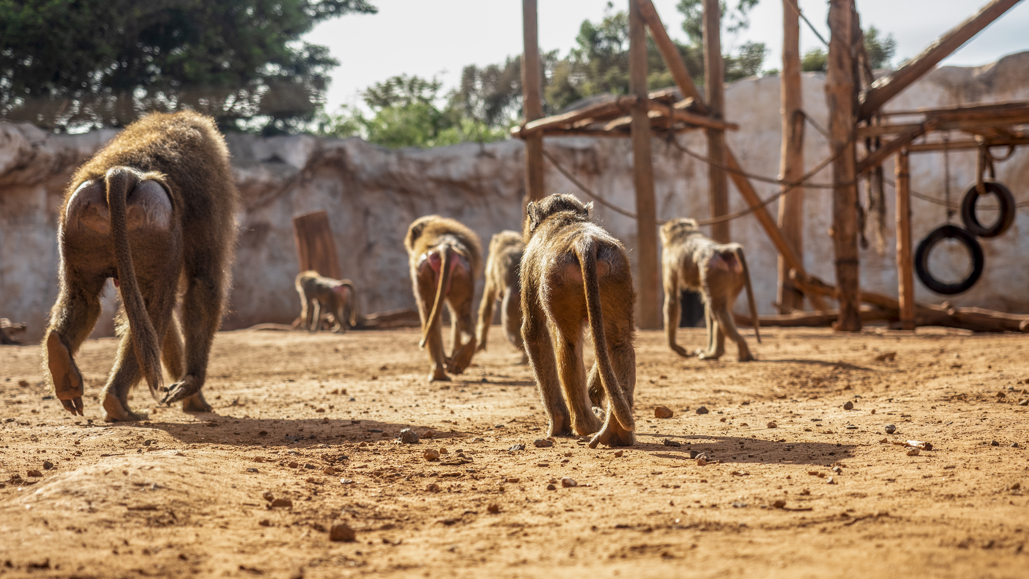

1. How many mammals are visible? 7 (taxonomic) (baboons)

2. How many baboons are walking towards the viewer? 4 (relational) (baboons)

3. If each baboon had two tails, how many tails would be visible? 14 (physical) (tails)

## Image 93 (zoo)

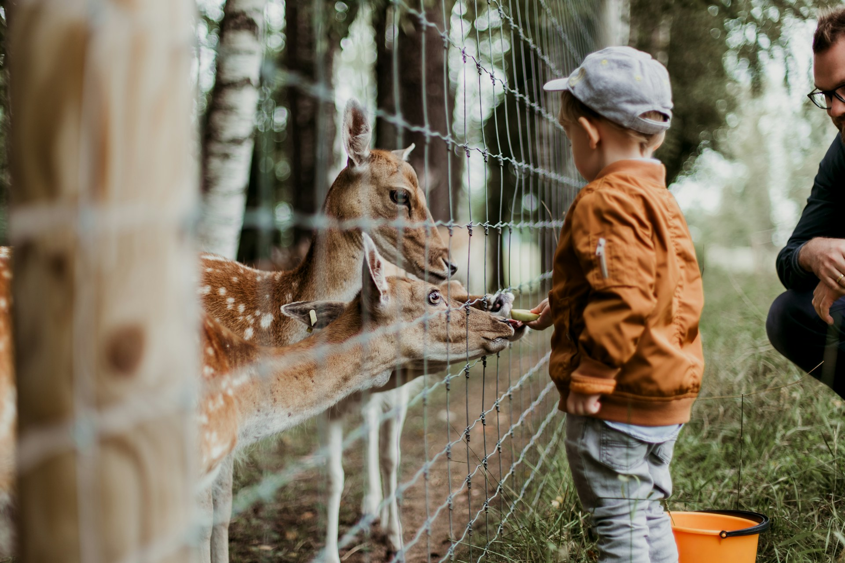

1. How many mammals are visible? 3 (taxonomic) (deer)

2. How many items are used for holding are visible? 1 (functional) (bucket)

3. If the fence wasn't there, how many deer would be close to the boy? 3 (relational) (deer)

## Image 94 (zoo)

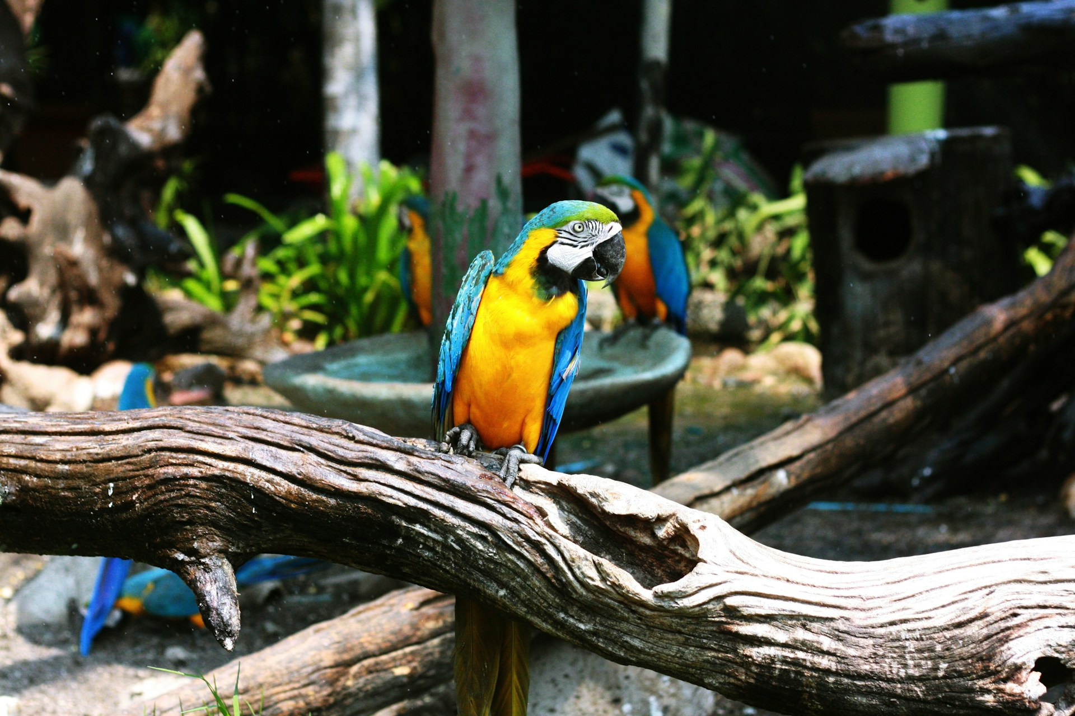

1. How many birds are visible? 4 (taxonomic) (parrots)

2. How many objects are part of a flock? 4 (relational) (parrots)

3. If all the branches were made of metal, how many objects would be made of metal? 4 (physical) (branches)

## Image 95 (zoo)

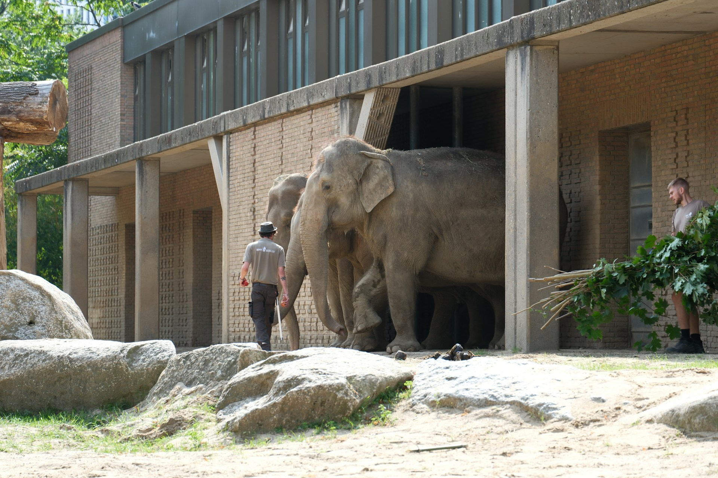

1. How many mammals are visible? 3 (taxonomic) (elephants and people)

2. How many people are standing near the elephants? 2 (relational) (people)

3. If the rocks were removed from the ground, how many large solid objects would remain? 1 (physical) (building)

## Image 96 (zoo)

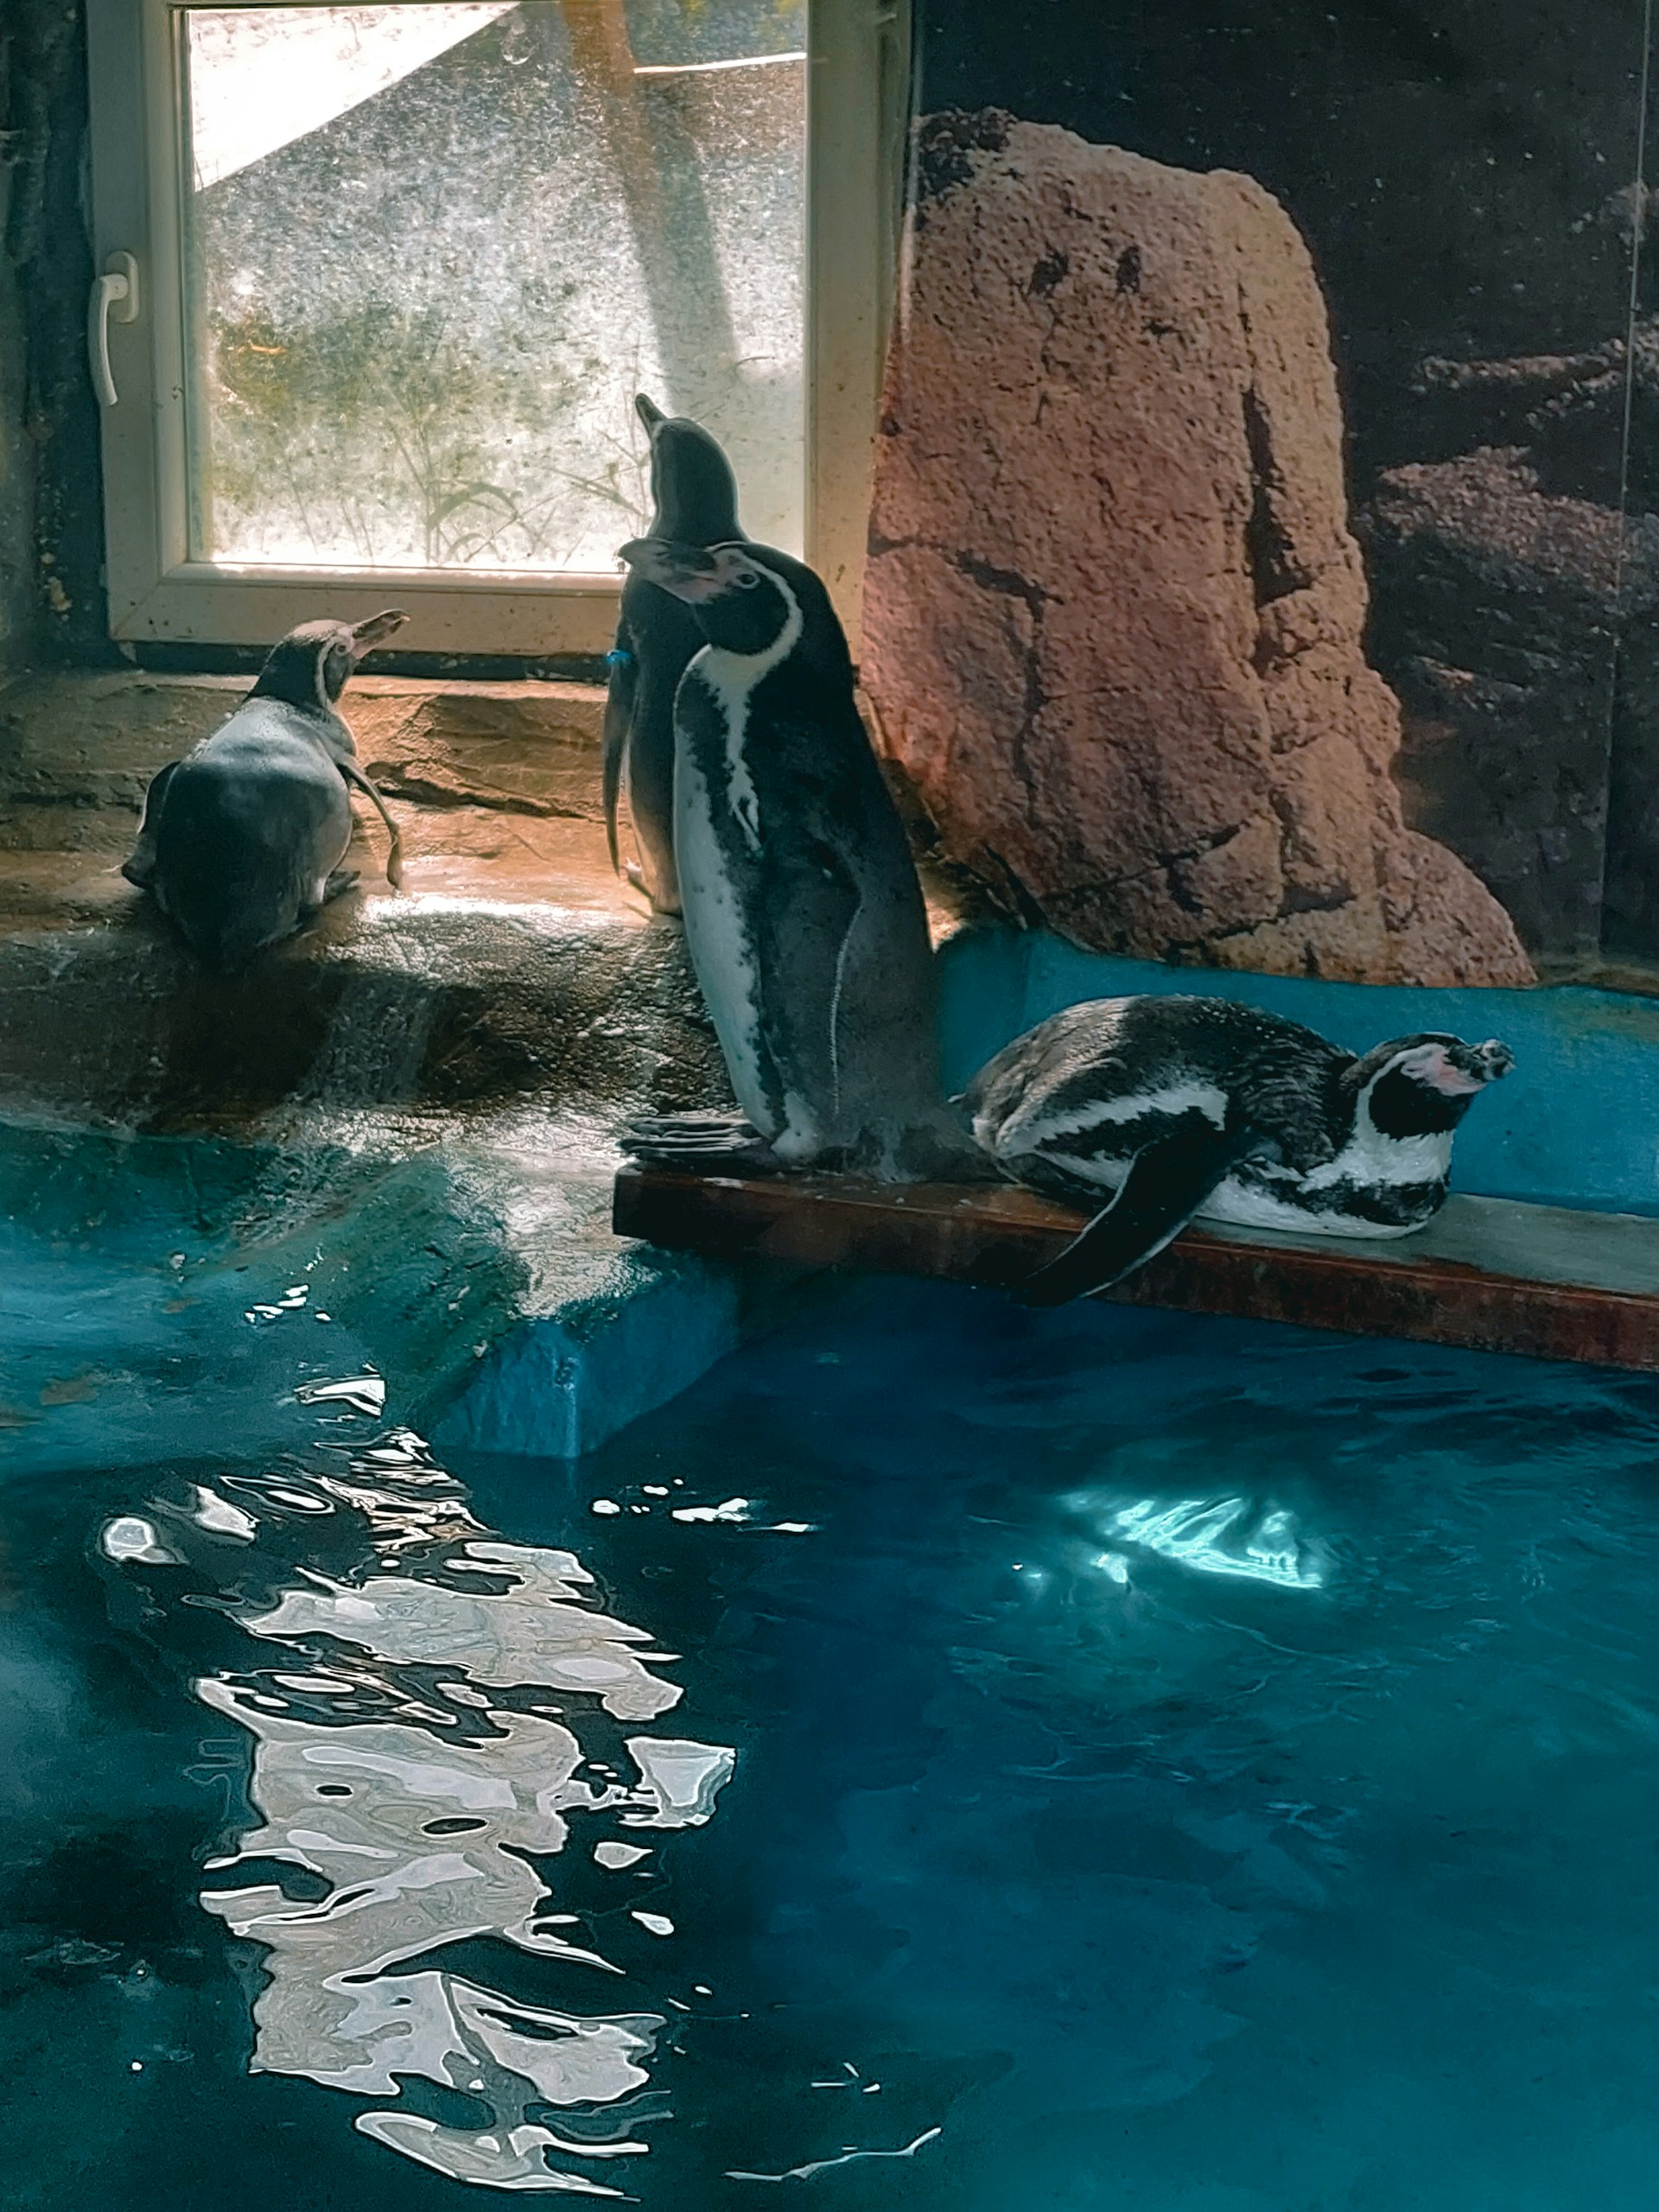

1. How many birds are visible? 4 (taxonomic) (penguins)

2. How many penguins are resting on a surface? 2 (relational) (penguins)

3. If the rock was made of glass, how many transparent objects would be visible? 1 (physical) (rock)

## Image 97 (zoo)

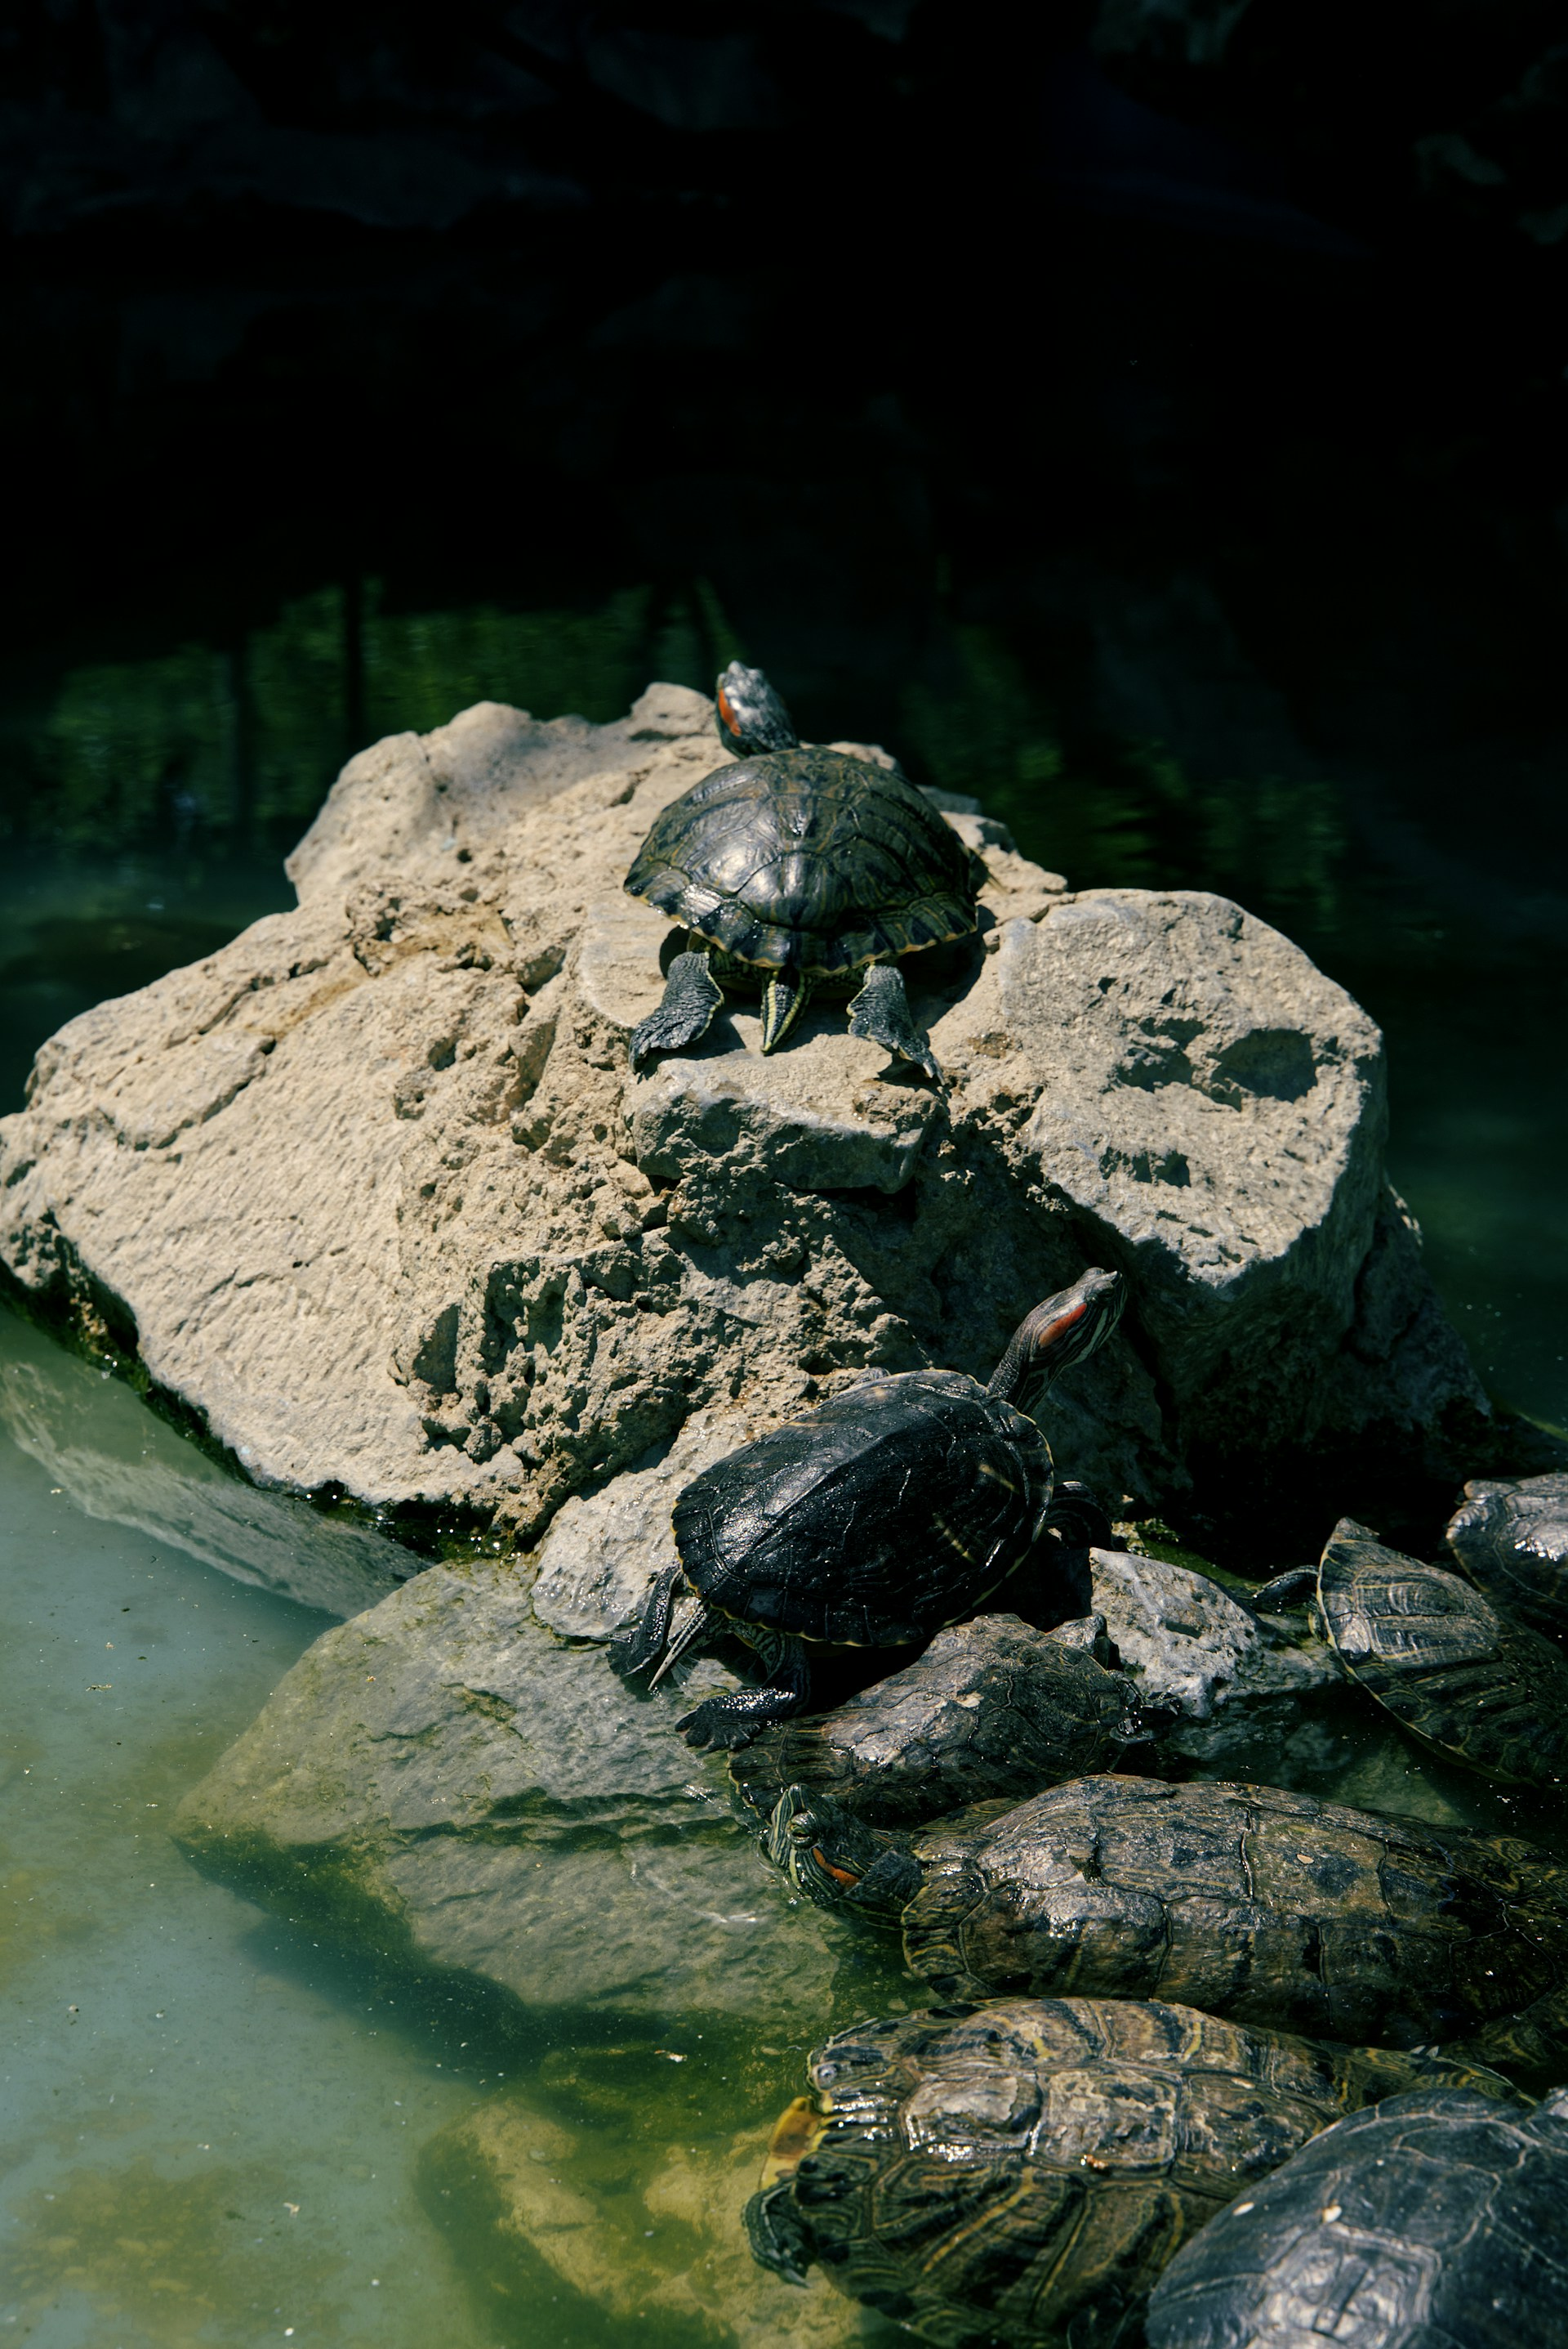

1. How many reptiles are visible? 6 (taxonomic) (turtles)

2. How many turtles are stacked on top of each other? 3 (relational) (turtles)

3. If all the turtles were flying, how many turtles would be in the air? 6 (taxonomic) (turtles)

## Image 98 (zoo)

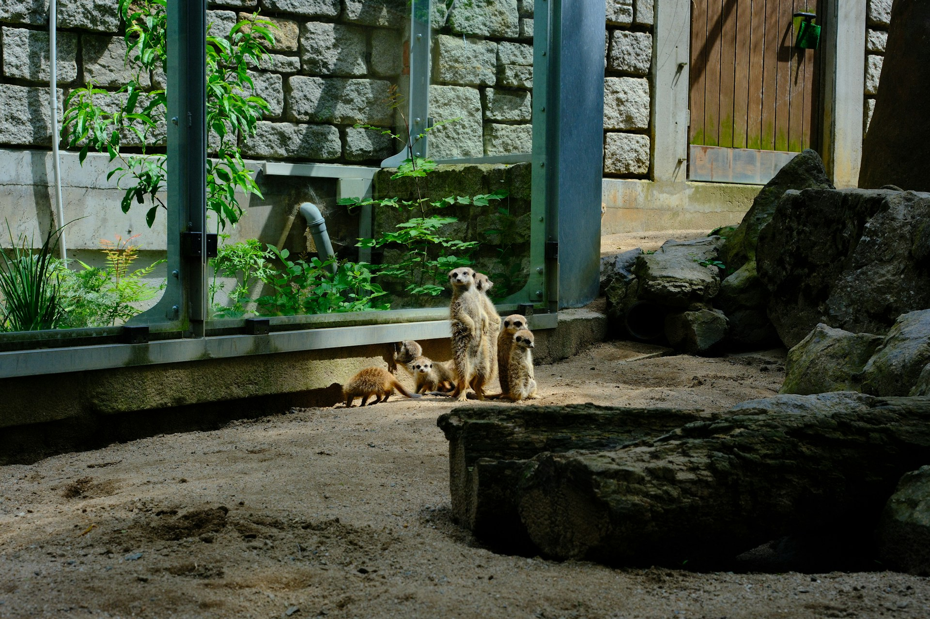

1. How many mammals are visible? 4 (taxonomic) (meerkats)

2. How many objects are standing on the ground? 3 (relational) (meerkats)

3. If the rocks were made of soft clay, how many malleable objects would be visible? 5 (physical) (rocks and meerkats)

## Image 99 (laboratory)

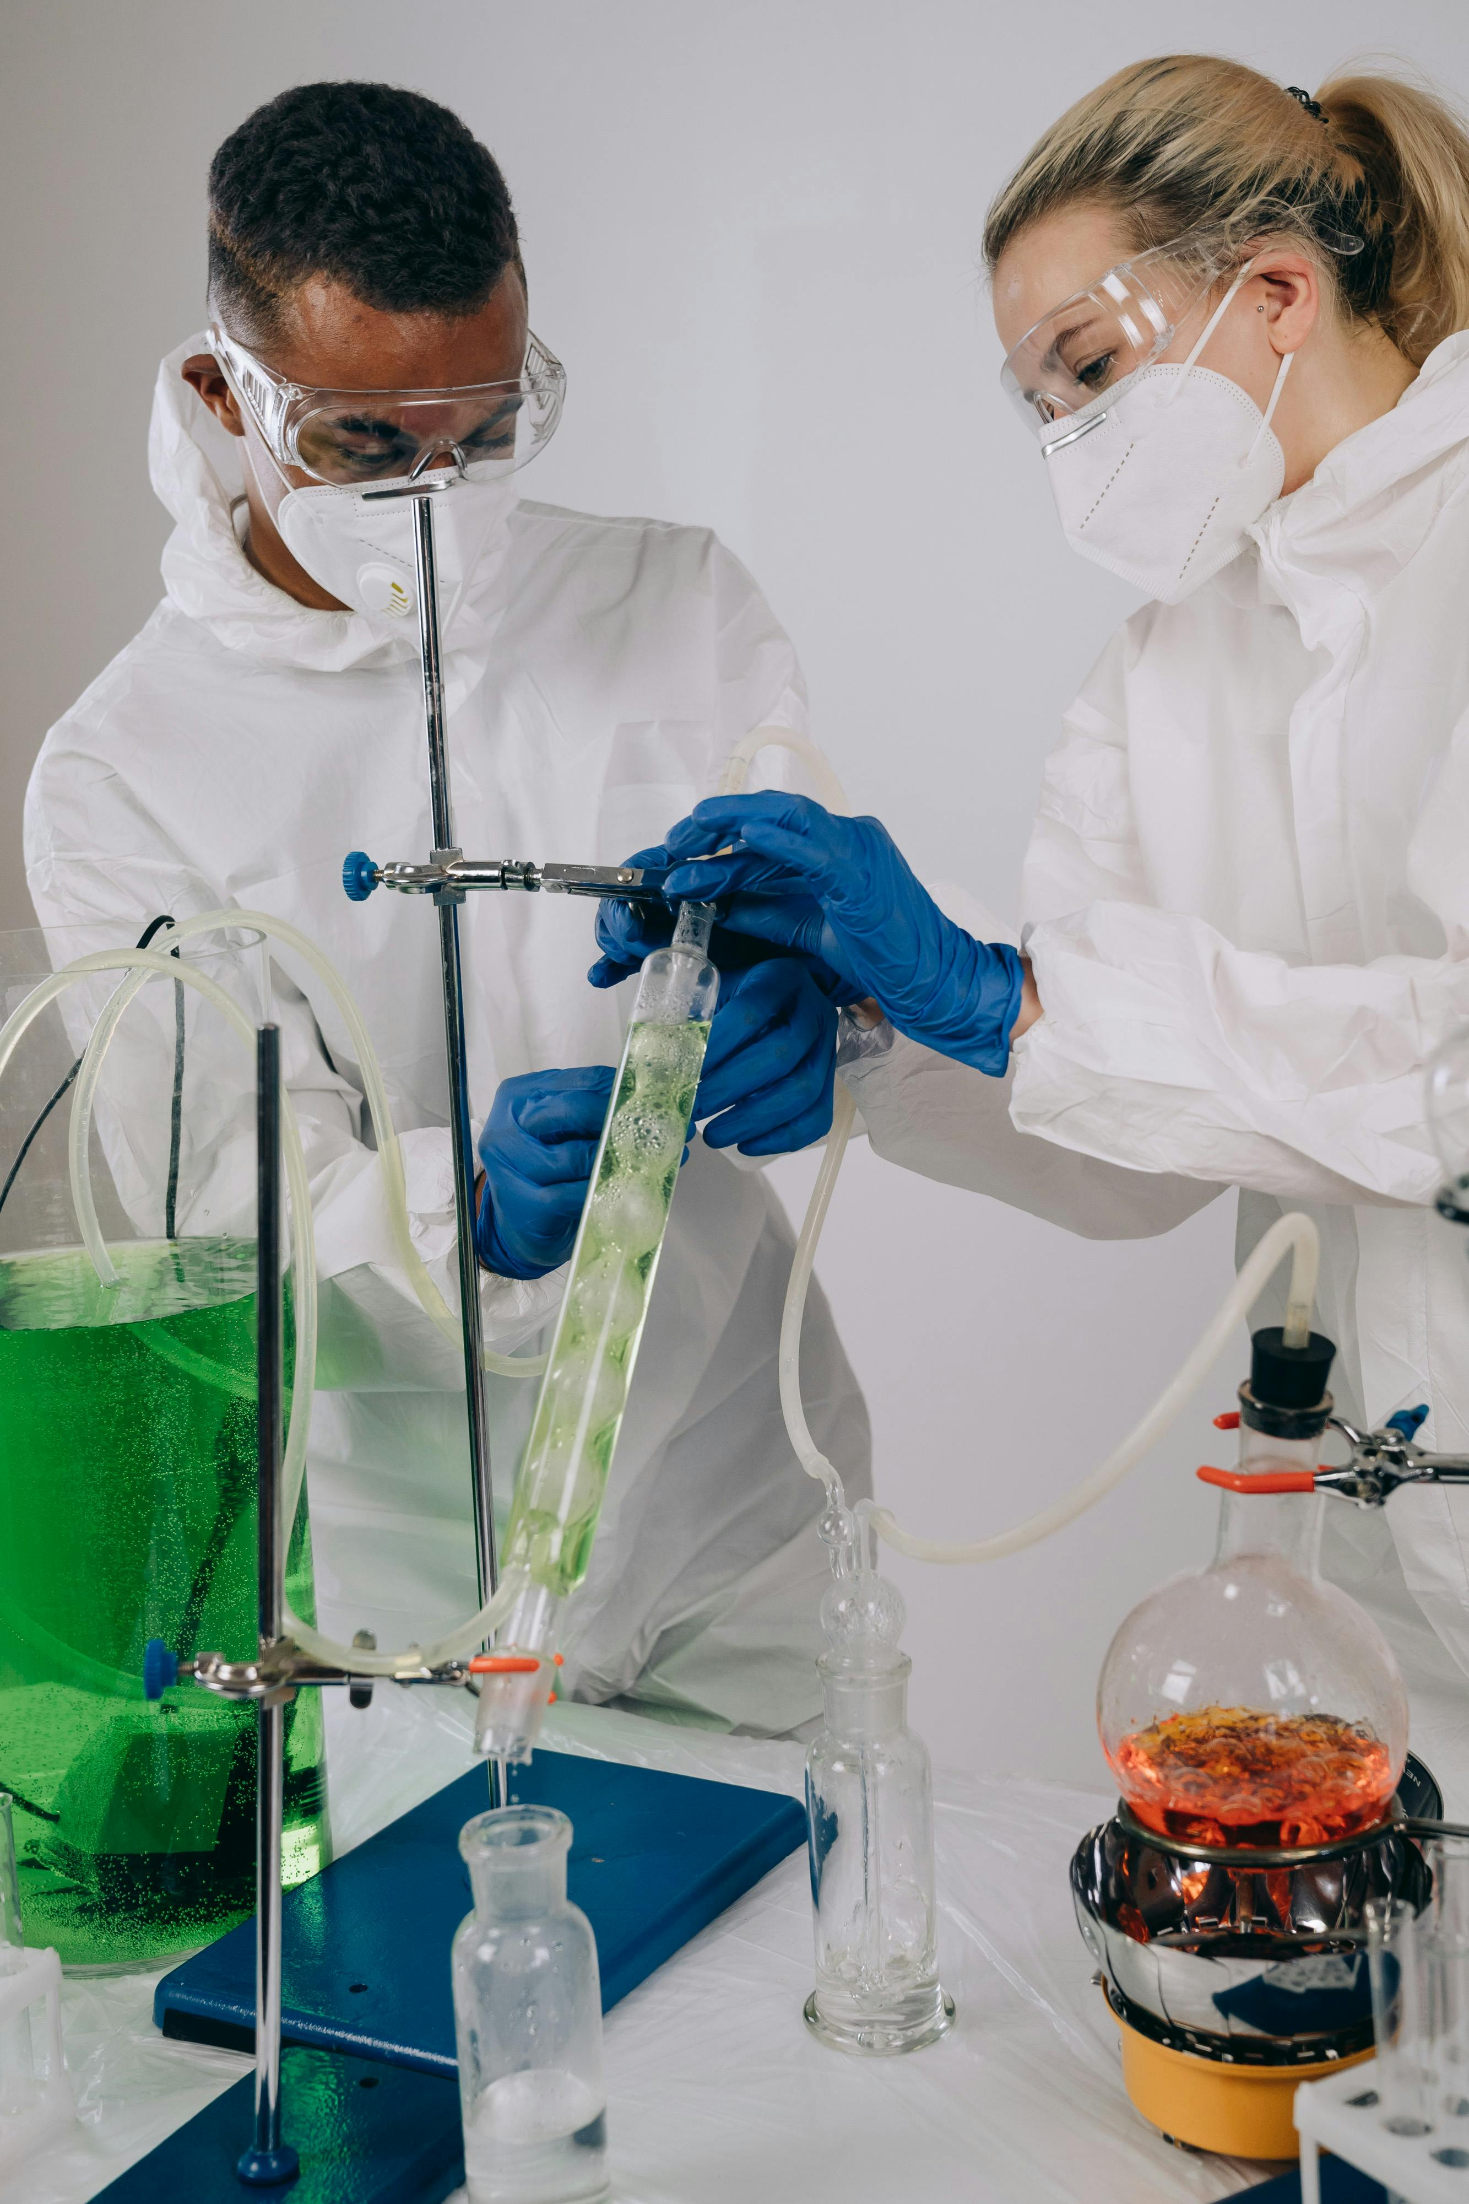

1. How many items made of glass are present? 5 (physical) (beakers/flasks)

2. How many people wearing protective eyewear are visible? 2 (functional) (scientists)

3. If the green liquid was removed from the large container, how many containers holding liquid would be visible? 3 (relational) (containers)

## Image 100 (laboratory)



1. How many objects made of glass are present? 5 (physical) (beakers/test tubes)

2. How many people wearing protective gear are visible? 2 (functional) (scientists)

3. If the microscope was not present, how many open books would be visible? 1 (relational) (notebook)

## Image 101 (laboratory)



1. How many glass objects are present? 3 (taxonomic) (bottles, flask)

2. How many containers can hold liquid are visible? 4 (functional) (bottles, bowl)

3. If the bottles were all clear instead of amber, how many transparent objects would be visible? 6 (physical) (bottles, flask, bowl)

## Image 102 (laboratory)

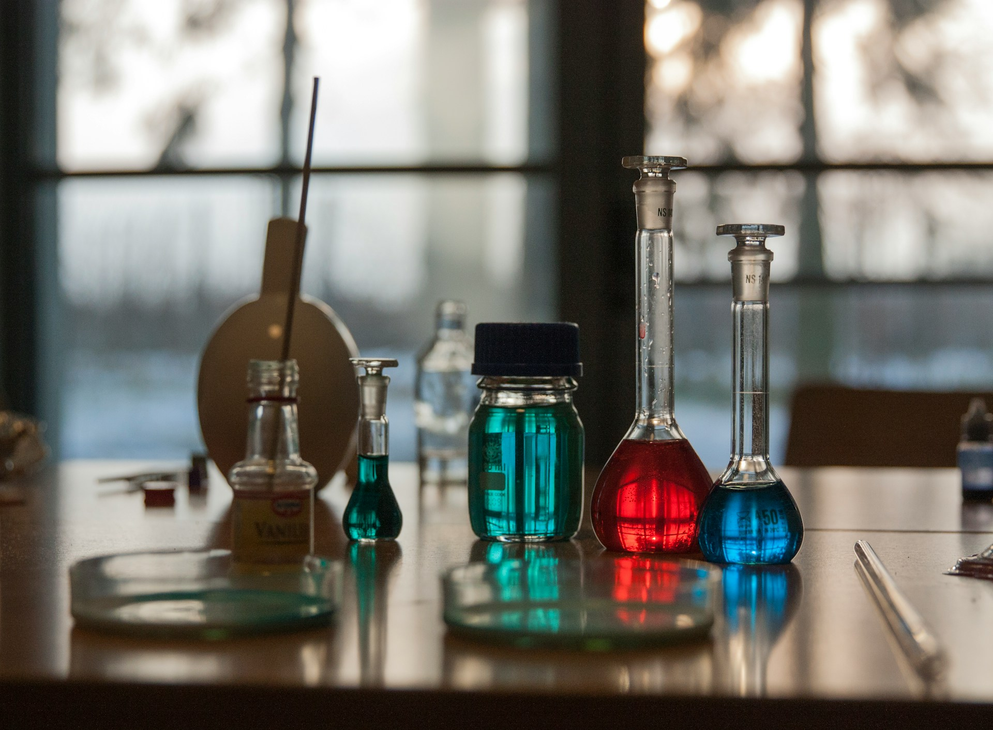

1. How many objects made of glass are present? 6 (physical) (flasks and bottles)

2. How many objects are sitting on a circular surface? 4 (relational) (flasks and bottles)

3. If all the liquids were removed from the containers, how many empty containers would be visible? 6 (functional) (flasks and bottles)

## Image 103 (market)

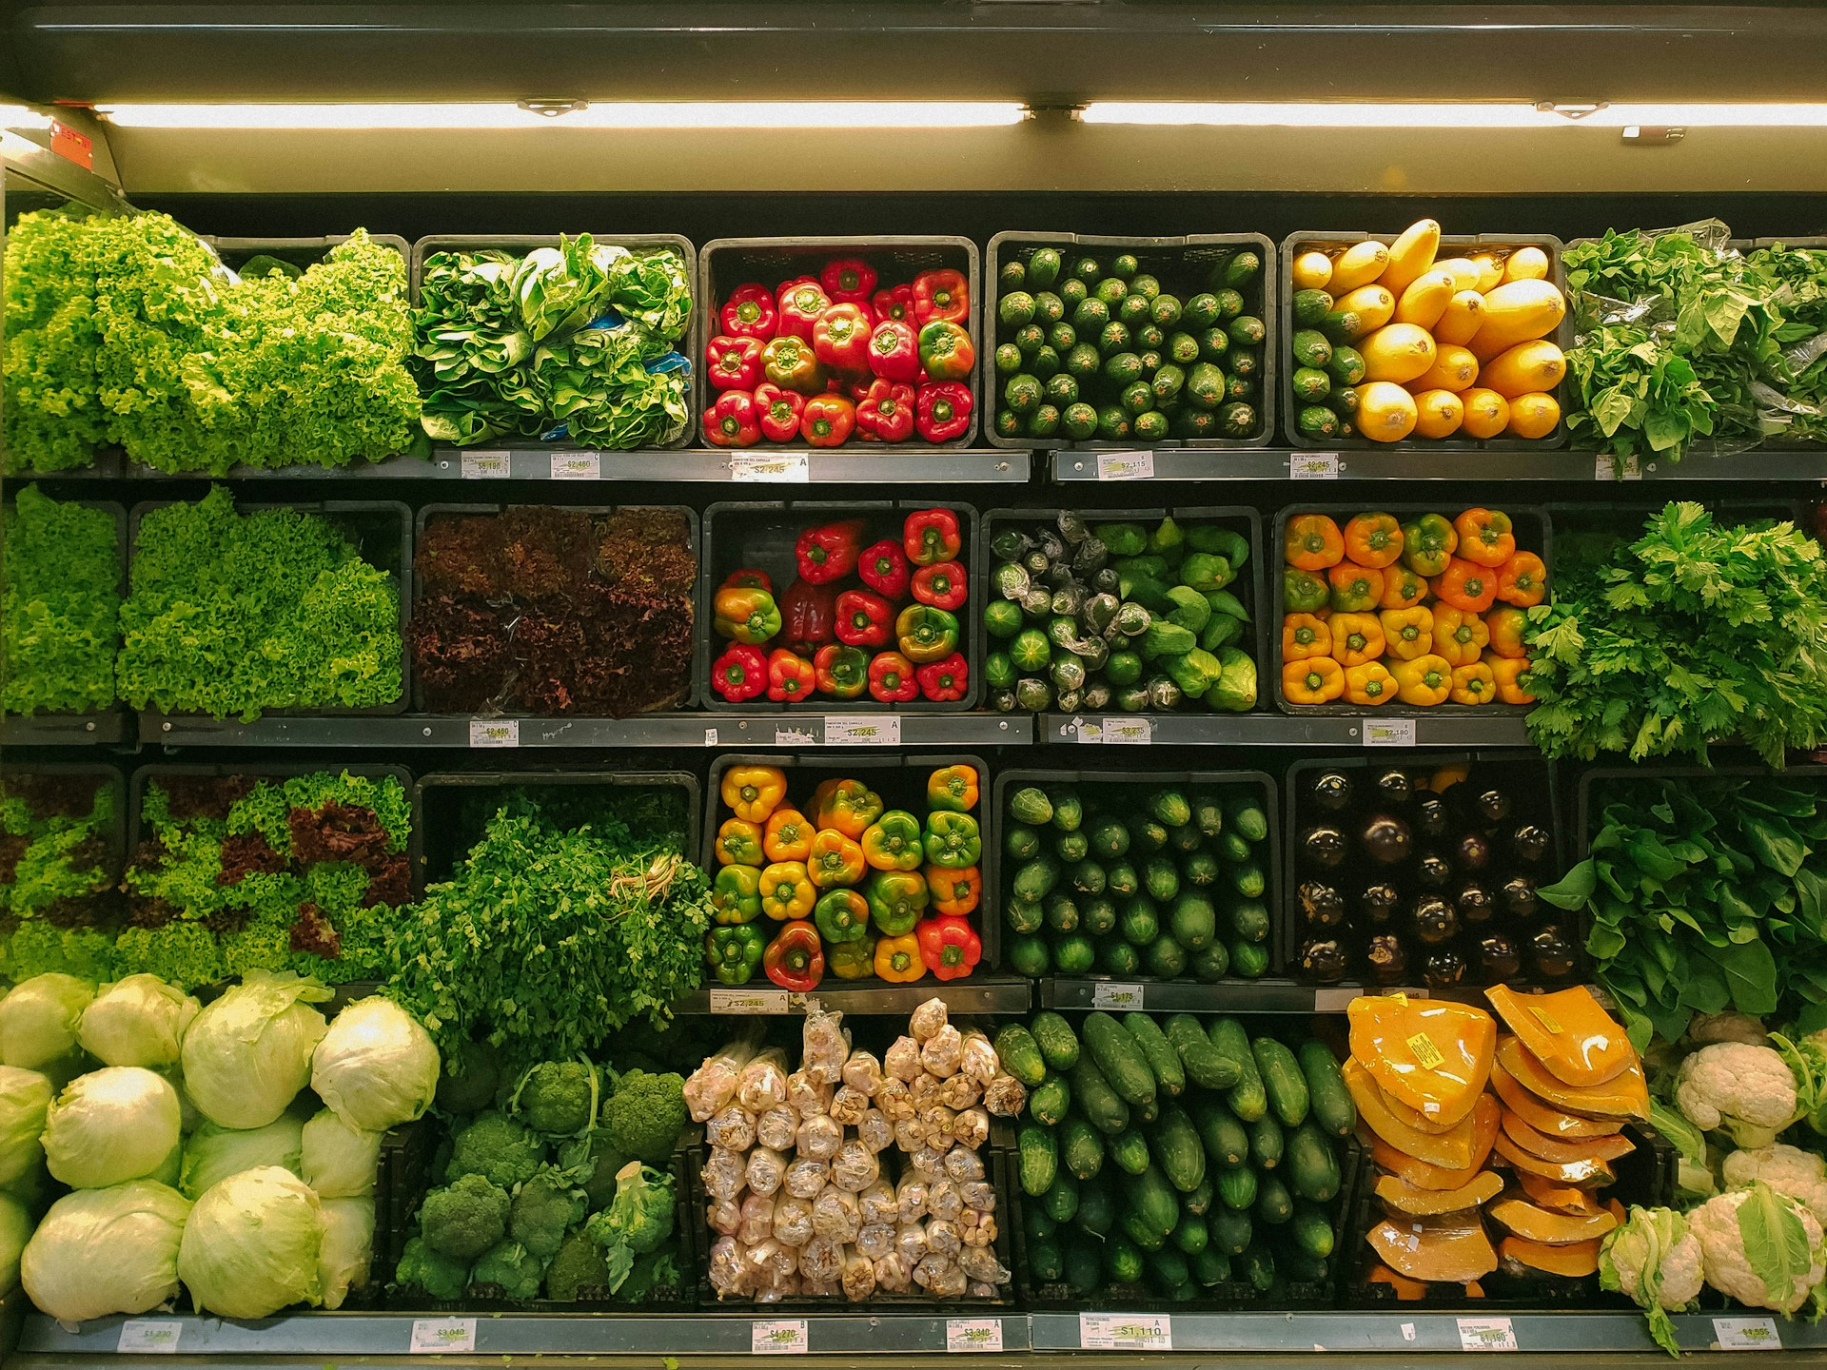

1. How many items are vegetables? 24 (taxonomic) (types of vegetables)

2. How many containers are holding produce? 24 (relational) (black plastic containers)

3. If all the yellow bell peppers were red, how many red bell peppers would there be? 12 (taxonomic) (bell peppers)

## Image 104 (urban)

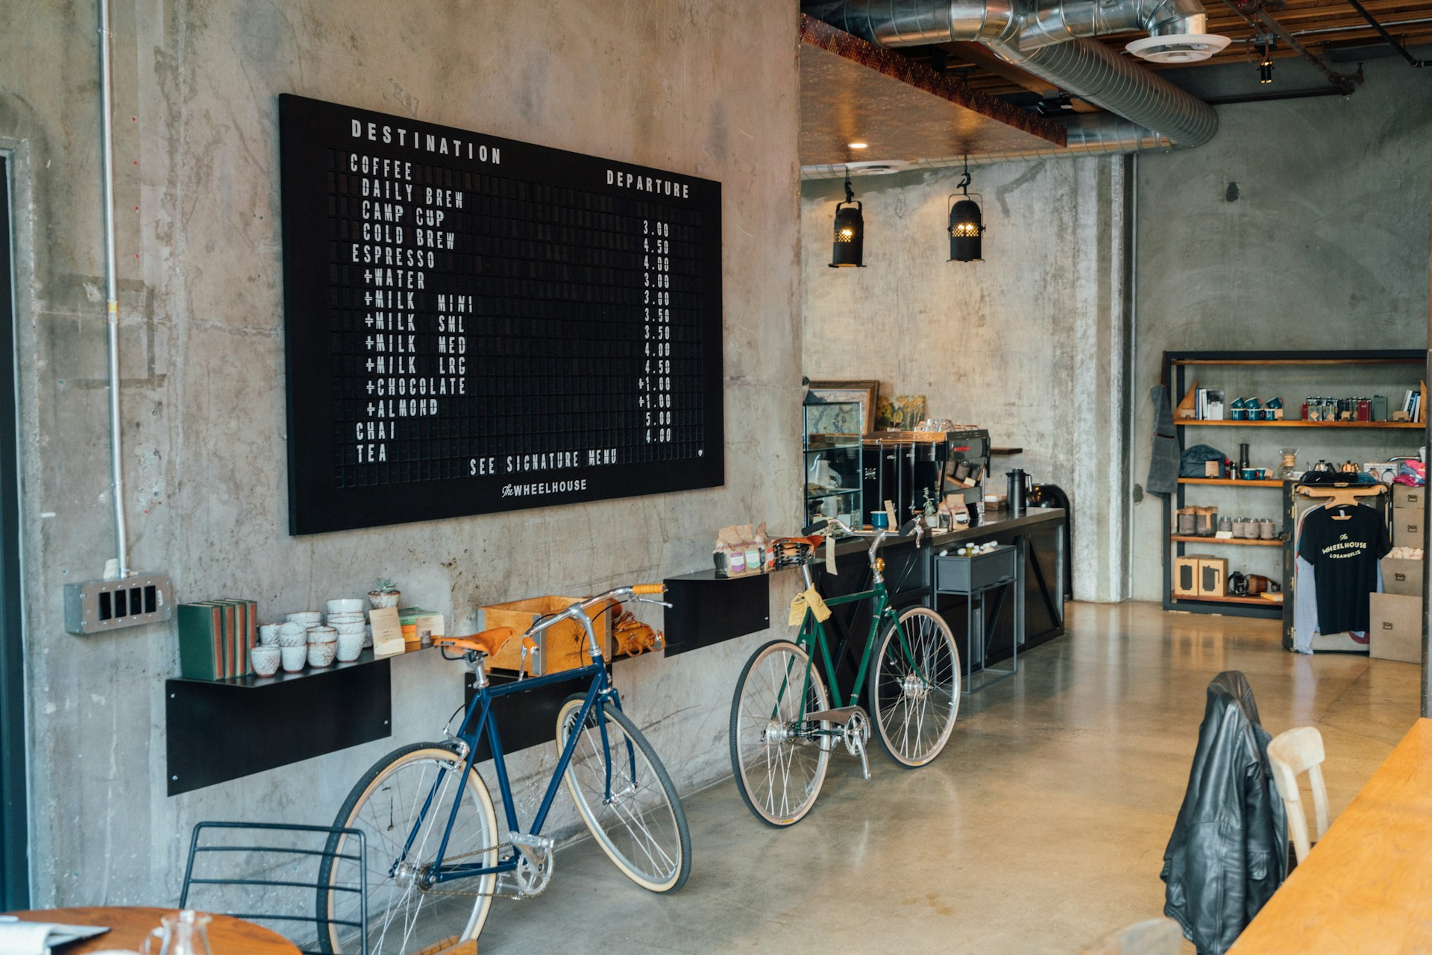

1. How many bicycles are visible? 2 (taxonomic) (vehicles)

2. How many items are on top of the shelf to the right of the counter? 8 (relational) (containers)

3. If the chalkboard menu was not present, how many wall-mounted objects would be visible? 2 (relational) (light fixtures)

## Image 105 (kitchen)

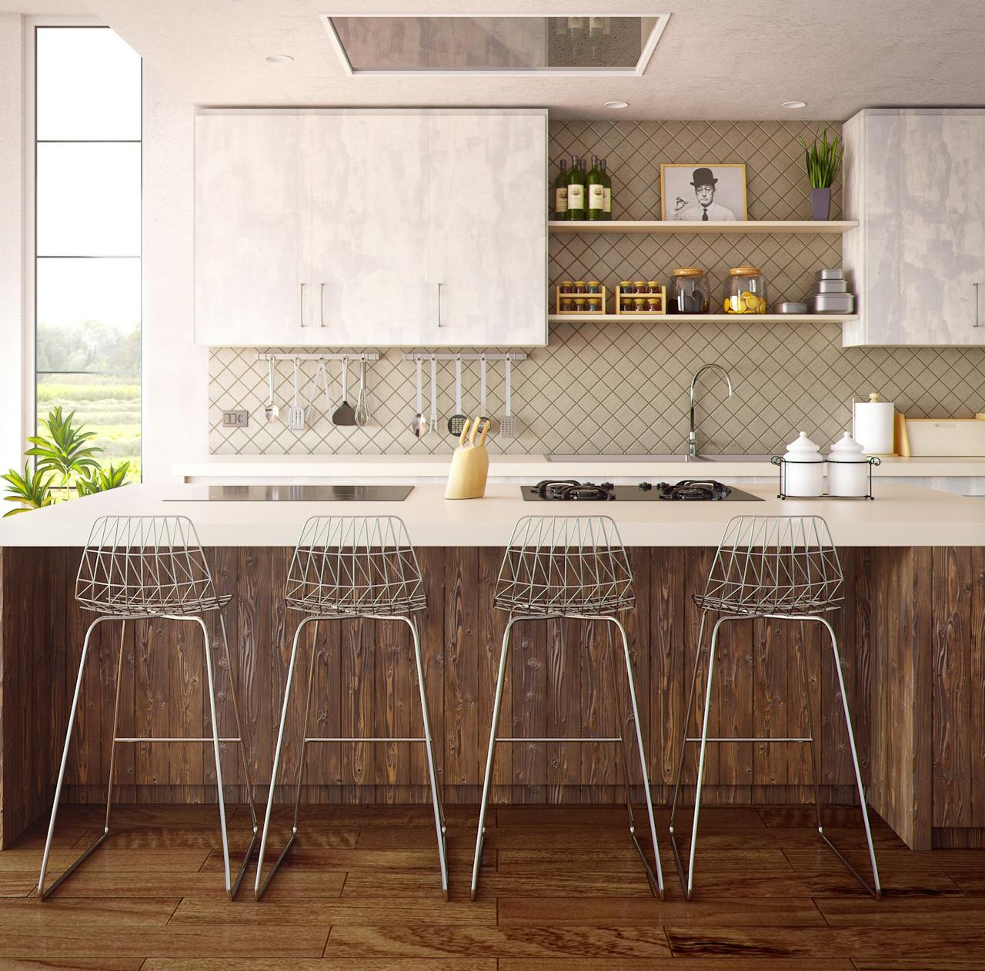

1. How many chairs with metal legs are present? 4 (taxonomic) (chairs)

2. How many items are on top of the kitchen counter? 7 (relational) (jars, canisters, spice containers)

3. If the kitchen backsplash tiles were a different color, how many tiles would still be visible? 30 (physical) (tiles)

## Image 106 (kitchen)

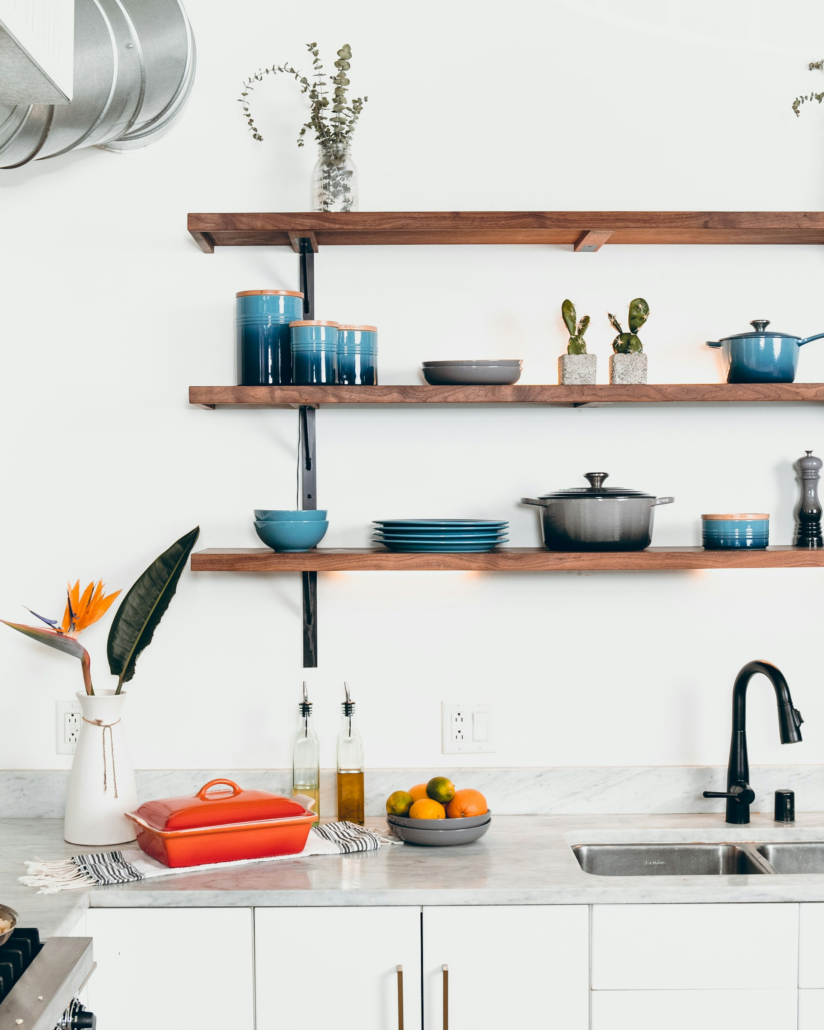

1. How many objects made of ceramic are present? 6 (physical) (pots/pans)

2. How many items are placed on top of the shelves? 11 (relational) (objects)

3. If the oranges were replaced with apples, how many fruits would be visible? 4 (taxonomic) (fruits)

## Image 107 (kitchen)

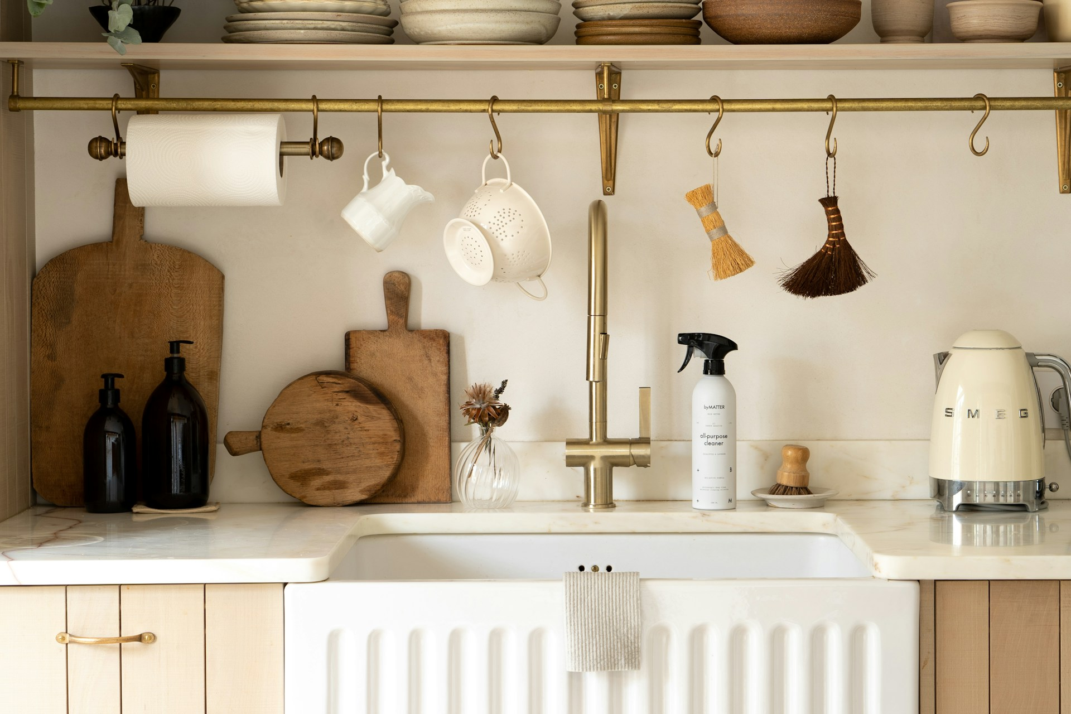

1. How many objects made of wood are present? 4 (physical) (cutting boards)

2. How many items are hanging from the rail? 6 (relational) (brushes and mugs)

3. If the kettle was blue instead of cream, how many cream-colored objects would be visible? 2 (physical) (kettle and soap dispenser)

## Image 108 (kitchen)

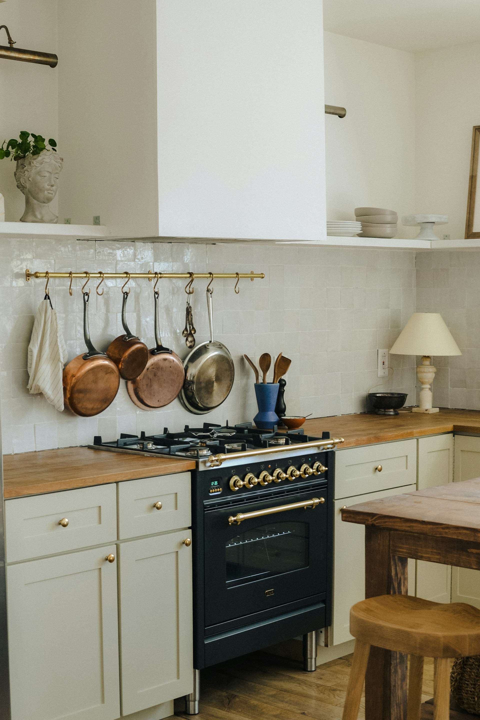

1. How many items made of metal are present? 8 (physical) (pots and pans)

2. How many items are hanging above the stove? 5 (relational) (pots, pans, and towels)

3. If the wooden spoons were replaced with metal spatulas, how many metal items would be visible? 13 (taxonomic) (pots, pans, stove details, and spatulas)

## Image 109 (kitchen)

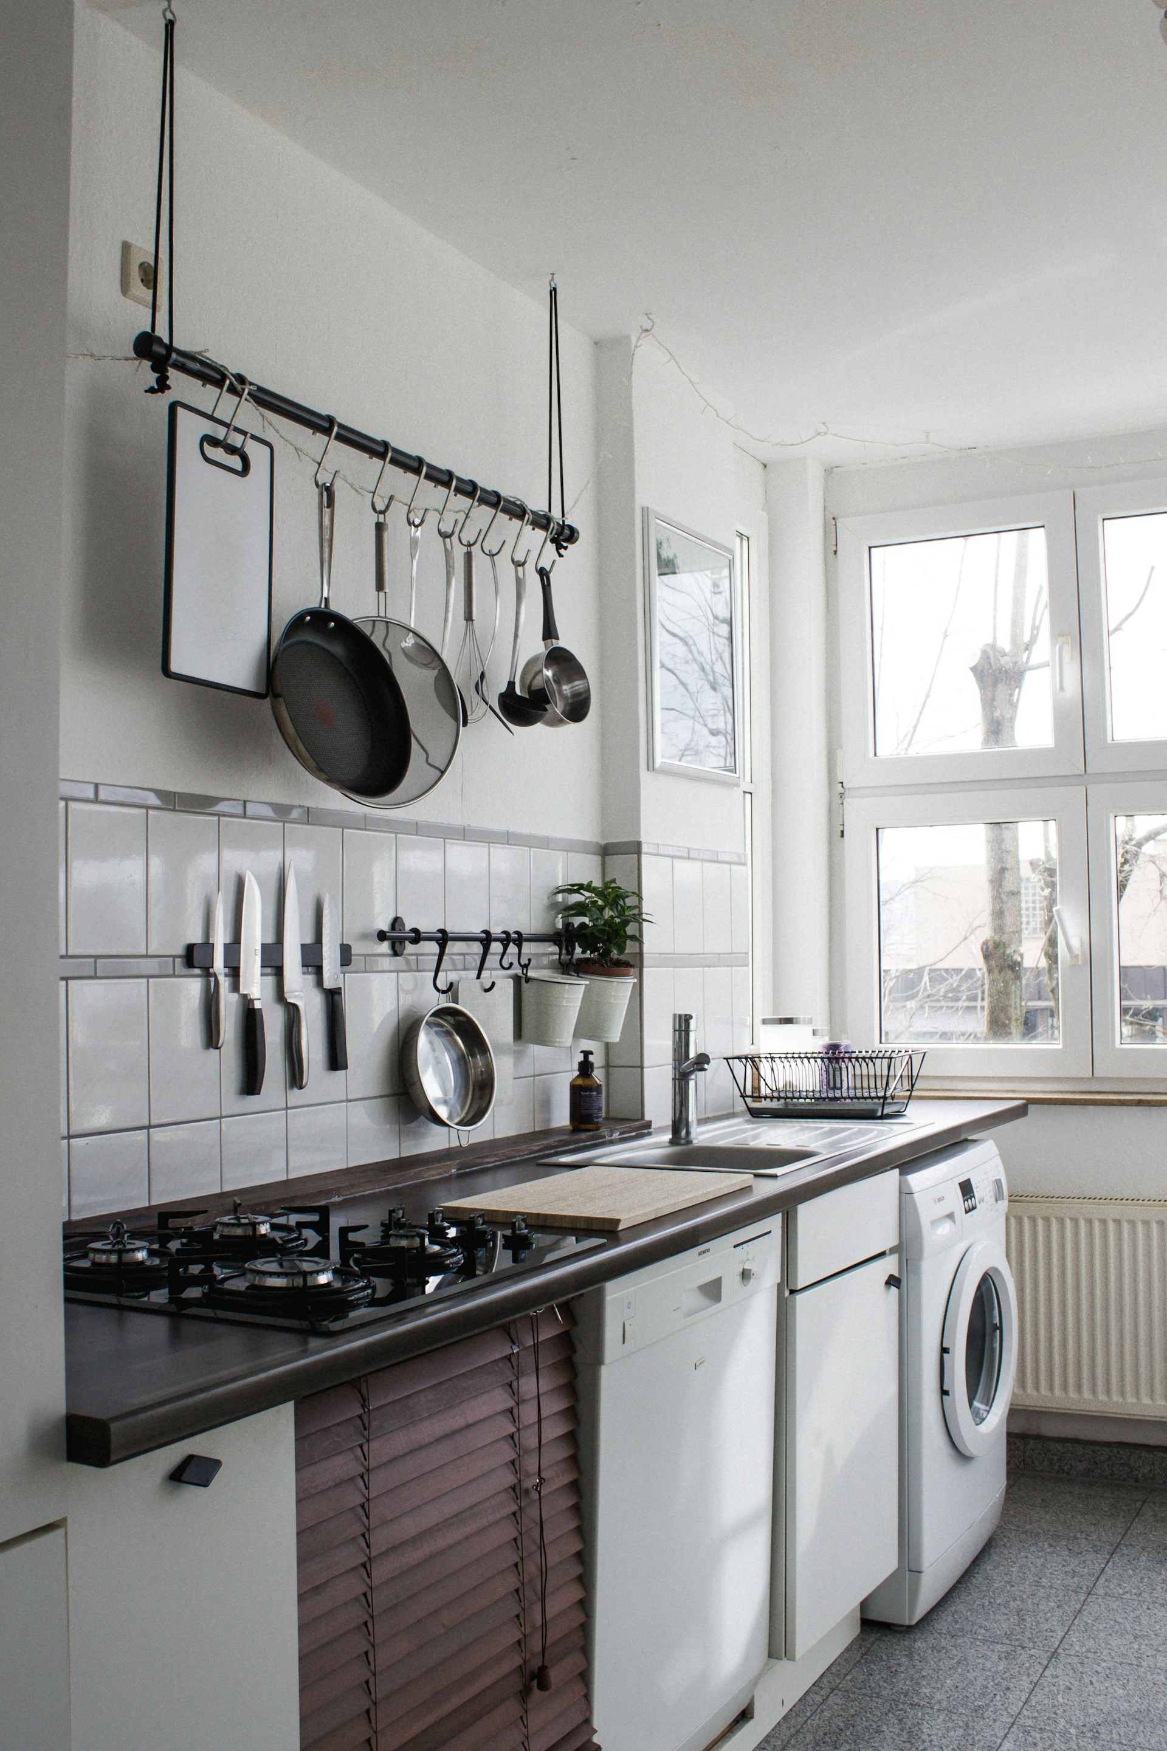

1. How many items made of metal are present? 12 (physical) (pots, pans, and utensils)

2. How many items are hanging on the wall? 10 (relational) (pots, pans, and utensils)

3. If the washing machine was a different color, how many white appliances would be visible? 2 (taxonomic) (dishwasher and washing machine)

## Image 110 (kitchen)

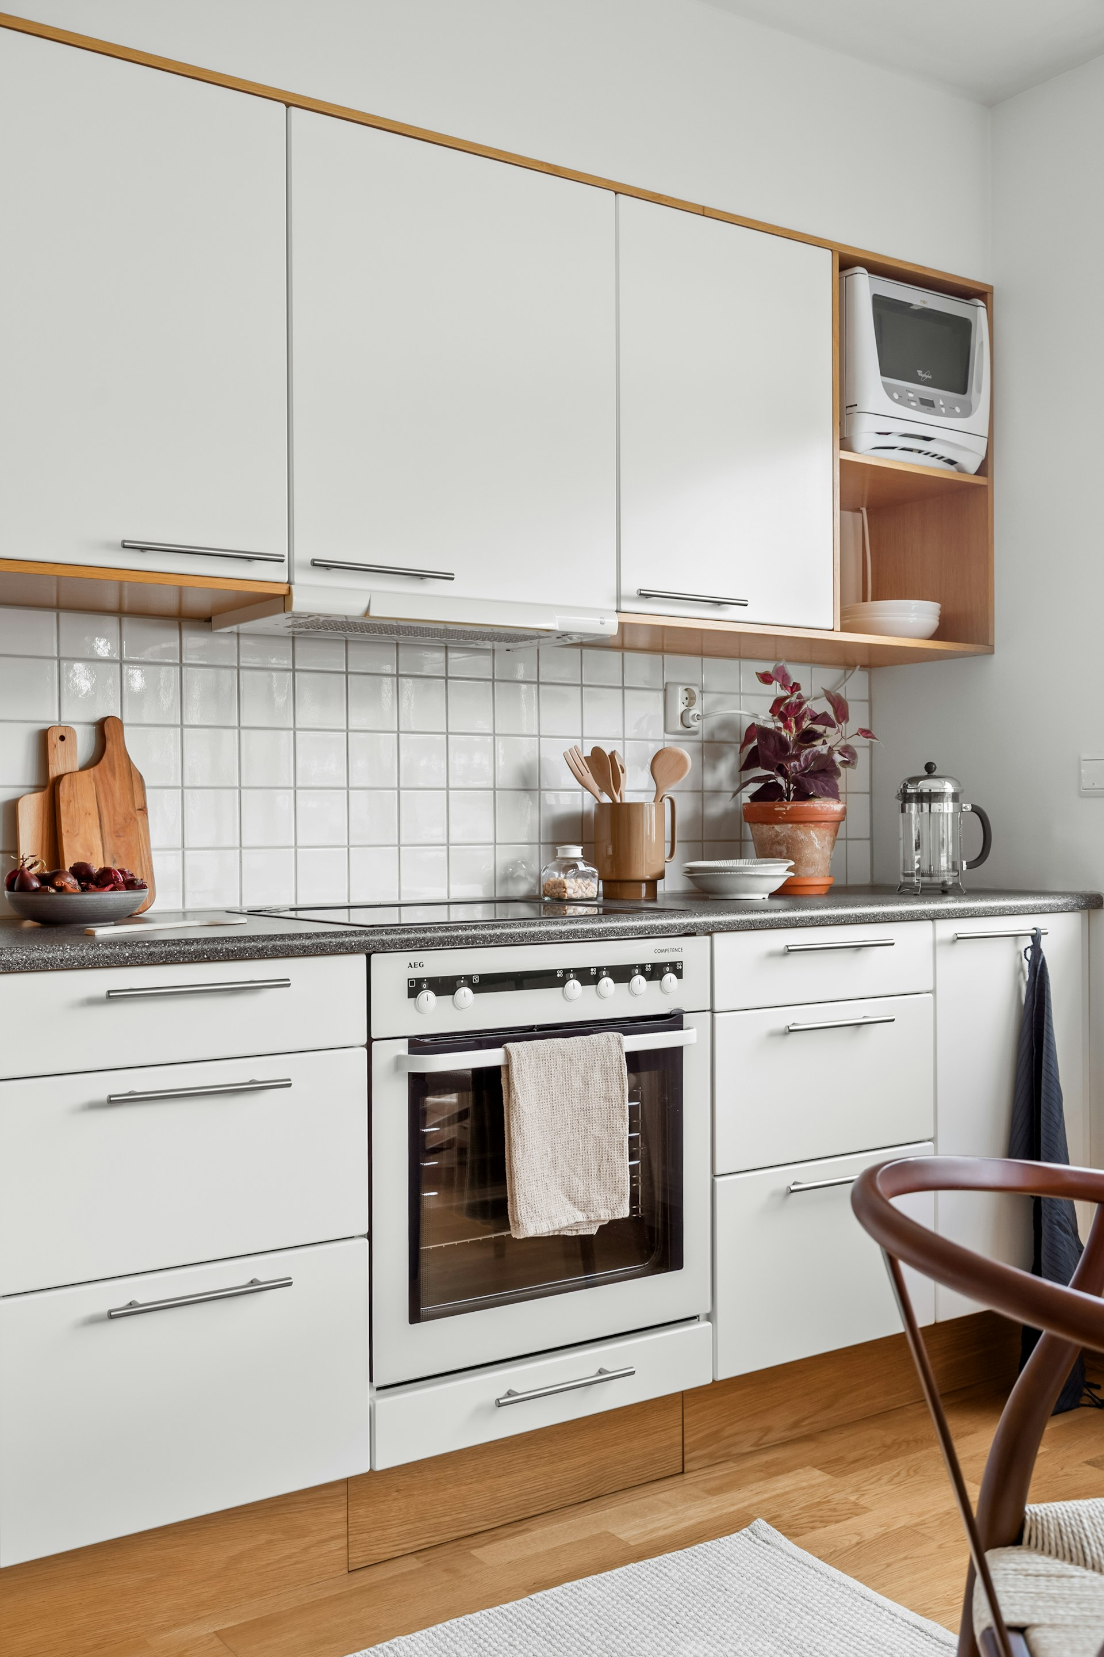

1. How many cabinets are present? 6 (taxonomic) (kitchen cabinets)

2. How many items are on top of the countertop? 7 (relational) (objects)

3. If the towel hanging on the oven door were a different color, how many white objects would be visible? 11 (physical) (objects)

## Image 111 (tech)

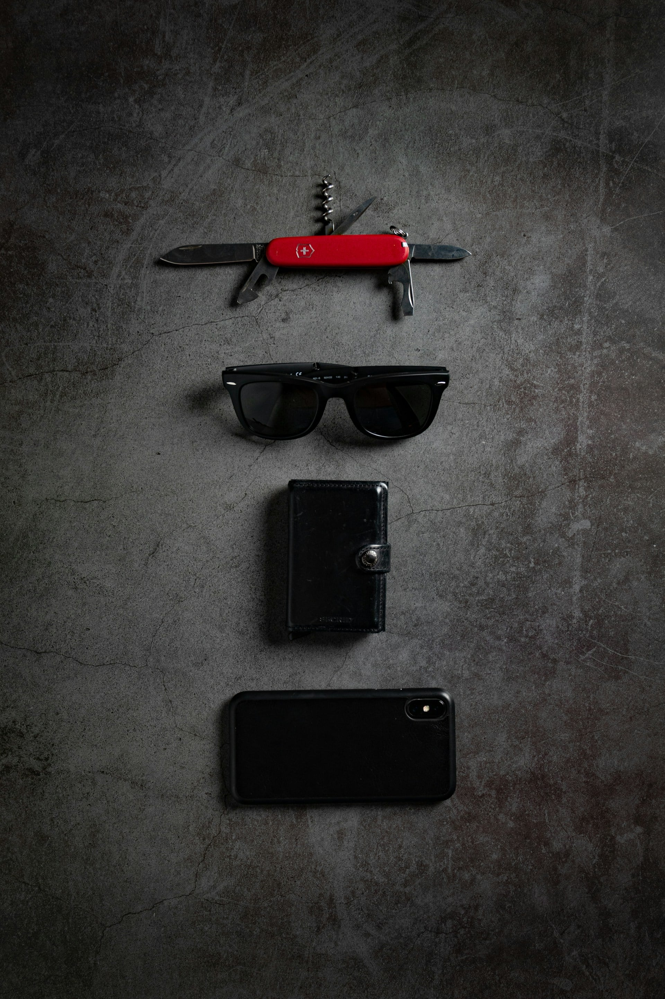

1. How many objects made of metal are present? 4 (physical) (knife, sunglasses, wallet clasp, phone frame)

2. How many objects can hold small personal items? 2 (functional) (wallet, phone)

3. If the sunglasses were replaced with a hat, how many wearable objects would be visible? 1 (relational) (hat)

## Image 112 (tools)

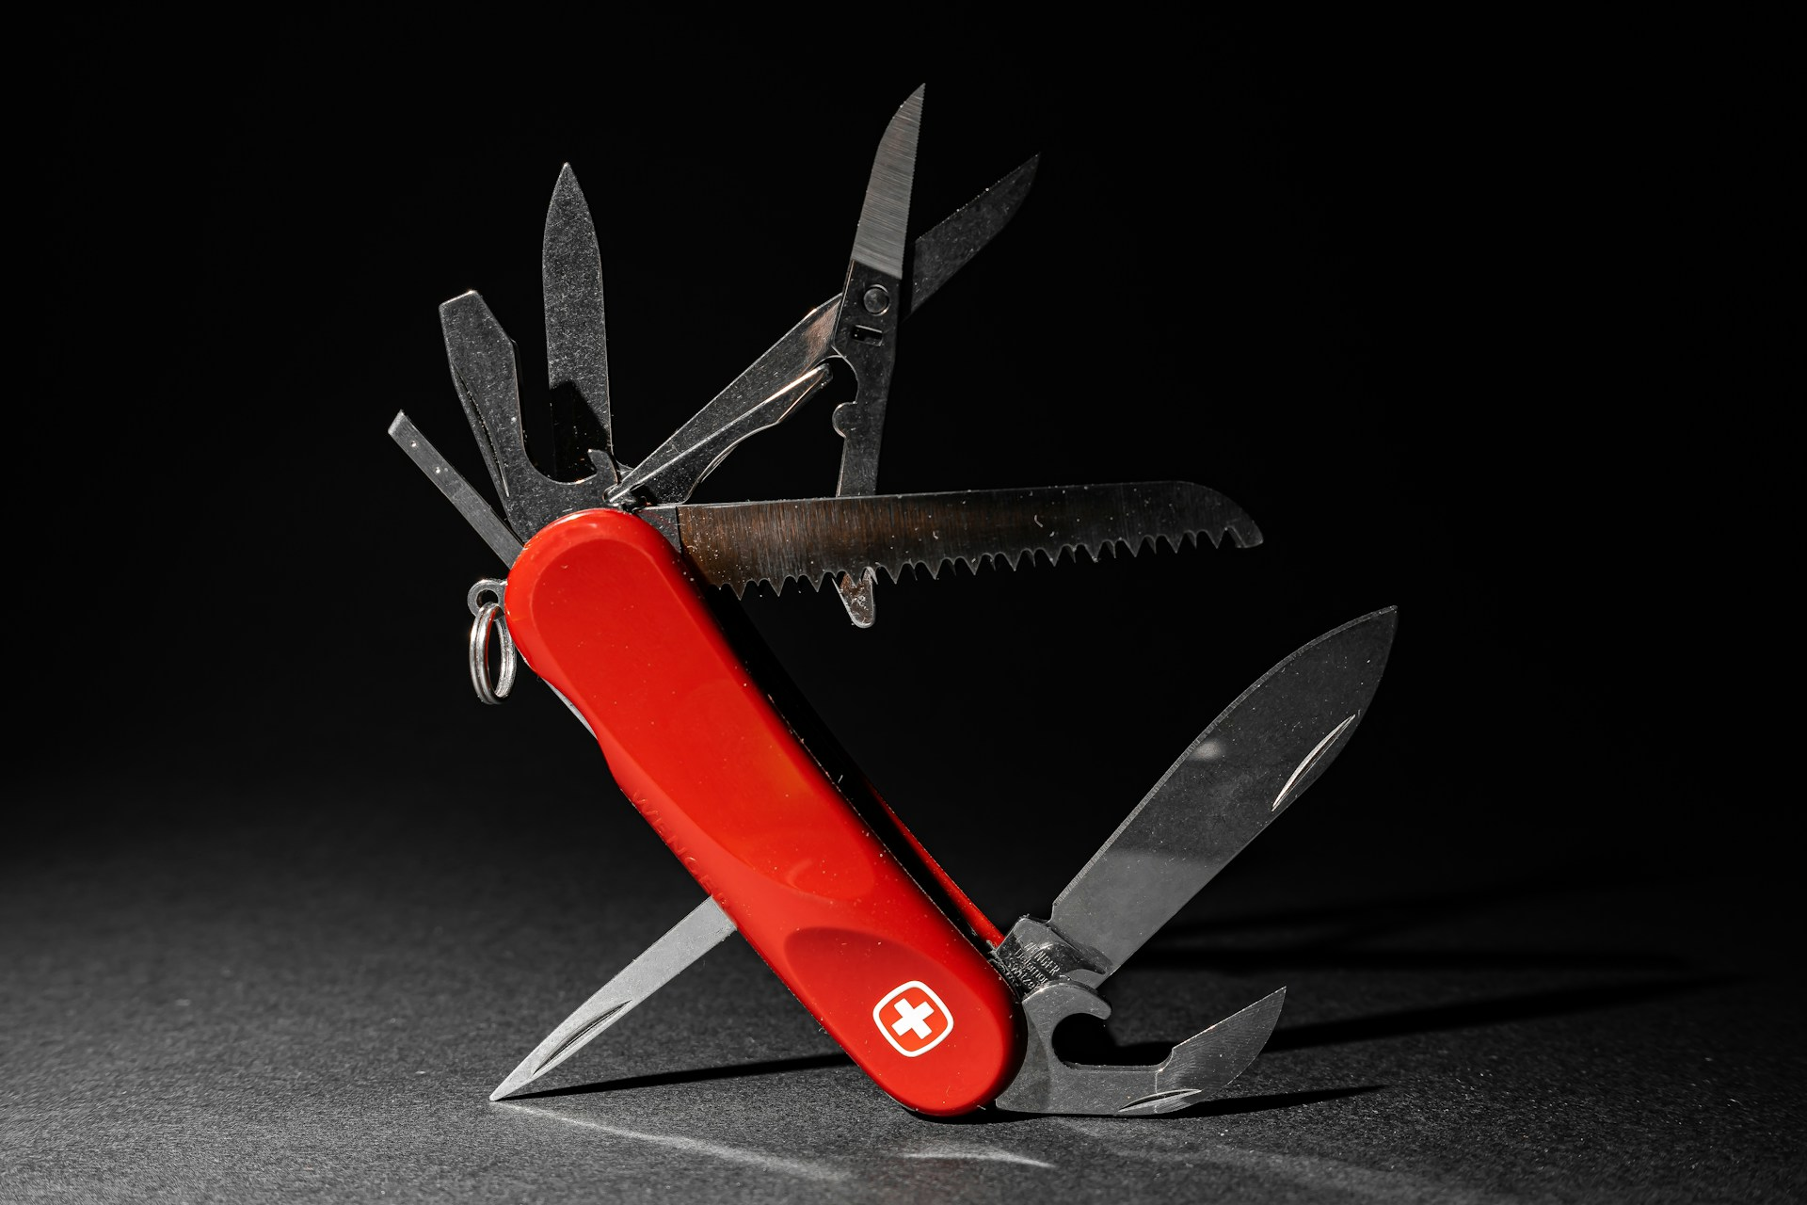

1. How many objects made of metal are present? 7 (physical) (knife blades and tools)

2. How many tools that can be opened are visible? 6 (functional) (knife tools)

3. If the red handle was made of wood instead of plastic, how many objects would be made of wood? 1 (physical) (handle)

## Image 113 (gardening)

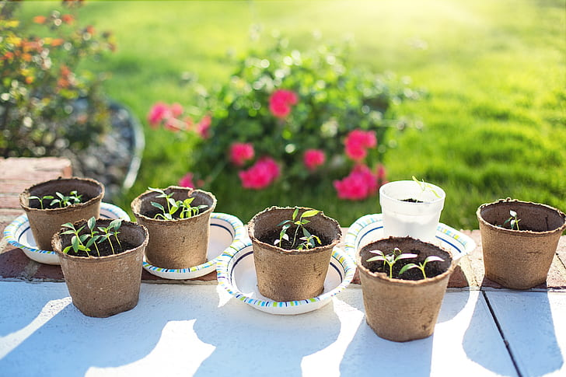

1. How many pots made of biodegradable material are present? 6 (physical) (pots)

2. How many pots are sitting on saucers? 2 (relational) (pots and saucers)

3. If all the plants were fully grown rose bushes, how many rose bushes would be visible? 7 (taxonomic) (plants)

## Image 114 (bedroom)

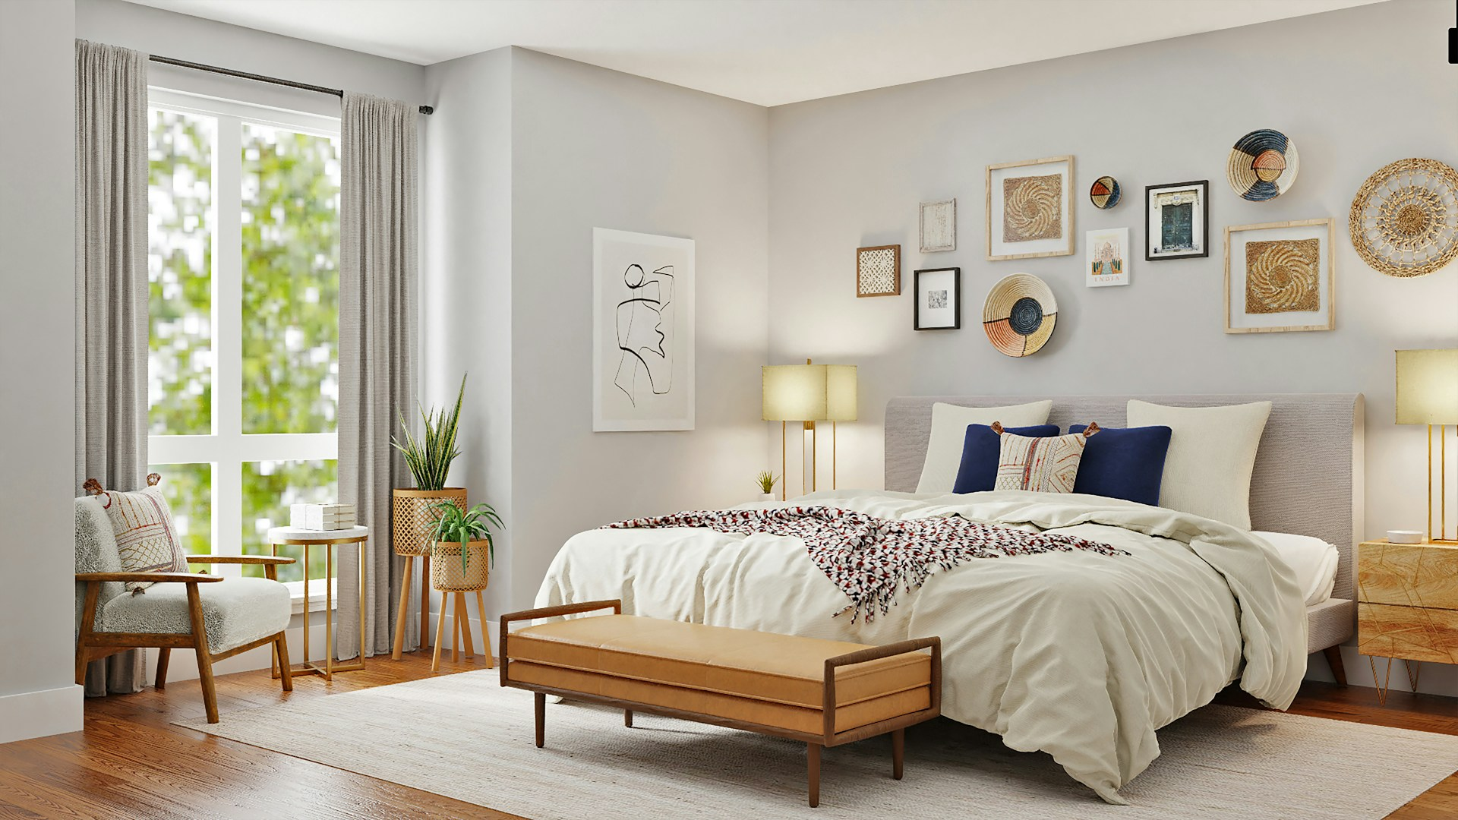

1. How many pieces of furniture are present? 6 (taxonomic) (bed, bench, chair, 2 nightstands, side table)

2. How many items are on top of other items? 5 (relational) (lamps on nightstands, books on side table, blanket on bed, pillows on bed, plant in basket)

3. If all the wall art was replaced with mirrors, how many reflective surfaces would be visible? 9 (physical) (mirrors)

## Image 115 (biking)

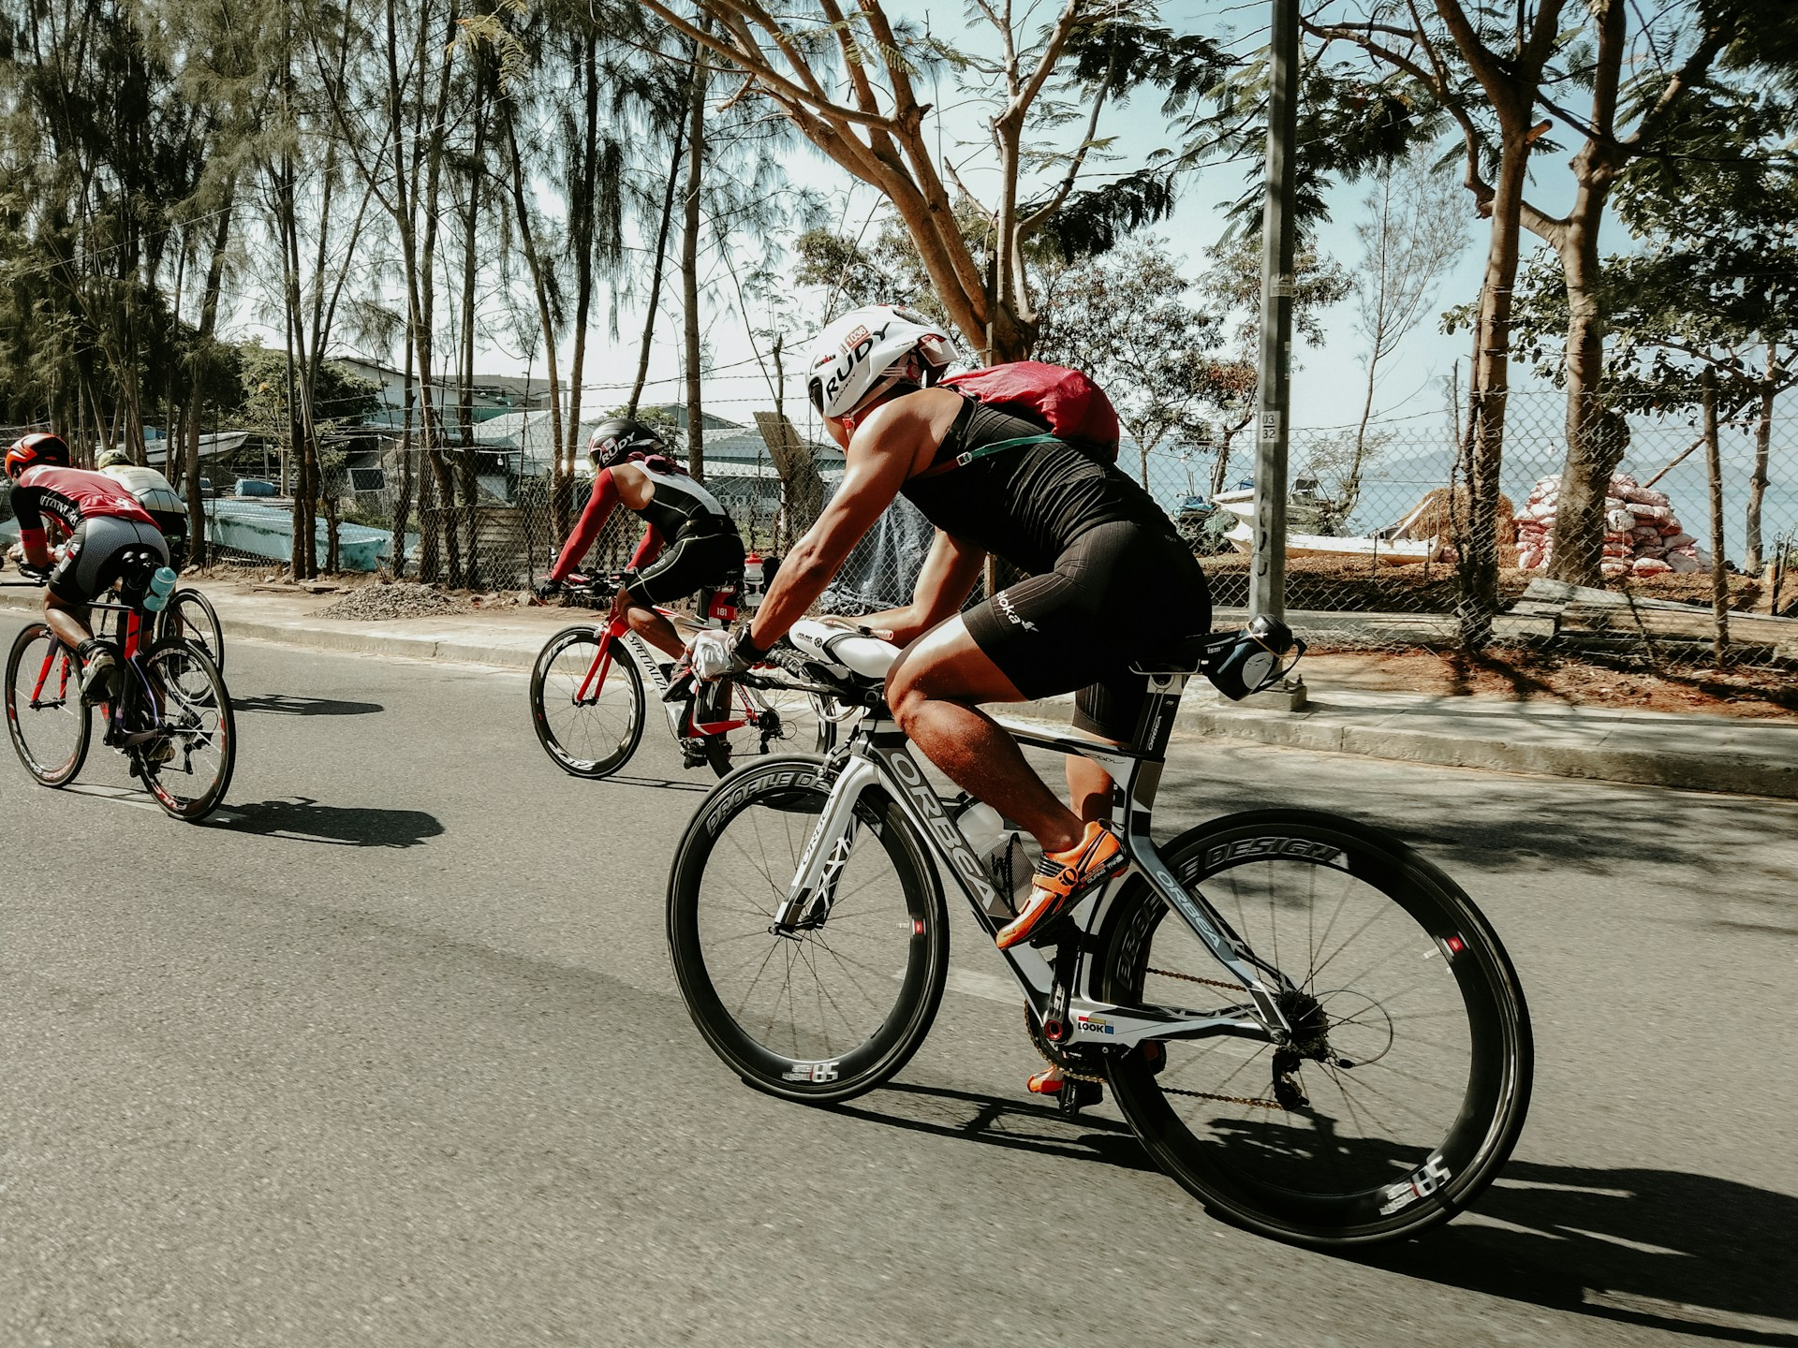

1. How many vehicles with wheels are present? 4 (taxonomic) (bicycles)

2. How many people are wearing helmets? 3 (functional) (cyclists)

3. If the trees were removed from the background, how many visible vertical structures would remain? 2 (physical) (light poles)

## Image 116 (biking)

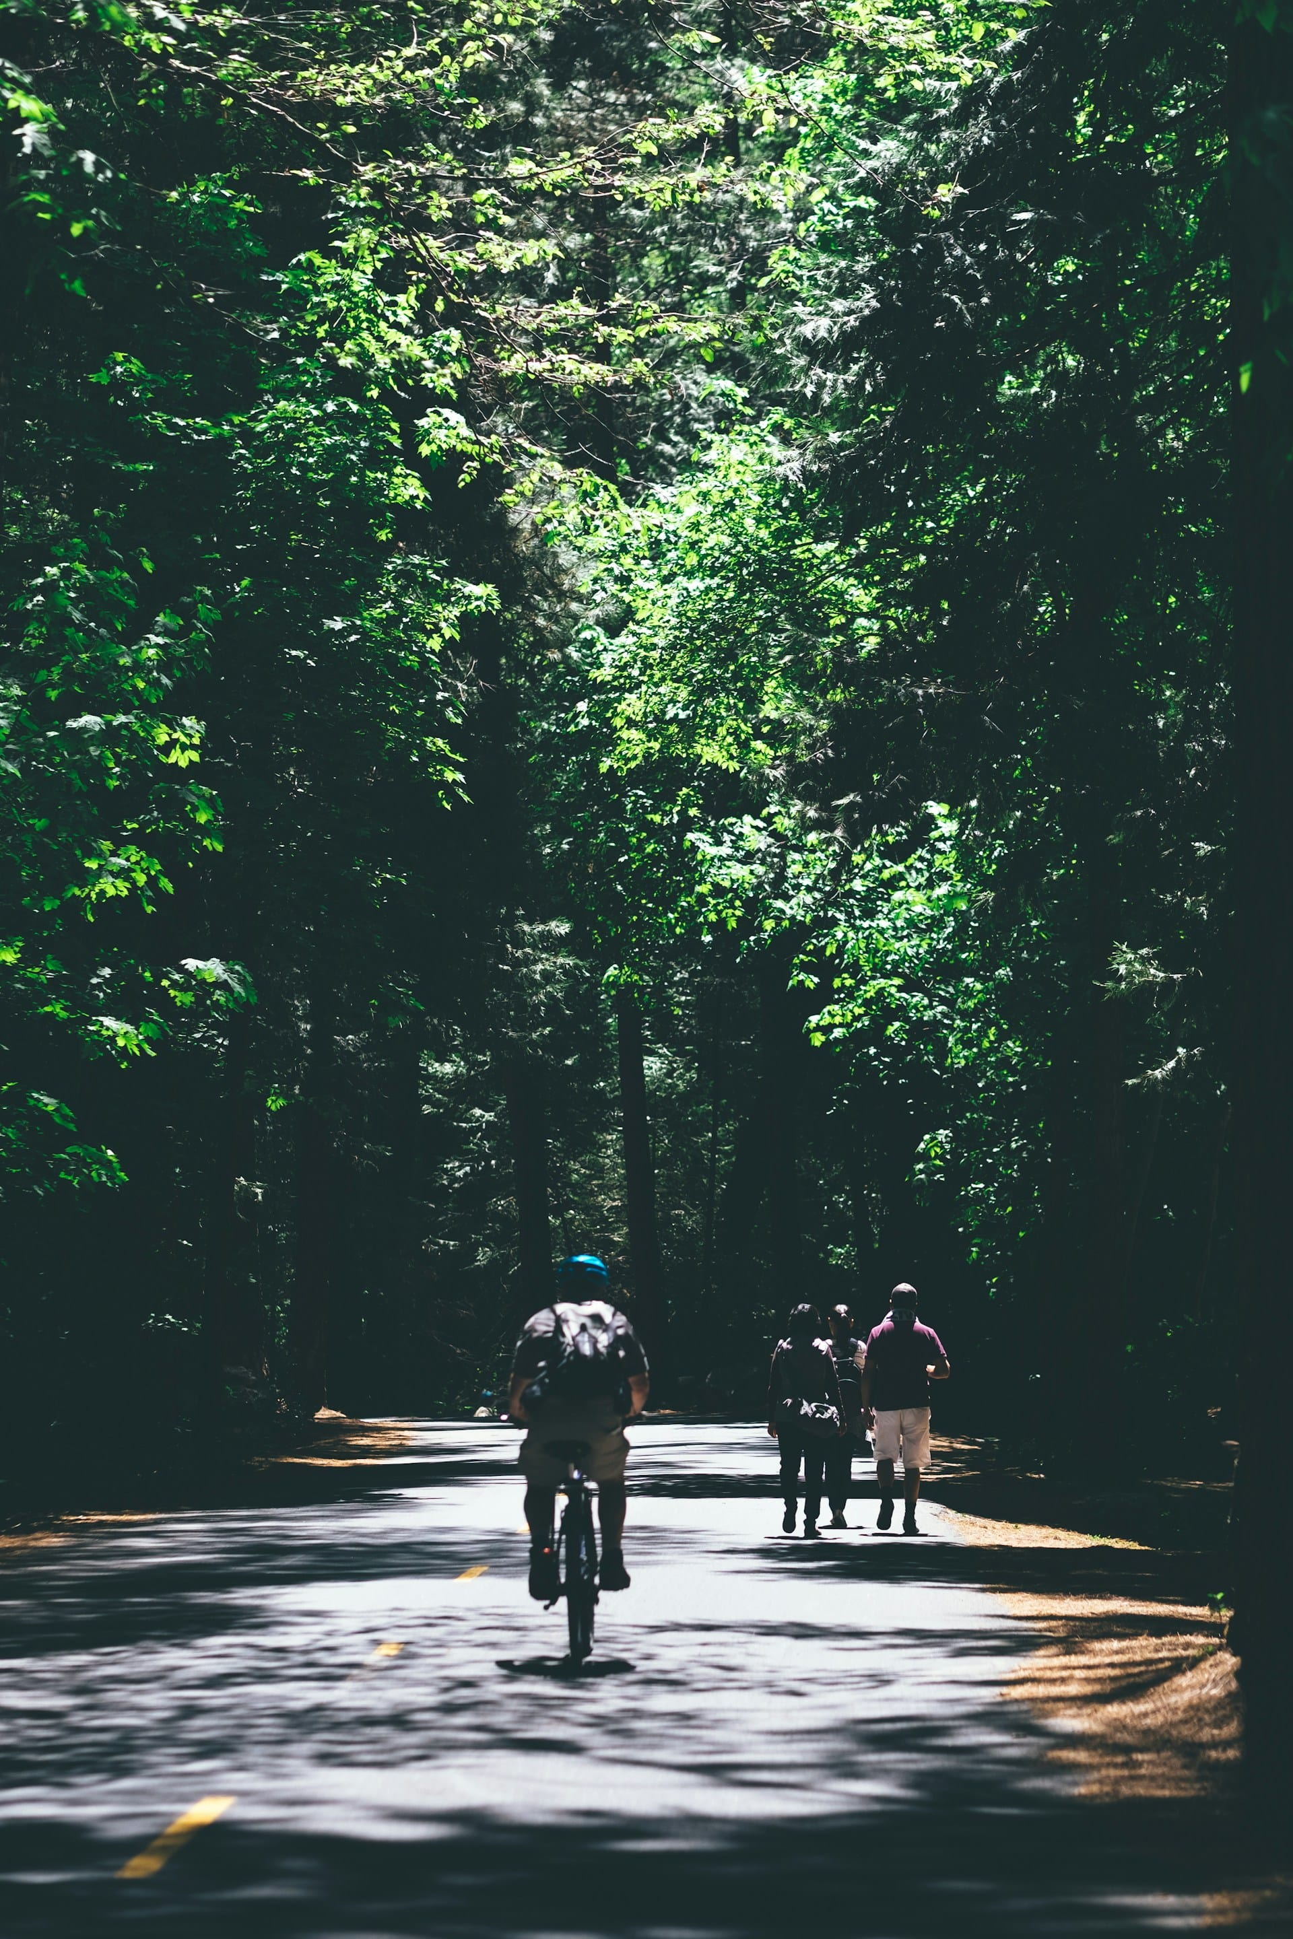

1. How many people are visible? 4 (taxonomic) (humans)

2. How many groups of people are standing together? 1 (relational) (group)

3. If the bicycle had four wheels instead of two, how many wheels would be visible? 4 (physical) (wheels)

## Image 117 (urban)

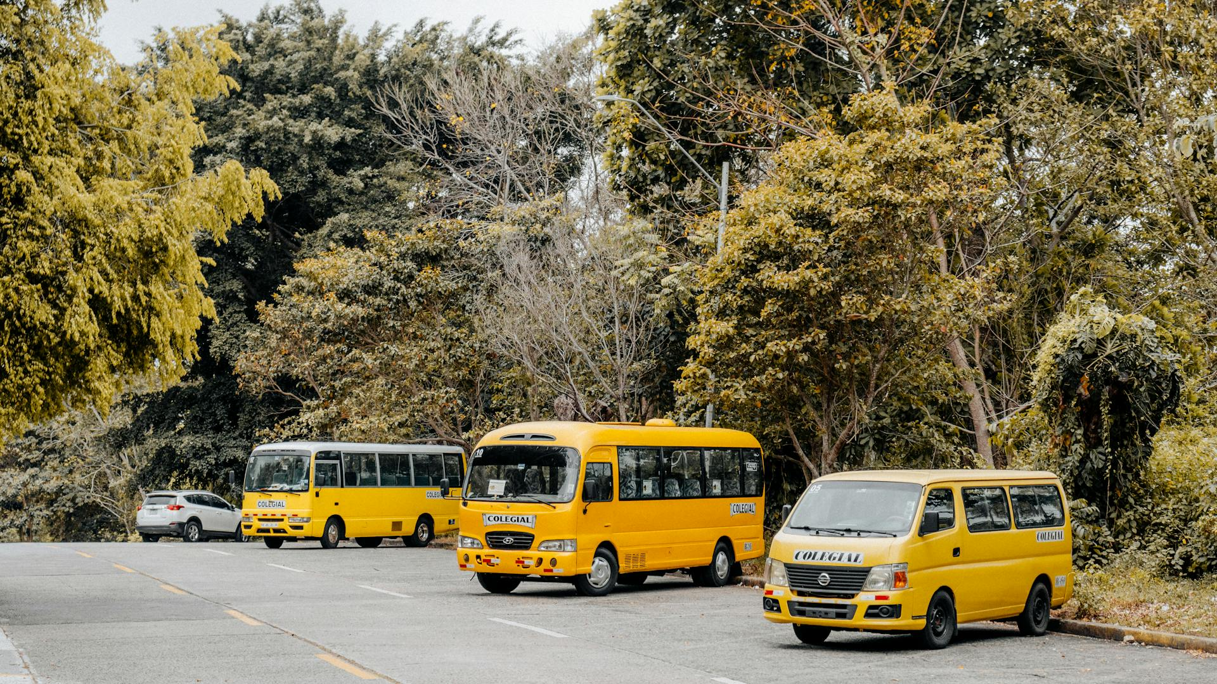

1. How many vehicles are visible? 5 (taxonomic) (buses)

2. How many vehicles have yellow coloring? 5 (physical) (buses)

3. If all the buses were red instead of yellow, how many red vehicles would be visible? 5 (physical) (buses)

## Image 118 (garage)

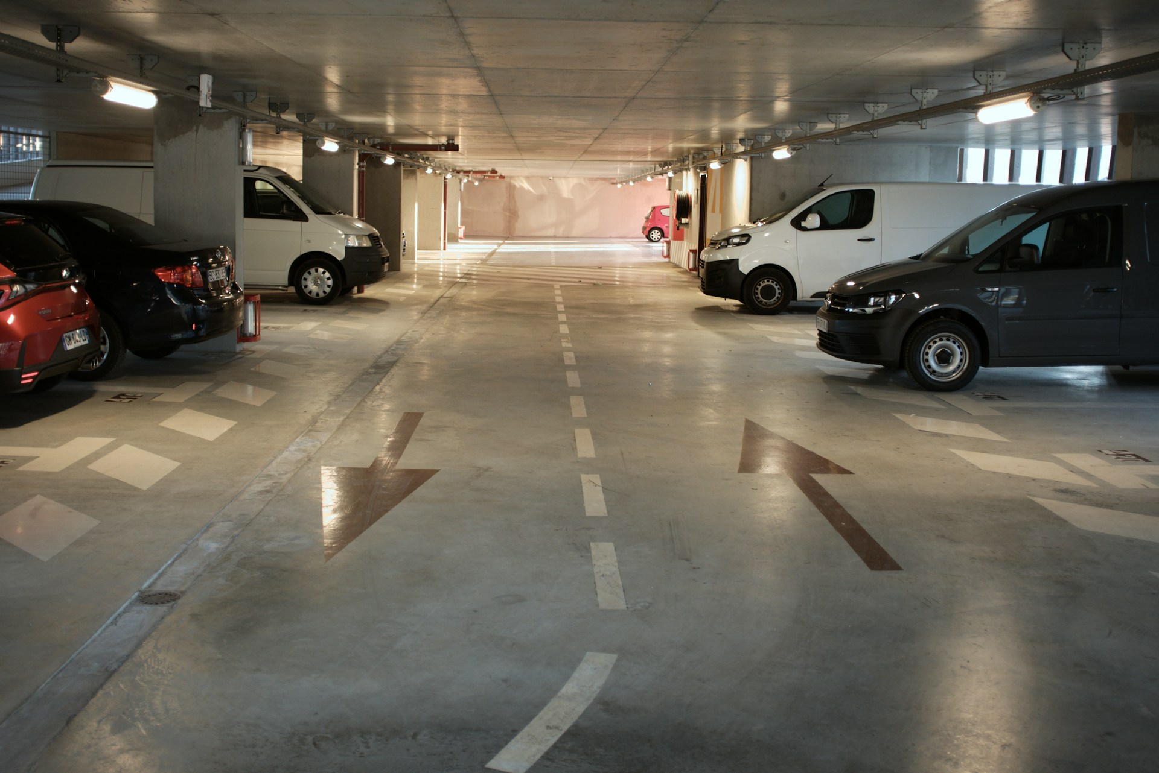

1. How many vehicles are visible? 7 (taxonomic) (cars and vans)

2. How many parking spaces have a vehicle in them? 7 (relational) (parking spaces and vehicles)

3. If all the vans were red, how many red vehicles would there be? 3 (taxonomic) (vehicles)

## Image 119 (classroom)

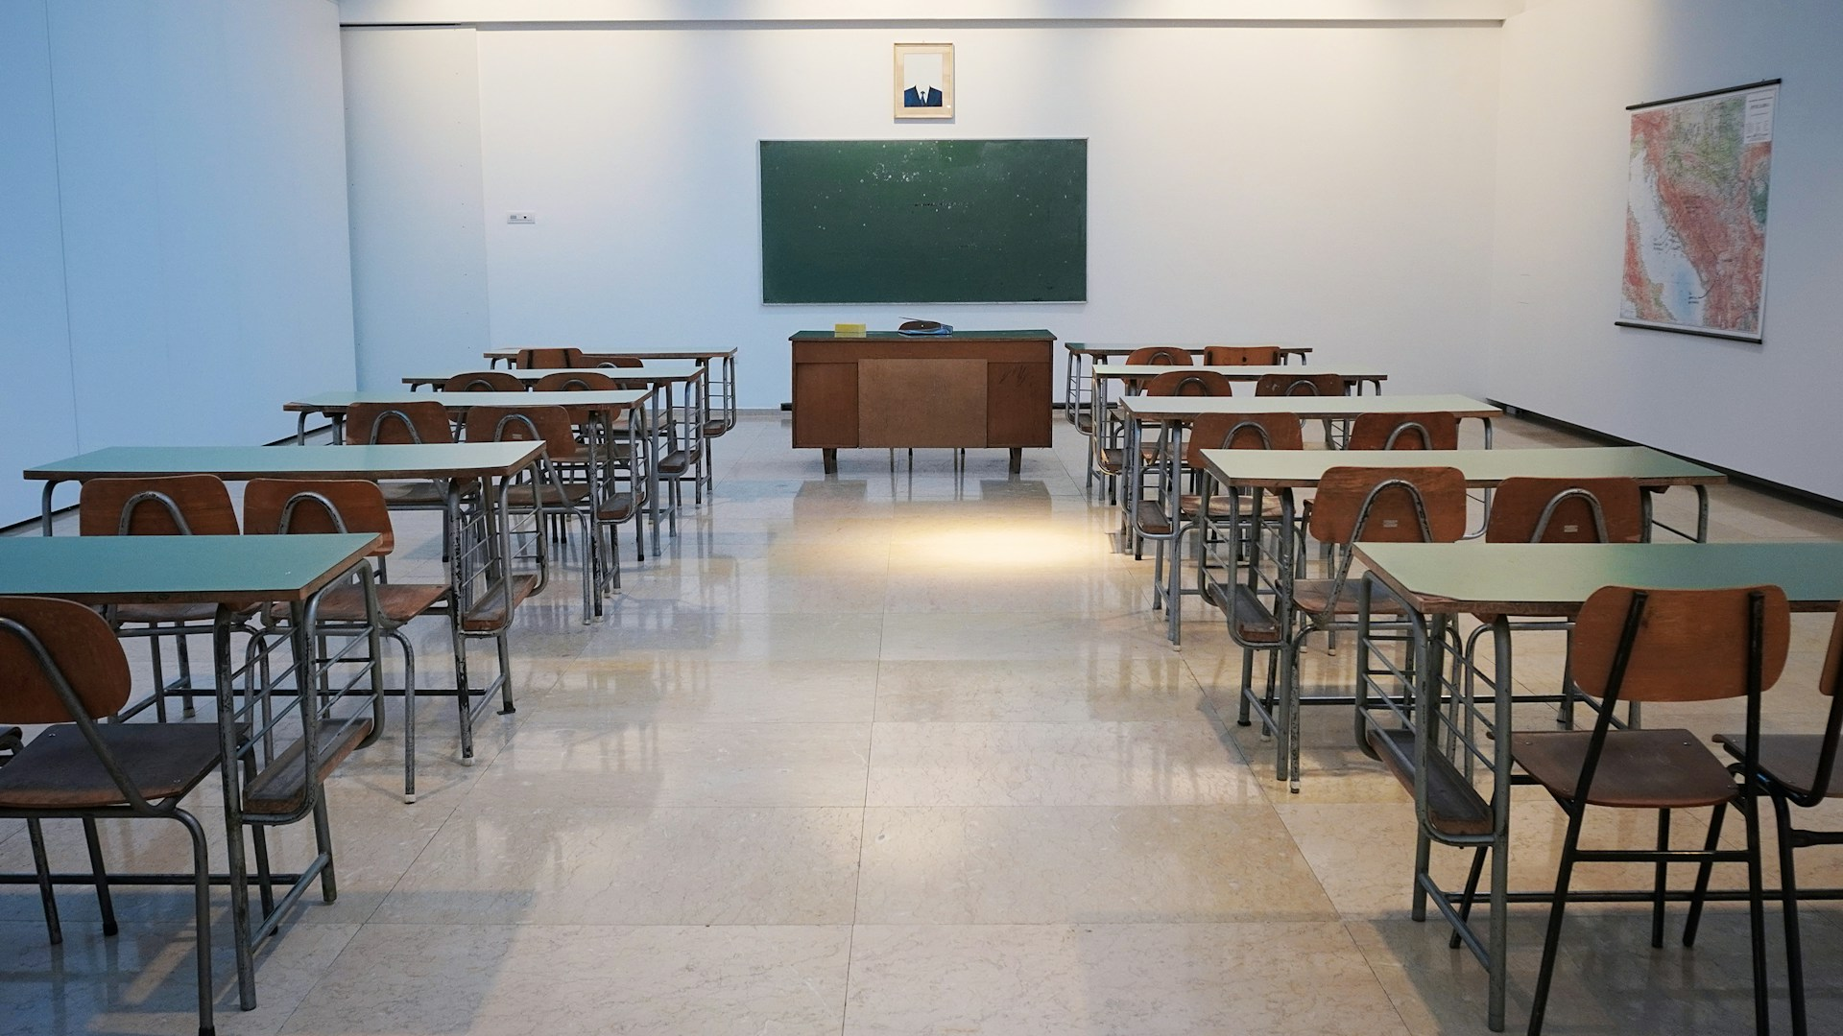

1. How many objects made of wood are present? 4 (physical) (desks/teacher's desk)

2. How many sets of desk and chair are visible? 12 (relational) (student desks and chairs)

3. If all the chairs were stacked on top of each other, how many chairs would there be? 24 (taxonomic) (chairs)

## Image 120 (home setup)



1. How many books are visible? 4 (taxonomic) (books)

2. How many items are stacked on top of each other? 2 (relational) (books and pencils)

3. If the lamp was not present, how many light sources would be visible? 0 (functional) (lamps)